STAGE 3 HUMAN BIOLOGICAL SCIENCE

A cereal company commissioned a nutritionist to study the effect of ingesting dietary fibre on the amount of calcium absorbed into the bloodstream. The nutritionist set up an experiment whereby she tested the effect of differing amounts of fibre has on the absorption of calcium from the gut. She setup three groups. Group A, consisting of 9 individuals, were given a dietary plan with no cereal at all, with their breakfast; group B of 12 individuals, were given 50g of all-bran cereal; and group C, which consisted of 14, were given 150g of the cereal. All three groups had the same diet regime except for the cereal. Since it takes 6-8 hours for food to pass through the small intestine, the nutritionist took three blood samples at 6, 7 and 8 hours after breakfast over a period of three days. She used the ionized calcium blood test, which measures the amount of ‘free’ calcium present in blood. ‘Free calcium’ refers to calcium that’s not bound to any proteins and not together with an anion in your blood. She took three samples of blood from each individual in each group and averaged the results for each group. A normal reference range for the blood total calcium test in adults is between 8.6 and 10.2 milligrams per deciliter (mg/dL).

The results were tabulated.

 | Average blood calcium levels (mg/dL)
 | 6 hours post breakfast |  |  | 7 hours post breakfast |  |  | 8 hours post breakfast
Amount of cereal (g) | Day 1 | Day 2 | Day 3 | Day 1 | Day 2 | Day 3 | Day 1 | Day 2 | Day 3
0 | 9.6 | 9.4 | 9.5 | 10.2 | 10.4 | 10.8 | 10.0 | 10.2 | 10.4
50 | 7.8 | 7.6 | 7.7 | 8.2 | 8.9 | 8.0 | 7.6 | 7.5 | 7.8
150 | 5.6 | 5.8 | 5.9 | 6.0 | 6.2 | 6.3 | 5.7 | 6.0 | 6.1

(a) (i) State the hypothesis for this investigation.
An increase in the amount of cereal consumed results in a lowered blood

calcium level.

(ii) Identify the independent variable.

Amount of cereal consumed

(iii) Identify the dependent variable.

Average blood calcium level

(iv) Identify the control group in this investigation.

Group A; the group which did not consume any cereal.

(v) State two variables that are already controlled.
Time blood sample is taken (6-8 hours); same diet; period of testing (3days).

(vi) State two additional variables that can be controlled.

amount of blood taken in a sample; the method used to extract blood sample;

type of cereal provided.

(b) Identify the outlier in the collected data.

Group B, second sample on day 2. (8.9mg/dL)

(c) Calculate the averages over the three days for each group

6 hours after 7 hours after 8 hours after
Group A: 9.93 mg/dL 10 mg/dL 10.2 mg/dL
Group B: 7.86 mg/dL 8.0 mg/dL 7.8 mg/dL
Group C: 5.77 mg/dL 6.0 mg/dL 5.83 mg/dL

(d) Calculate the median for each group for each testing session.

6 hours after 7 hours after 8 hours after
Group A: 9.5 mg/dL 10.2 mg/dL 10.2 mg/dL
Group B: 7.7 mg/dL 8.2 mg/dL 7.6 mg/dL
Group C: 5.8 mg/dL 6.2 mg/dL 6.0 mg/dL

(e) Graph the above data.

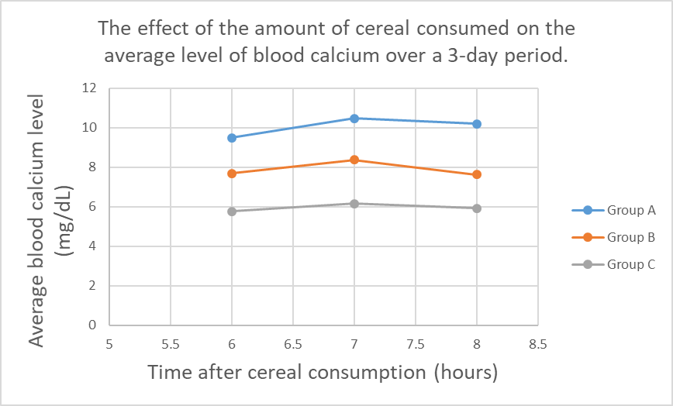

 | Time (Hours)
 | 6 | 7 | 8
Group A | 9.5 | 10.47 | 10.2
Group B | 7.7 | 8.37 | 7.63
Group C | 5.77 | 6.17 | 5.93

(f) The nutritionist did not maintain the same number of participants in each group. Explain any effect this might have on the validity of the investigation.
This does not render the investigation invalid, since an average of the group is

obtained; also, the number of participants in each group is similar.

(g) Describe two specific ways she can improve her experiment’s validity.

Randomise the participants. Blind the study.

(h) Describe 2 ways she can improve reliability of this investigation.

Repeat the experiment; replicate, reduce errors; increase sample size.

(i) What type of data is obtained?

Quantitative data.

(j) Comment on the ethics of this experiment.

Too much fibre can result in constipation.

(k) Describe two errors that could have taken place during the investigation.

Systematic error: measuring calcium levels.

Experimental error: correctly labelling collected blood samples.

(l) By how much did the average blood calcium level increase from 6 to 7 hours after breakfast consumption? Show calculations.
(32-28) / 28 = 14.28%
Group A: (10.47-9.5)/9.5 * 100 = 10.2%;
Group B: (8.1-7.7)/7.7 * 100 = 5.2%;
Group C: (6.17-5.77)/5.77 * 100 = 6.9%;

(m) What data would support the hypothesis?

A decrease in average blood calcium levels with an increase consumption

of cereal.

(n) What data would refute the hypothesis?

No difference between the control and experimental groups’s level of blood

calcium; and, if groups B and C have lower blood calcium levels than Group A.

END

