S A L I N I T Y

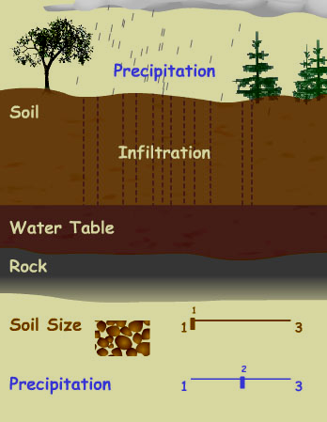
Salinity is one of the greatest environmental threats facing Western Australia’s agricultural land, water, biodiversity and infrastructure. It is caused by too much water containing dissolved salts in the wrong places in the landscape, which has been accelerated by the clearing of perennial vegetation since European settlement.

Dryland salinity occurs when the concentration of soluble salts near the soil surface is sufficient to reduce plant growth. In Western Australia, this is basically a water management problem: increased recharge raises the watertable, bringing naturally stored salts from depth to the surface.

Recharge is not uniform across the landscape. It is higher in deep sandy soils(poor water-holding capacity) and lower in clay soils(high water-holding capacity).

Flat ground is most susceptible to salinity where there is no clear escape for groundwater or surface water.

According to the most recent estimates from Land Monitor (2004) based on satellite images, about 1 million hectares in the south-west agricultural region were severely affected by salinity in the year 2000. Another 2.8 to 4.5 million hectares have been identified as representing a salinity hazard.

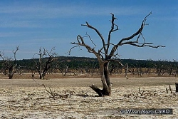
In 2006, monitoring of groundwater levels by Department of Agriculture and Food hydrologists indicated that groundwater levels are continuing to climb in most agricultural areas. The National Land and Water Resources Audit indicated that up to 6.3 million hectares of farmland in Western Australia could be at high risk of developing shallow saline watertables by the year 2050.

Problems that develop from surface salinity include loss of agricultural productivity, loss of natural biodiversity, damage to buildings, roads and degradation of water supplies.
Salinity could be classified as primary or secondary. Primary salinity occurs in arid climates. 29 million hectares in Australia are affected by primary salinity. Secondary salinity is developed by changing land use and management.
It is caused by a change in the water balance, leading to more water in the soil and a rising watertable. Clearing for agriculture has been the major cause of secondary salinity in Australia.

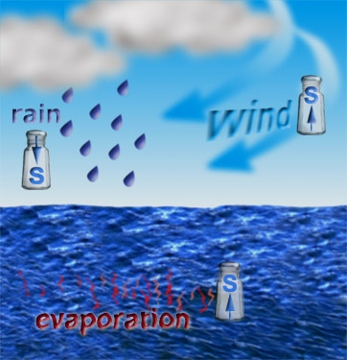
Salinity is usually noticed first when plants grow poorly, and yields of farm plants are reduced by more than 25 to 30%. About 2.5 million hectares of secondary salinity was estimated in Australia in 1996. Symptoms of dryland salinity begin to appear when the watertable rises to within 1 or 2 meters of the soil surface.

Soil salt can come from breakdown of parent rock, geological inundation by oceans and from wind blown salt from ocean rainwater.
Salt in rainfall can range from about 20kg/ha/year to more than 200kg/ha/year.

Bush has many perennial plants with deep roots and tolerance to the highly variable climate in southern Australia. Most agricultural plants have shallow root systems and use less water. Clearing of native deep-rooted woodlands and forests and the introduction of shallow-rooted crops and pastures in large areas has led to a significant increase in the amount of rainfall ‘leaking’ into the groundwater systems.

It is estimated that in some places, groundwater has risen by 30 meters since the 1880s in south-eastern Australia, and by about 20 meters in south-western Western Australia.

Western Australia was estimated to have nearly 2 million hectares of secondary salinity in the South-West zone(9.4% of cleared land) in 1994.
It is projected to be 3.3 million hectares by 2020.

$2million investment by the Australian and West Australian governments, funded under the National Action Plan for Salinity and Water Quality, is used to tackle salinity and improve water quality.

$500,000 is used for the Avon region to develop town water management plans, which will protect town infrastructure, and, native flora and fauna from the impacts of salinity. These plans include groundwater pumping, drainage, surface water harvesting and storage, mineral extraction and desalination.

$350,000 was assigned for salinity management in the West River Catchment. These funds will help implement sustainable low recharge farming systems in the catchment to stop or reduce to amount of agricultural land affected by salinity.

Questions

Q1. How much of farming areas will salinity affect by 2050?

6.3 million hectares

Q2. How does salinity develop?

when trees are cleared, the roots are no longer able to syphon water

from ground and release it to the atmosphere. With recharge/rainfall,

the water table rises carrying with it dissolved salts to the surface.

Q3. Identify factors that cause salinity.

Land clearing; overuse of fertilisers on farming land;

change in land management and the use of shallow rooted vegetation.

Q4. Identify some of the problems that arise as a result of salinity.

Loss of agricultural productivity; building and road damage;

Degradation of water supplies;

Loss of biodiversity.
Q5. How can you tell that salinity is affecting a farming area?

Yield of farm plants is reduced by 25-30%.

Poor growth of plants.

Q6. What are some government initiatives to tackle salinity?

$2million investment by the Australian and West Australian Water

governments, funded under the National Action Plan for Salinity and

quality, is used to tackle salinity and improve water quality.

$350000 to help implement sustainable low recharge farming systems.

$500000 to develop water management to protect town infrastructure

and flora and fauna from the impacts of salinity.

