Biomagnification

Biomagnification, or biological magnification, is the increase in concentration of a non-degradable substance in organisms as it is passed along food chains.

One such substance is DDT(dichlorodiphenyltrichloroethane), a pesticide, first synthesised during the WWII. DDT helped control the mosquitoes that were transmitting the sporozoan disease agents (plasmodium japonicum) causing malaria.
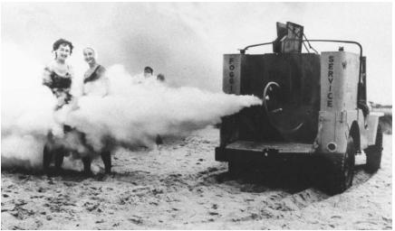
In European cities, people were suffering from rashes, fever and headache associated with typhus. DDT helped control the body lice that were transmitting the bacterial agent of that disease.

After WWII, DDT was used as a general pesticide in huge quantities in agricultural and forest areas. DDT is an insoluble chemical that gets carried by water vapour and winds to distant places. DDT is also soluble in fats, therefore, it can accumulate in the tissues of organisms.

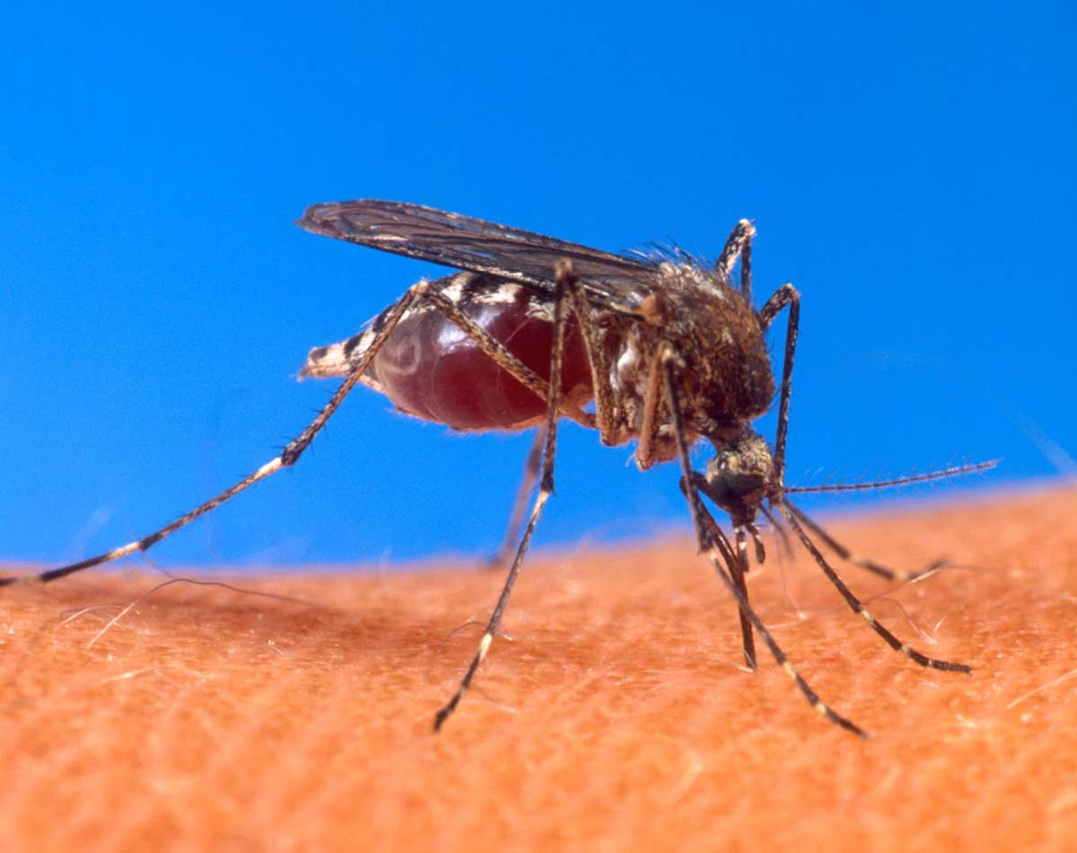
Most of the DDT from all the organisms that a consumer eats during its lifetime will become concentrated in its tissues. DDT is extremely toxic to many aquatic and terrestrial animals.

In cities where DDT was spread to control Dutch elm disease, songbirds started dying. In streams flowing through forests where DDT was sprayed to control spruce budworms, salmon started dying.

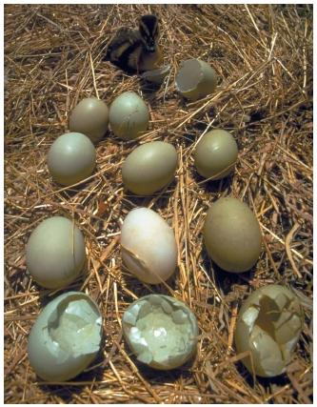
DDT was indiscriminately killing the natural predators that had been keeping pest populations in check. DDT moved along the food chain until it reached the top consumer the bald eagle. Eagles numbers started to dwindle quickly even though they were far away from the application zone of DDT. They fed on birds, who in turn, fed on fish with DDT and the poison accumulated in their tissues. The eggs had brittle shells that many of the chick embryos didn’t make it to hatching time.
QUESTIONS.

1. Name the organism directly responsible for malaria?

_____________________________________________________________

2. Identify one chemical that has been used extensively to eliminate malaria.

_____________________________________________________________

3. Why does DDT accumulate in fatty tissues?

_____________________________________________________________

4. How did DDT reach the bald eagle population?

__________________________________________________________________________________________________________________________
5. How did DDT affect the bald eagle population?

__________________________________________________________________________________________________________________________
6. Why did the pest population get out of control?

__________________________________________________________________________________________________________________________
7. Define the term biomagnification.

__________________________________________________________________________________________________________________________

