Yr9 Urbanisation & Agriculture - Human impact on environment.

- Give a definition for the following terms:

- Feral species:

- Pest species:

- Invasive species:

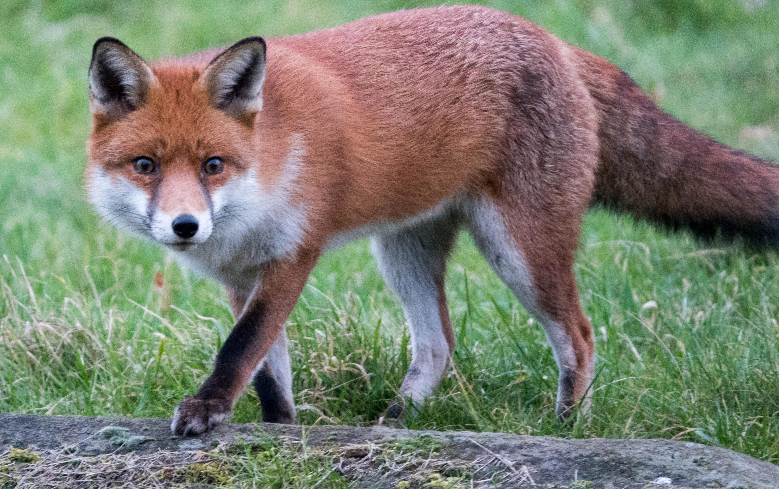

- Identify an animal that has become a feral in Australia

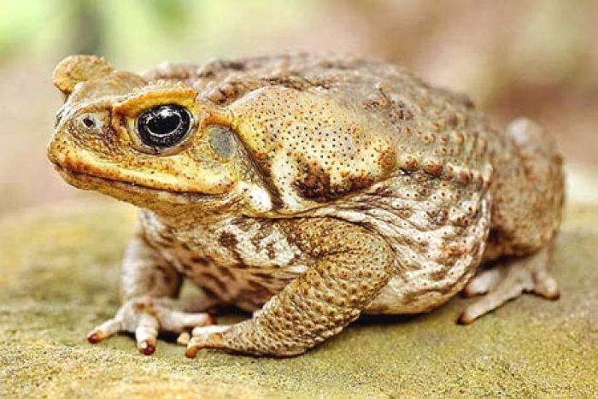

- Explain why when an organism is introduced into a new habitat, the balance of population numbers in an ecosystem is removed.

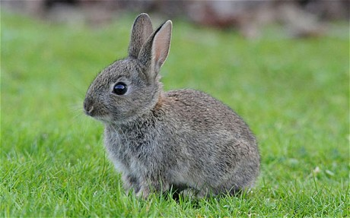

- The cane toad was introduced to Australia from Hawaii in 1935.

- Give a reason for its introduction.

- Explain why it was not successful.

- What was the impact of this introduced species on Australian ecosystem?

- Is the cane toad an invasive species? Justify your answer.

