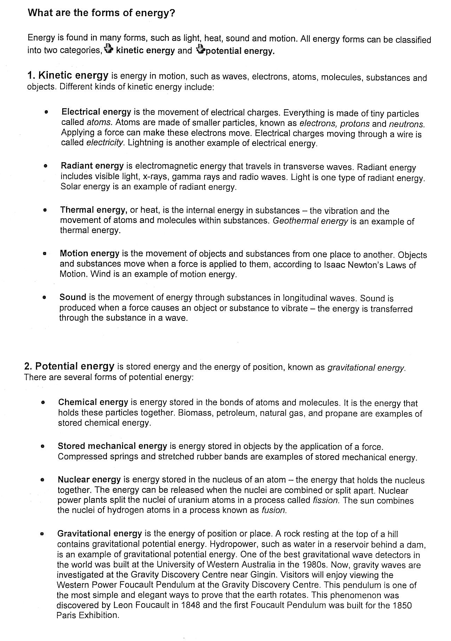

Potential energy is classified depending on the applicable restoring force.
- Gravitational potential energy – potential energy of an object which is associated with gravitational force. For example, when a book is placed on top of a table, energy required to raise the book from the floor and energy possessed by the book due to its elevated position on the table is gravitational potential energy. Here gravity is the restoring force.
- Elastic potential energy – energy possessed by an elastic body like the bow and catapult when it is stretched and deformed in one direction is elastic potential energy. The restoring force is elasticity which acts in the opposite direction.
- Chemical potential energy – energy related to arrangement of atoms and molecules in a structure is chemical potential energy. Chemical energy possessed by a substance due to the potential it has to undergo a chemical change by taking part in a chemical reaction is chemical potential energy of the substance. When fuel is used, for example, chemical energy stored in fuel is converted to produce heat.
- Electrical potential energy – energy possessed by an object by virtue of its electric charge is electrical potential energy. There are two types – electrostatic potential energy and electrodynamic potential energy or magnetic potential energy.
- Nuclear potential energy – potential energy possessed by particles (neutrons, protons) inside an atomic nucleus is nuclear potential energy. For example, hydrogen fusion in the sun converts potential energy stored in solar matter into light energy.

