States of matter

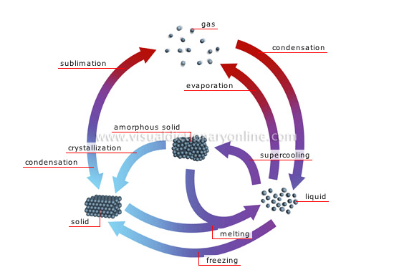

http://resources.yesican-science.ca/lpdd/g07/lp/nelson/nel08.html

http://2012books.lardbucket.org/books/introduction-to-chemistry-general-organic-and-biological/s11-02-solids-and-liquids.html
answer the questions on this page and then look up the answers.

http://www.bbc.co.uk/bitesize/ks2/science/materials/changing_states/play/
Play a game where you need to perform a task relating to state of matter. Enjoy

