Heat transfer in the home

Vaccum Flask
Q1. Name each part of the vacuum flask and explain how the property of each element helps in retarding (diminishing) heat transfer.
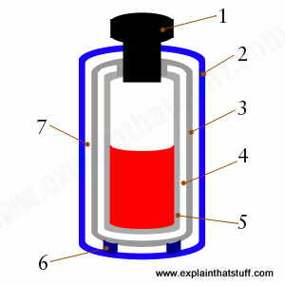

Q2. Explain how the structure of an esky keeps the content inside cool.

Q3. When you get into bed at night the sheets, and at first, the blankets feel cold. After a short time we begin to feel warm. Explain what is happening to make us feel warm.

Q4. Premature babies are wrapped in cotton wool and aluminium foil. Justify the use of these materials.

Q5. Eskimos live in igloos. Why don’t they freeze?

Q6. In the following picture of a motorbike engine you can see the fins on the cylinder head. What is the function of those fins?
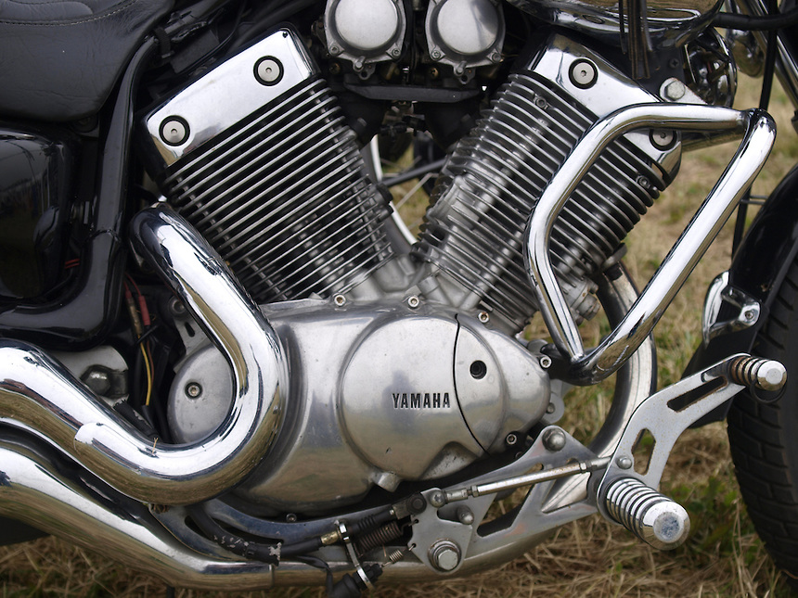

Q7. Explain why people in the Gulf prefer this type of clothing.


Q8. Explain how this illustration of window double-glazing works to reduce heat transfer.

