YEAR 9 SCIENCE REVISION HEAT Name:

- Two cars were parked under the sun. Which car will feel warmer to the touch? A or B? Circle the correct answer.

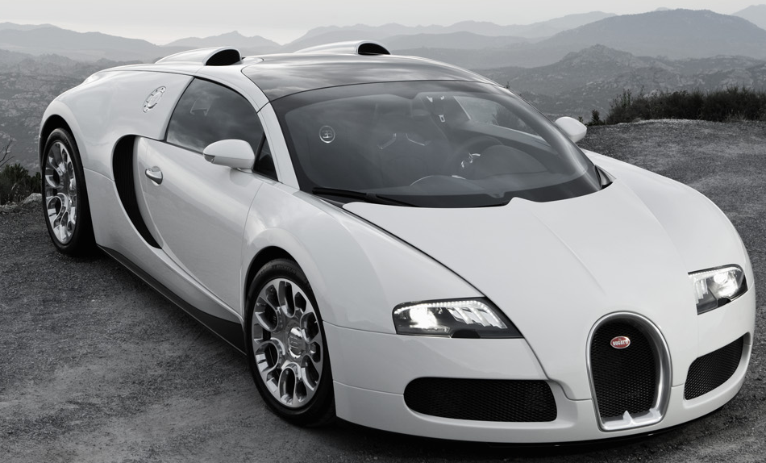
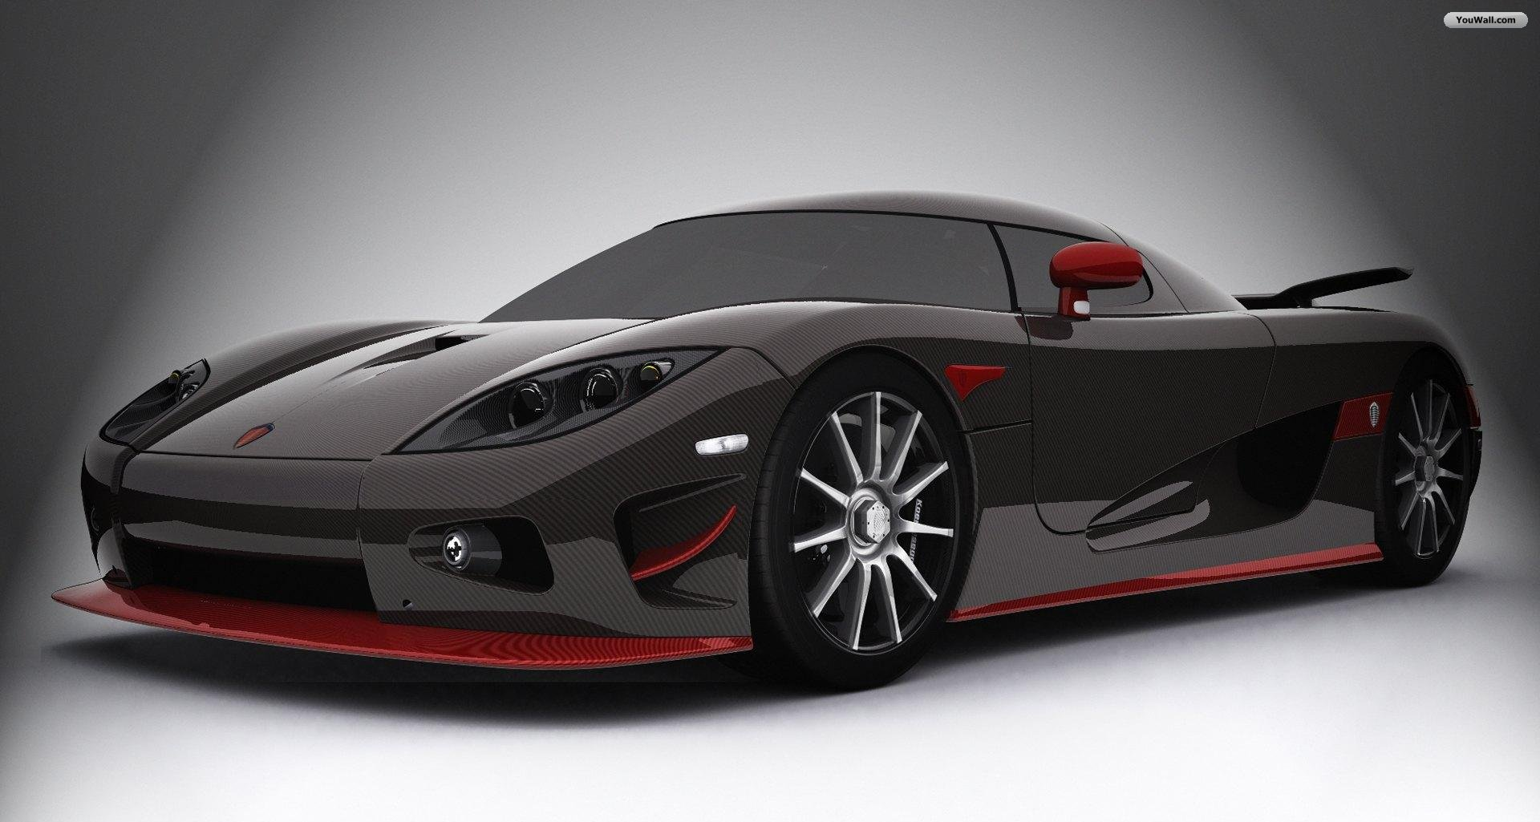

A
B

Explain your answer using one sentence.

B. because dark coloured objects will absorb more heat than light coloured objects.

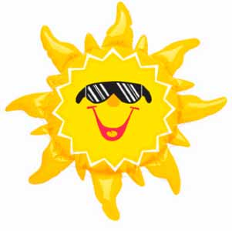
- Identify which type of energy is illustrated in the diagrams below.
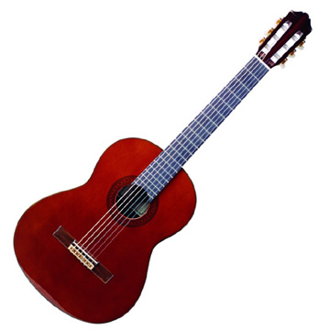
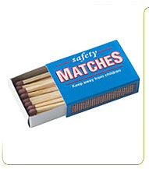

Sound Energy Chemical energy Radiant energy

- Identify the energy receiver in this diagram of a bell.


The bell – sound energy


- What type of energy does this diver have?

Kinetic energy as well as potential.

- Identify which sequence is the correct order that explains how kinetic theory works.

A particles vibrate faster.
B the material expands as a result.
C heat energy is applied to the material.
D the space between particles increases.

i A, B, C then D.
ii C, D, A then B.
iii C, A, D then B.
iv C, A, B then D.

- Identify which method of heat transfer is responsible for heating:
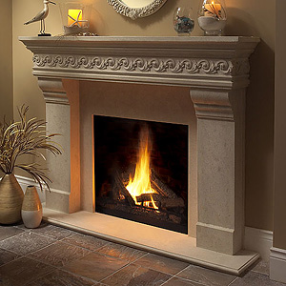
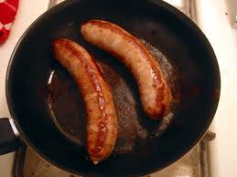

A sausage The room

Conduction Radiation
_____________________ _______________________

- Temperature is best defined as:
a how cool an object is.
b how hot an object is.
c the transfer of heat into an object.
d the measure of heat energy in an object.

- Indicate, using arrows, in which direction heat will travel between two objects below.


- Which container contains more heat in the following scenarios? Tick the correct answer.



Scenario 1


25ºC
24ºC

Scenario 2


25ºC
25ºC

Scenario 3


22ºC
21ºC
- Metals conduct heat at different rates. The four metals tested are: nickel(Ni), aluminium(Al), magnesium(Mg) and chromium(Cr). Four metal bearings were attached to the bottom of each metal strip and all metals strips were heated at the same time. When a metal strip becomes too hot, the bearing would fall.

Given the information in the table, list the conductivity of the metals below in order of least to most conductive given data below.

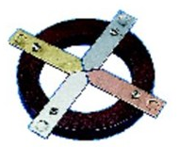
Type of metal | Time (seconds)
Ni | 21
Al | 52
Mg | 72
Cr | 41

Mg Al Cr Ni

T
F
- Indicate if the following statements are TRUE or FALSE

a) Every type of energy can be converted to heat energy.
T
F

T
F
b) You will feel cooler wearing a black rather than a white shirt on a hot day.

T
F
c) The energy receiver in a piano is sound energy.

T
F
d) When you shower, heat is transferred to your body by convection.

T
F
e) Sublimation is the change of state of matter from a gas to a liquid.

f) Heat is transferred in a metal by particles colliding against each other.
T
F
as they vibrate.

T
F
g) Insulators are materials that allow heat to travel through an object.

- List as many features you can find in a vacuum flask that allows it to trap heat inside it for a long time.
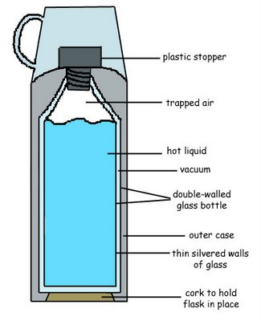
- Vacuum between two layers of glass.
- Silver-coated glass panels.
- Plastic stopper at the bottom to prevent contact with the outer casing.
- Plastic lid to minimise heat transfer.
- Air between outer casing and outer glass layer.

- Explain why in figure A you would feel the heat absorbed by the water but in figure B you would not.

When the test tube is heated at the bottom, water absorbs heat and expands and become less dense and rises to the surface and you will feel the hot water as it rises in convection currents.


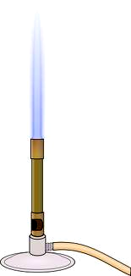
When you hold the test tube from the bottom and heat the top, hot water stays at the top because it is less dense than cold water. It will take a while before you feel the heat at the bottom of the tube as it travels by conduction, which is much slower.
Figure A
Figure B

