Yr 9 Science Energy & Change – HEAT- Revision

- List and explain the three methods of heat transfer.

Conduction: is when heat is transferred from one particle to another .

Convection: heat travels in the fluid by the fluid itself rising upwards as it becomes less dense when heated, using convection currents.

Radiation: when electromagnetic waves hit an object, it causes the particles of that object to vibrate more and heat is felt. The radiation itself is NOT hot. Radiation does not require a medium to go through.

- What are conductors? Give two examples.
Conductors are objects that can transmit heat and/or electricity, each metals.

- What are insulators? Give two examples.

Insulators are poor conductors of heat, such as plastic, glass, rubber, wood, etc…

- Explain how a vacuum flask is a good example of application of the principles of heat transfer.

The vacuum flask reduces transfer of heat by conduction by limiting contact between the outer glass and outer casing and by using plastic cap as well as glass for holding the liquid.
It reduces the transfer of heat through radiation by using silvered glass surfaces to radiate heat back into the liquid inside.
The vacuum between the two glass panels reduces convection.

- Dark coloured objects radiate more effectively than

light coloured objects.

- Dark coloured surfaces are better absorbers of radiation.

- Silver coloured surfaces reflect most radiation which falls on them.

- What is a bimetallic strip? Explain using a diagram showing two different metals (iron and copper). Indicate which way the strip bends.

It is a strip of metal made up to two metals welded together. One metal tends to expand more than the other metal, and since it cannot move past the other metal, it causes the whole strip to bend. The strip will bend towards the metal that does not expand that much as the other.

- When a metal bar is heated it expanded. Explain this using the kinetic theory.

When heat is applied to a metal bar, the particles vibrate more rapidly, resulting in the material expanding because the increase in the distance between the particles due to the weakening of the bond holding the particles together.

- State the law of conservation of energy.

Energy cannot be created or destroyed. It mainly moves from one form to another. It is converted to other forms of energy.

- If the cost of 1 kilowatt hour energy is 12 cents, how much would it cost to leave a
3000 watt heater on for 10 hours (1000 watts = 1 kilowatt)

12 x 3 = 36 cents. 36 x 10 = 360 cents or $3.60

- Use the following information to help you answer the questions which follow:
A metal nut with a mass of 15 grams was heated in boiling water for 3 minutes, removed and then immersed in 100mL of cool water at room temperature (22°C). The temperature of the nut and the water was recorded electronically during the entire experiment. The temperatures are recorded in the table below.
Stage of Experiment | Time in  minutes | Temperature of  nut °C | Temperature of  water °C
Start heating | 0 | 20 | 22
Start heating | 1 | 50 | 22
Start heating | 2 | 78 | 22
Start heating | 3 | 90 | 22
Immersed in cool water | 4 | 75 | 27
Immersed in cool water | 5 | 40 | 29
Immersed in cool water | 6 | 25 | 25
Immersed in cool water | 10 | - | -
Immersed in cool water | Allow 4 more minutes at the end of your graph to answer part (f) below.

    - Draw on the same axis a graph for the temperature of the nut and the water using the data from the table. (Graph for 10 minutes of time)
    - On immersion in the water at 22°C, the temperature of the nut fell quickly. Using the Kinetic Theory of Matter, explain how the nut lost its heat energy.
    - At 6 minutes, how many °C had the nut lost to the cool water?
    - At 6 minutes, how many °C had the water gained from the nut?
    - Why is the °C lost by the nut greater than the °C gained by the water?

    - On the graph, sketch a line to show the temperature of the water and the nut for the next four minutes.

a)

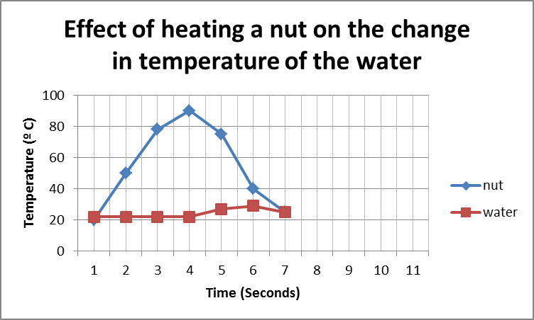
b) Energy from the nut went to the water by conduction. As the heat escaped the nut the rate of vibration of the particles in the nut decreased but the water particles started to vibrate more rapidly upon receiving the heat energy from the nut.

c) 75 ºC

d) 3 ºC

e) Because there is a larger volume of water compared with the nut. Furthermore, upon immersion of the nut in the water lot of heat escaped from the water in the form of vapour due to vapourisation.

f) See graph.

