SERIES CIRCUITS

Series circuits (where components are connected in one loop of wire).

Advantages

1. Easy to construct.

Disadvantages

1. If one component in a series circuit fails, then all the components in the circuit fail
because the circuit has been broken.
2. The more components there are in a series circuit, the greater the circuit's resistance.
[Greater resistance translates to dimmer light.]

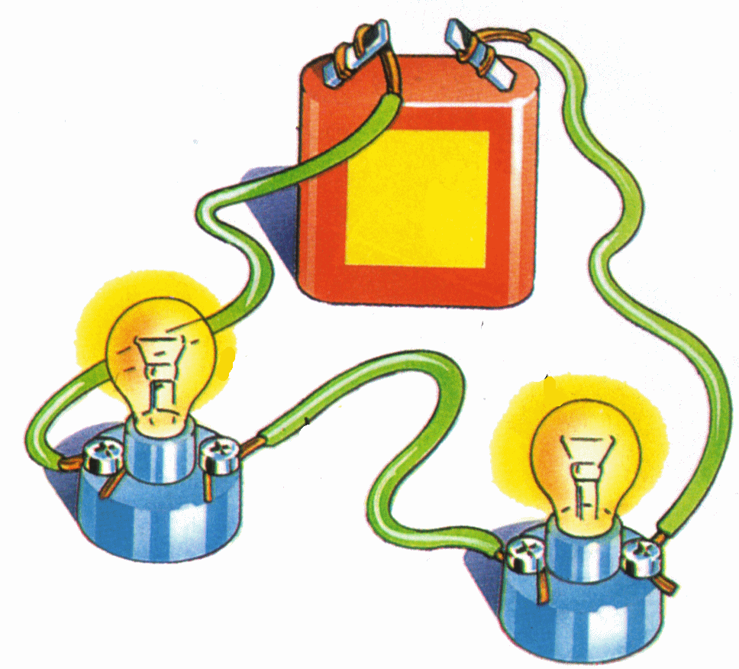

WORKSHEET ON SERIES CIRCUIT

Connect the following components in a SERIES circuit.

1.

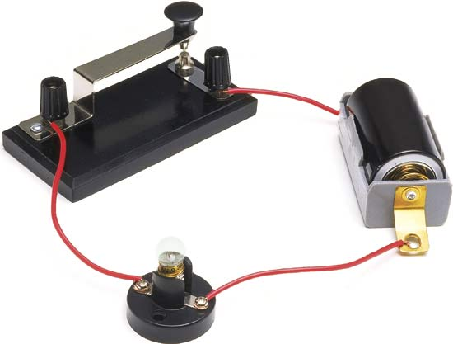



                   

2.

                   

3.

PARALLEL CIRCUITS

Parallel circuits(two or more series circuits connected to the same energy source).
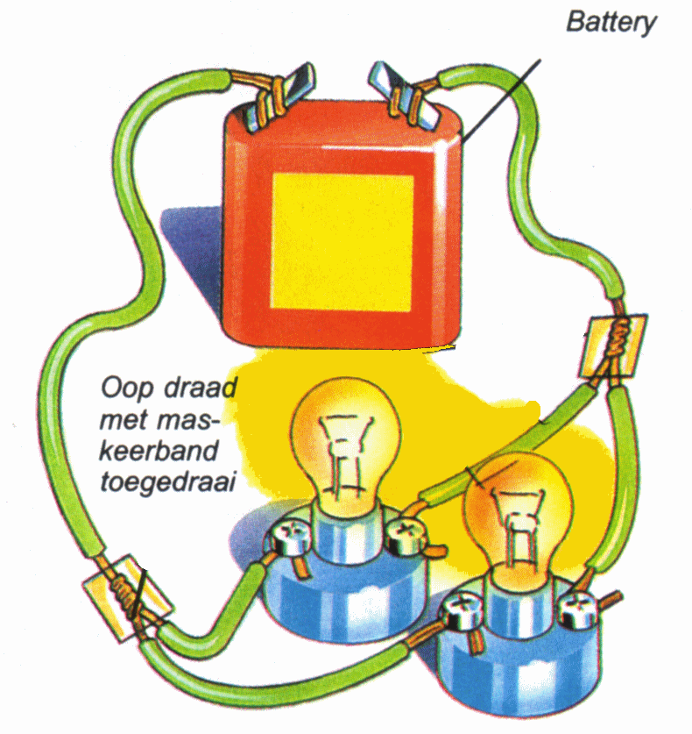

Advantages

1. A failure of one component does not lead to the failure of the other components.
[This is because a parallel circuit consists of more than one loop and has to fail in more than one place before the other components fail.]

2. More components may be added in parallel without the need for more voltage.

3. They all get the full battery voltage so they’re all bright.

Disadvantages

1. The more components connected in parallel, the lower the resistance, therefore, the
higher the current.
[Higher current translates to higher temperature of the electrical circuits (fire hazard).]

2. The more components connected in parallel, the more energy is used.
...the circuit below would light one lamp for 12 hours:

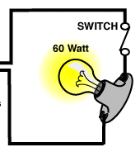

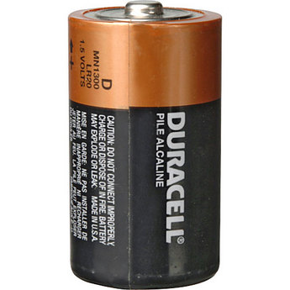

...the circuit below would light two lamps for 6 hours:
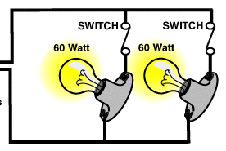

WORKSHEET ON PARALLEL CIRCUIT

Connect the following components in a PARALLEL circuit.

1.

                   

2.

                   
3.

                   

4.

