Electric generator

Magnet + Coil + Movement Electricity

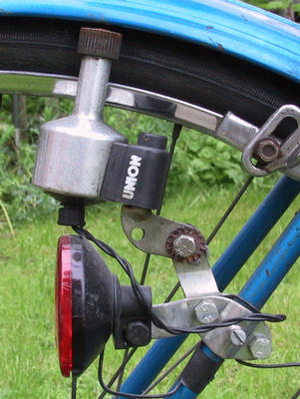
An electric generator is a device that converts mechanical energy to electrical energy.

The source of mechanical energy may be a turbine steam engine, water falling through a turbine or waterwheel, an internal combustion engine, a wind turbine, a hand crank, compressed air or any other source of mechanical energy.

Instead, generators induce a current by spinning a coil of wire inside a magnetic field, or by spinning a magnet inside a coil of wire. As this happens, a potential difference (voltage) is produced between the ends of the coil, which causes a current to flow.

One simple example of a generator is the bicycle dynamo. The dynamo has a wheel that touches the back tyre. As the bicycle moves, the wheel turns a magnet inside a coil. This induces enough electricity to run the bicycle's lights.
The faster the bicycle moves, the greater the induced current and the brighter the lights.
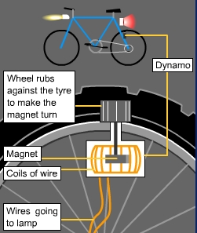

Electric Motor

Magnet + Coil + Electricity Movement

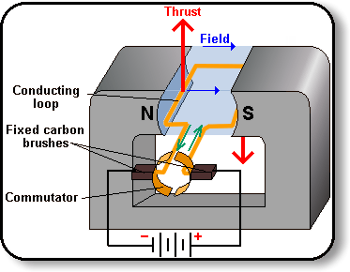

N S

Electricity is supplied from a battery. The battery is connected to two brushes, two commutator rings and a coil of wire (armature) in a circuit.

As electrons flow through the armature they create a magnetic field around the armature. The armature becomes a temporary magnet. This magnetic field goes in one direction.

This magnetic field will come in conflict with the magnetic field of the permanent magnet surrounding the armature. So you have a magnetic field within another magnetic field. The same poles of the two magnetic fields will repel and the armature will turn.

As the commutator turns half a turn the brushes will be in contact with the other ring of the commutator. This will reverse the flow of electrons going through the armature and hence the magnetic field will be altered(South becomes North and vice versa). This configuration will guarantee that the armature always have the same magnetic poles as the permanent magnet. Therefore, repulsion will always be taking place and the armature will keep spinning as it tries to get away(repel) from the housing magnet.

N S

