Thermocouples
Measurement and control of temperature is one of the most common requirements of industrial instrumentation and the thermocouple is by far the most widely used temperature sensor. Its characteristics include good inherent accuracy, suitability over a broad temperature range, fast thermal response, ruggedness, high reliability and low cost.

How does a thermocouple work?
In the 1820s, Thomas Johann Seebeck discovered that an electric current flows in a closed circuit of two dissimilar metals when one of the two junctions is heated with respect to the other.

Thomas Johann Seebeck
In a thermocouple circuit the current continues to flow as long as the two junctions are at different temperatures. The magnitude and direction of the current depends on the temperature difference between the junctions and the properties of the metals used in the circuit. This is known as the Seebeck effect.
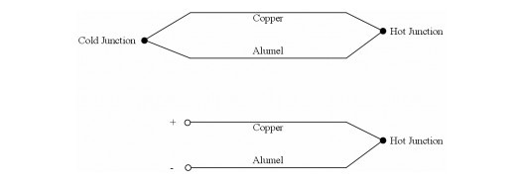
If this circuit is broken at the center, the net open circuit voltage (the Seebeck voltage) is a function of the junction temperature and the composition of the two metals.
If the hot and cold junctions are reversed, current will flow in the opposite direction. Any two dissimilar metals can be used and the thermocouple circuit will generate a low voltage output that is almost (but not exactly) proportional to the temperature difference between the hot junction and the cold junction. The voltage output is between 15 and 40µV per degree C, dependant on the thermocouple conductor metals used. The actual metals used in industrial thermocouples depend on the application and temperature measurement range required.

