Yr 9 Science Energy & Change – Electricity TEST

1. Connect the following components in a series circuit.

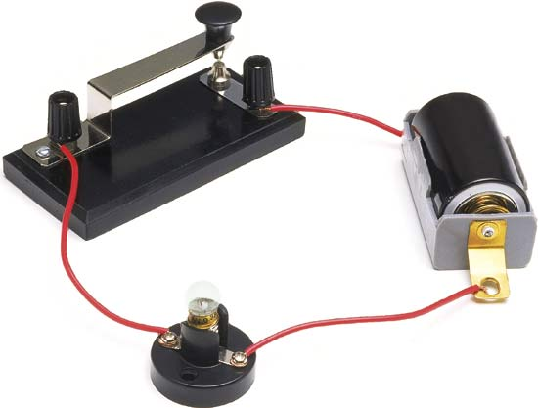



2. Connect the following components in a parallel circuit.

3. Which method of producing electricity is used in a generator?

__________________________________________________________

4. List two advantages of a parallel circuit.

______________________________________________________________________________________________________________________

5. Identify each method of producing electricity.

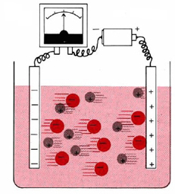


6. List one disadvantage of a series circuit.

___________________________________________________________

7. Identify two disadvantages of using parallel circuits.

______________________________________________________________________________________________________________________
8. Write an equation for the functioning of a motor.

9. Use the following terms to label the motor below.
Commumtator brush armature magnet battery
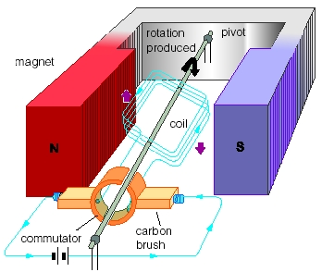

10. Describe two methods of safety when dealing with electricity.
______________________________________________________________________________________________________________________
11. What is the function of a fuse?
___________________________________________________________
12. Calculate the voltage when a current of 0.5A is applied to a circuit that has a resistance of 3.6 Ohms.

___________________________________________________________
13. What is the resistance of a globe that is receiving 9Volts and has 4.5A flowing through it?

___________________________________________________________
14. Tick the following statements as True or False.

T
F
Voltage is the rate of electrons flow in a conductor.
T
F
A fuse is a thick metal strip that prevents electrons from going
through and damaging electronic equipment.
T
F
A commutator is a part of a motor that turns into a temporary
magnet and repel from the outside magnet.
T
F
The nucleus of any atom carries a positive charge.
T
F
In a short-circuit, current is increased and heat is produced.
T
F
An advantage of a parallel circuit is that the battery will run out
fast compared with a series circuit because more current is used.

