Yr 9 Revision worksheet

Q1. Fill in the correct missing words from the following word bank:

negative fuse resistor voltage current repel attract

Positively series parallel

Similar charges ________________ , while opposite charges _________________ .

Electrons carry a _______________ charge, while protons are __________________ charged.

A _________________ circuit is one where electrons flow only in one pathway. A

circuit that has alternate pathways is known as a ________________ circuit.

A __________ is a thin metal wire that acts as a circuit breaker in the case of voltage
overload.

An electric globe may be called a __________________.

The force of pushing electrons across a conductor is known as ____________.

The flow of electrons through a conductor is known as a _____________.

Q2. Which of the following combinations of features of a coil results in the greatest
resistance?

a) Short and thin
b) Short and thick
c) Long and thin
d) Long and thick

Q3. Which of the following pairs results in an electrostatic charge buildup when rubbed?

a) Glass and wool
b) Plastic and fur
c) Iron and plastic
d) Polystyrene and cotton

Q4. Identify which equation that can describe a generator.

a) Electricity + coil + magnet movement

b) Movement + coil + magnet electricity

c) Movement + metal + coil movement

d) Movement + coil + metal electricity

Q5. Draw the symbols of the following components:

Fuse Earth

Globe Battery

Cell Resistor

Ammeter Switch

Q6. A screwdriver connected two leads and as a result the globes went out. This could
be best explained in that:
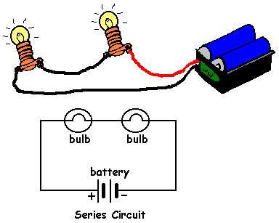
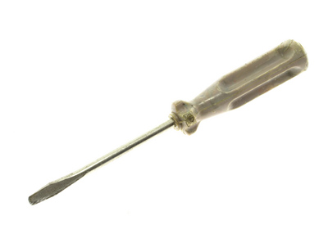

a) The globes burned down as more current went through them.
b) The globes are receiving a current too small to light up.
c) The current is directed through the screwdriver.
d) The screwdriver created a short circuit(short pathway).

Q7. Which of the following circuits (A - D) would globe 1 be the brightest?

A B C
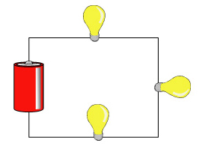

1 1 1
2 4 2

2 3 3

1

2

D

Q8. Circle the correct diagram showing a correct wiring of a parallel circuit.

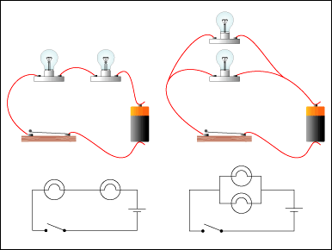

A B C

Q9. Name three safety practices to avoid electrocution (electric shock).

________________________________________________________________________
________________________________________________________________________
________________________________________________________________________

Q10. State the function of the ‘brushes’ in a motor.

________________________________________________________________________________________________________________________________________________

Q11. State the function of a ‘commutator’ in a motor.

________________________________________________________________________________________________________________________________________________

Q12. State the function of an ‘armature’ in a motor.

________________________________________________________________________________________________________________________________________________

Q13. State the function of an ‘earth pin’ in a electric plug.

________________________________________________________________________________________________________________________________________________

Q14. Determine the current in a circuit that provides 5 ohms of resistance and has 12.5V impressed across it.

Q15. Determine the voltage across globe 1 in the following circuits.

1 1
9V 2 9V 24V
1 2 3

3 2

Voltage = __________ Voltage = __________ Voltage = __________

Q16. List the four methods of producing electricity.

_________________________ ____________________________

_________________________ ____________________________

Q17. Determine which globes are on and which are off when switches are open or
closed.

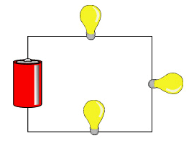
2
1

A B

3 C

A | B |  | C | 1 | 2 | 3
O | C | C
C | O | O
C | O | C
C | C | C

