Activity sheet – Energy 1

How is electricity generated?
When a magnet moves near a coil, electricity is generated in the coil.
Equipment:
- 2 alligator clips
- 2 electrical leads
- large test tube (to wind wire around and make a coil)

- bar magnet
- 50 centimetre length of copper wire
- sandpaper (to remove any insulation
at the end of the wire)
- microammeter
1 Set up the equipment as shown in the diagram.
2 In a table in your workbook, record what happens to the microammeter
when the magnet is moved in the following ways:
- Put the magnet into the coil.
- Pull the magnet out of the coil.
- Move the magnet slowly into and out of the coil.
- Move the magnet quickly into and out of the coil.
- Move the coil instead of the magnet.
A lot of electricity in Australia, India and China is generated using coal. The heat from burning coal is used to boil water to make steam. The steam rises and pushes against the blades of a turbine, making it turn. The turbine turns a coil inside a magnet, producing electricity. The coil and magnet are called a generator.
Coal is a non-renewable resource, which means it will eventually run out. Scientists and engineers are continually researching and developing sustainable ways of moving a turbine, such as:
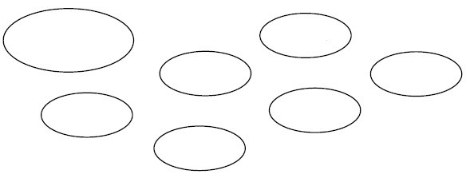
A waterwheel is
a kind of turbine.
Falling water pushes
on the blades of
the waterwheel,
making it turn.
geothermal
tides
biogas
hydro
waves
wind
solar

Activity sheet – Energy 1

Sustainable electricity
Read the Activity sheet ‘How is electricity generated?’ then answer these questions.
1 In your workbook, write definitions for a) a turbine and b) a generator.
2 Draw a line to match each sustainable method of generating electricity with how
the turbine is moved.
Sustainable method | How the turbine is moved
Hydro (‘Hydro’ means ‘water’) | Tidal or wave movement of water turns the turbine.
Wind | Falling water turns the turbine.
Geothermal (‘Geo’ means ‘earth’, ‘thermal’ means  ‘heat’) | Rotting vegetables and plants produce methane. The  methane is burned, producing heat to boil water. Steam  rises and turns the turbine.
Biomass (‘Bio’ means ‘living’) | Wind turns the turbine.
Solar tower | Heat from inside Earth boils water. Steam rises and turns  the turbine.
Ocean | Sunlight is concentrated on a small area, using mirrors.  The heat produced boils water. Steam rises and turns the  turbine.
3 Use the word bank to complete the sentences.
More than one sustainable method of producing _ _ _ _ _ _ _ _ _ _ _ will be needed to
replace coal. When you use electricity, you are _ _ _ _ _ _ _ _ _ _ _ for the coal used
to make it. But there are things you can do to use less electricity now,
Word bank
summer
off
full
electricity
energy
pay
coal
reward
house
responsible
which means using less _ _ _ _:
- Turn appliances _ _ _ at the wall when not using them.
- Turn the temperature on the air conditioner up a few degrees
in _ _ _ _ _ _.
- When buying new appliances, buy the most _ _ _ _ _ _ efficient one.
- Make sure the washing machine and dishwasher are _ _ _ _
before using them.
- Save as much electricity around the _ _ _ _ _ as you can and ask
your parents to _ _ _ you the difference between electricity bills
this year compared to last year as a _ _ _ _ _ _.
Activity sheet – Energy 1

Sustainable electricity
Read the Activity sheet ‘How is electricity generated?’ then answer these questions.
1 In your workbook, write definitions for a) a turbine and b) a generator.
2 Draw a line to match each sustainable method of generating electricity with how
the turbine is moved.
Sustainable method | How the turbine is moved
Hydro (‘Hydro’ means ‘water’) | Tidal or wave movement of water turns the turbine.
Wind | Falling water turns the turbine.
Geothermal (‘Geo’ means ‘earth’, ‘thermal’ means  ‘heat’) | Rotting vegetables and plants produce methane. The  methane is burned, producing heat to boil water. Steam  rises and turns the turbine.
Biomass (‘Bio’ means ‘living’) | Wind turns the turbine.
Solar tower | Heat from inside Earth boils water. Steam rises and turns  the turbine.
Ocean | Sunlight is concentrated on a small area, using mirrors.  The heat produced boils water. Steam rises and turns the  turbine.
3 Use the word bank to complete the sentences.
More than one sustainable method of producing _ _ _ _ _ _ _ _ _ _ _ will be needed to
replace coal. When you use electricity, you are _ _ _ _ _ _ _ _ _ _ _ for the coal used
to make it. But there are things you can do to use less electricity now,
Word bank
summer
off
full
electricity
energy
pay
coal
reward
house
responsible
which means using less _ _ _ _:
- Turn appliances _ _ _ at the wall when not using them.
- Turn the temperature on the air conditioner up a few degrees
in _ _ _ _ _ _.
- When buying new appliances, buy the most _ _ _ _ _ _ efficient one.
- Make sure the washing machine and dishwasher are _ _ _ _
before using them.
- Save as much electricity around the _ _ _ _ _ as you can and ask
your parents to _ _ _ you the difference between electricity bills
this year compared to last year as a _ _ _ _ _ _.
Activity sheet – Energy 1

Biogas
Biogas is a sustainable source of electricity.
Word bank
dioxide
trees
reduces
sustainable
animal
burn
waste
houses
cheap
China
rubbish
1 Complete the sentences using words from the word bank.
Biogas is the mixture of methane and carbon dioxide gases
produced when plant and _ _ _ _ _ _ wastes are broken down
anaerobically by bacteria. Anaerobically means without using
oxygen. This happens naturally in places such as _ _ _ _ _ _ _
dumps and sewage plants, where the gases usually escape to
the atmosphere. Biogas digesters capture the methane and
_ _ _ _ it to produce electricity. Burning methane does produce
carbon _ _ _ _ _ _ _, but methane is twenty times worse as a
greenhouse gas than carbon dioxide, so burning biogas
actually reduces greenhouse gas emissions.
Thirty million families in rural areas of _ _ _ _ _ and 2 million families in India
produce their own biogas. This saves forests because _ _ _ _ _ do not need to be
cut down for fuel. Biogas digesters are _ _ _ _ _ and can be used for years without
needing any maintenance. As well as producing electricity, the leftover heat can be
used for cooking, to warm _ _ _ _ _ _ and heat water. Larger biogas digesters are used on farms and some are big enough to digest the _ _ _ _ _ at town rubbish dumps.
The leftover waste makes good fertiliser for crops and _ _ _ _ _ _ _ the amount of space needed for people’s rubbish. Plant and animal waste is made quickly, so biogas is a _ _ _ _ _ _ _ _ _ _ _ fuel. It provides constant power day and night.
2 List two disadvantages of biogas digesters.

3 Identify five advantages of biogas digesters.

Activity sheet – Energy 1

Solar energy
Solar energy is a sustainable source of electricity. Sunlight is used to produce electricity. One way of doing this is with solar panels, or photovoltaic cells. Solar panels are made of silicon. Solar energy is different to other methods of electricity generation because solar panels have no moving parts that can break, making them reliable and long lasting.
Solar towers use hundreds of mirrors to reflect sunlight to the top of a tall tower. This concentrated sunlight can reach temperatures of over 1000ºC. Water or air at the top of the tower heats up and turns a turbine to generate electricity. The Australian Commonwealth Scientific and Industrial Research Organisation (CSIRO) is building a solar tower in Newcastle, New South Wales, that uses heated compressed air to turn the turbine. This is useful in places where water is limited.
1 Finish the flow chart showing how electricity can be generated using a solar tower.
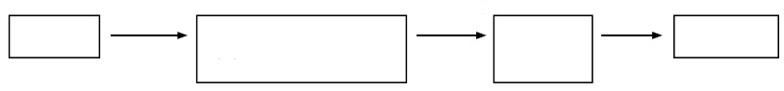
su_light
mirrors
co_ce_trated sunli_ht at to_ of to_er
h_ating
ho_ air
or s_eam
tu_bin_
_l_ctricity

2 Describe two different ways solar energy can be used to generate electricity.
a)__________________________________ b) _________________________________
3 Write ‘advantage’ or ‘disadvantage’ next to each issue about using solar energy.
Issue | Advantage/disadvantage?
Expensive to set up.
Produces sustainable energy.
Needs little maintenance once installed.
Doesn’t work at night or on rainy days.
Works best in areas that receive large amounts of sunlight.
No waste produced.
No fuel needed.
Solar panels are easy to install in existing electricity systems.
Some solar towers need only sunlight and air to produce
electricity.
4 How are solar panels different to other forms of sustainable electricity?
Activity sheet – Energy 2

The problem with coal
Word bank
sugar
buried
out
black
more
photosynthesis
Read the Resource sheet ‘Burning coal to produce electricity’ and
then answer these questions.
1 Use the word bank to complete the flow chart.
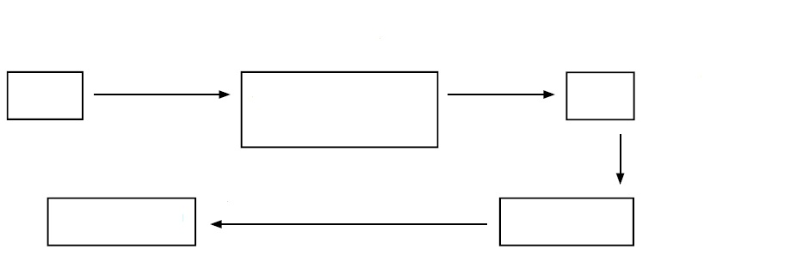
_ _ _ _ _ _ _ _ _ _ _ _ _ _
Plant dies and is _ _ _ _ _ _
Liquids squeezed out
Plant
Peat
Chains of _ _ _ _ _
molecules
More liquid
squeezed _ _ _
_ _ _ _ liquid squeezed out
Brown coal
_ _ _ _ _ coal

2 Cross out any answers that are incorrect.
Problems with using coal are that it | is sustainable  adds to the greenhouse effect  contributes to climate change
The fuel with the least amount of liquid is | black coal peat brown coal
The coal that we use today probably  formed | 350 million years ago  350 thousand years ago  350 years ago
When coal burns, the carbon atoms | join with oxygen atoms  form sugar molecules  form the product carbon dioxide
Use the pie graph to answer the questions.
3 Identify the largest source of electricity generation. ________________________
4 What is the total percentage of electricity that comes from coal? _____________
5 Like coal, natural gas is a fossil fuel. What is the total percentage of electricity
that comes from fossil fuels? ______________
6 What is the total percentage of electricity that doesn’t come from fossil fuels? ____
7 Name the two main sources of electricity generation that do not use fossil fuels.
________________________________________________________________
Activity sheet – Energy 2

Hydroelectricity
Hydroelectricity is a sustainable source of electricity. China is building the Three Gorges Dam across the Yangtze River to generate hydroelectricity. It is the biggest dam in the world. A dam is a barrier across a river that controls the flow of water. Water is stored behind the dam and slowly released through a tunnel in the dam, where it turns a turbine to generate electricity before continuing downstream.
1 Label the parts of a hydroelectric power plant using the words
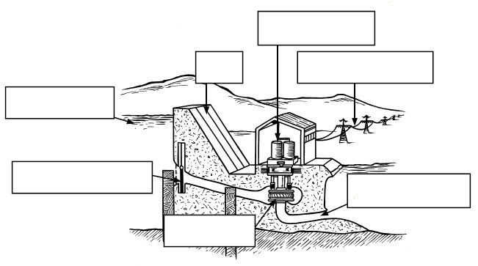
in the word bank.
_ _ _ _ _ _ _ _ _
Word bank
power lines
turbine
generator
reservoir
downstream
dam
control gate
_ _ _
_ _ _ _ _ _ _ _ _ _
_ _ _ _ _ _ _ _ r

_ _ _ _ _ _ _ _ _ _ _
_ _ _ _ _ _ _ _ _ _
_ _ _ _ _ _ _

2 Hydroelectricity has advantages and disadvantages. Write whether each issue is an
advantage or a disadvantage.
Issue | Advantage or disadvantage
Provides a sustainable form of electricity.
If rain patterns change, the dam will be less useful.
Doesn’t add carbon dioxide to the atmosphere.
Building dams floods valleys and destroys the habitat of
some species.
Changing the flow of a river can disrupt ecosystems and
cause extinctions.
Building dams can provide many jobs.
Changing the level of the water in the dam can cause
landslides and earth movements.
Dams can prevent floods downstream.

Activity sheet – Energy 2

Ocean energy
Ocean energy is a sustainable form of electricity. Ocean energy includes tidal and
wave energy.
Tidal energy uses the natural rise and fall of water in oceans, caused by the moon’s gravity. As the tide goes in and out, water flows past a turbine and makes it turn, generating electricity. Tidal energy plants are being developed in India and South Korea.
Wave energy is being researched by scientists off the coast of Port Kembla in New South Wales. Waves push air up through a narrow tube, similar to what happens naturally in a blowhole. The air turns a turbine as it moves up the tube and also as it moves back down when the water rushes out of the tube. The turbine turns a generator to produce electricity.
1 Finish the flow chart showing how electricity can be generated using waves.
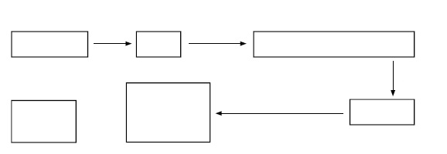
wi_d
nar_ow tub_
_cean water
w_ves
a_r forced quic_ly up t_be
tu_bin_
tur_ _ne
wa_er flows
ba_k to the o_ean
ai_ drawn
_uickly down
the tu_e
_l_ctricity
more
ele_tri_ity

2 Identify three places where ocean energy will be used to generate electricity.
________________________________________________________________
________________________________________________________________
3 Write ‘advantage’ or ‘disadvantage’ next to each issue about using ocean energy.
Issue | Advantage or disadvantage
Can only be used at sites with a big difference in high and
low tides each day, or with reliable waves.
Can produce large amounts of sustainable energy
May disrupt marine habitats.
No waste produced.
No fuel needed.
Some types may be noisy or look ugly.
Activity sheet – Energy 2

Wind energy
1 Use the word bank to complete the information on wind energy.
Word bank
farm
generator
waste
supply
large
storm
sustainable
rapid
Cool
wind
needed
land
habitats
blades
high
sun
people
electricity
Wind is produced when the _ _ _ heats up an area of air, which then rises.
_ _ _ _ air then moves in to replace the hot air. This movement is called wind.
When generating electricity using wind, the wind blows directly onto
the _ _ _ _ _ _ of the turbine to make it turn. The turbine is attached to
a _ _ _ _ _ _ _ _ _ which produces electricity. Wind turbines need to be
built in places that have plenty of _ _ _ _, such as near the coast, because
they don’t work if it’s not windy. They need to be shut down in a _ _ _ _ _
or they could be damaged.
Wind turbines need to be built _ _ _ _ above nearby buildings or
trees to avoid turbulance. Turbulance means _ _ _ _ _ changes in wind
speed. Wind turbines can be constructed on _ _ _ _ or at sea. Just one
turbine can be built or many can be built together to make a wind
_ _ _ _. Wind farms don’t use much land, so they don’t have a large impact
on animal _ _ _ _ _ _ _ _. The land underneath them can be used for things
such as farming. Some _ _ _ _ _ _ think they make the landscape look ugly.
Wind turbines can be very _ _ _ _ _ and power many homes or they
can be small enough to just power a few appliances. For example, four
large wind turbines on top of an apartment building being constructed
in Melbourne, Victoria will produce some of the electricity _ _ _ _ _ _ to
run the building. Wind energy is a _ _ _ _ _ _ _ _ _ _ _ form of energy and doesn’t need fuel to run. Wind turbines don’t produce any _ _ _ _ _ once they are operating. There are many wind farms in the Asia–Pacific region that produce _ _ _ _ _ _ _ _ _ _ _ for thousands of people. For example, wind farms _ _ _ _ _ _ about 4% of New Zealand’s electricity.
2 List five advantages and five disadvantages of producing electricity with wind turbines.
Advantages | Disadvantages

