RCDs are a bit like transformers
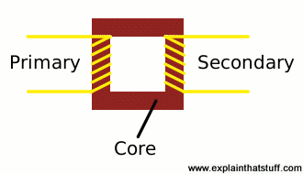
RCDs work in a similar way to electricity transformers; if you're not familiar with those, you might find it helpful to review our detailed article on transformers so you understand what's coming up next.
In a transformer, two coils of copper wire (called the primary and the secondary) are wrapped around a circular iron core (sometimes called a toroid). By using different amounts of wire in the two coils, a transformer can change a high-voltage electric current into a low-voltage one (or vice versa):
Artwork: A simplified illustration of a transformer. The copper primary and secondary cables are connected magnetically, via the iron core, rather than electrically.
Inside an RCD, the live and neutral cables from the electric supply wrap around an iron core much like the one in a transformer. The live cable wraps around one side of the core and the neutral cable goes around the other, so:
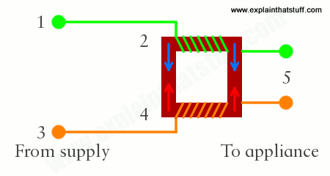
- Alternating current flows back and forth through the live wire (green).
- As it does so, it induces (creates) a magnetic field in the iron core, just like in a transformer (blue arrow).
- Meanwhile, an opposite alternating current is also flowing back and forth through the neutral wire (orange).
- The neutral current induces an equal and opposite magnetic field in the core (red arrow).
- Under normal conditions, the magnetic fields induced by the live and neutral wires cancel out: there is no overall magnetic field in the core and there's nothing to stop current flowing to the appliance you're using.

What happens when there's trouble?
Now suppose you cut through or damage the cable leading to your appliance. If you cut through one of the wires, there's effectively a current "leak" from the circuit, so there will be unequal currents flowing in the live and neutral wires. One of the wires will carry more current than the other, so the magnetic fields they produce will no longer cancel out and there will be a net magnetic field in the core.
How does that helps us? The iron core has a third, smaller coil of wire wrapped around it. This is called the search or detector coil and it's wired up to a very fast electromagnetic switch called a relay. When a current imbalance occurs, the magnetic field induced in the core causes an electric current to flow in the search coil. That current triggers the relay, and the relay then cuts off the power. See how it happens in the animation in the box below.

How does an RCD work?
- Under normal operation, when there is no magnetic field in the core, no electricity flows through the search coil (gray) or relay (blue).
- Suppose you cut through the live wire (green) with your garden shears—and suppose it takes a tenth of a second for you to chop right through.
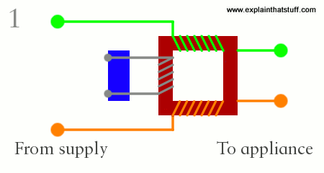
- During that tenth of a second, just as you're starting to cut, there is a current imbalance between the live and neutral cables. More current flows through the neutral wire (orange) than through the live wire (green), so the neutral wire produces a greater magnetic field (red arrow) in the iron core than the live wire does (blue arrow).
- The two magnetic fields no longer cancel out. The net magnetic field in the core causes an electric current to flow in the search coil (gray), which activates the relay (blue).
- The relay snaps open breaking the incoming circuit cables and stopping all power from flowing in as little as 30 milliseconds—far faster than you can cut the cable.

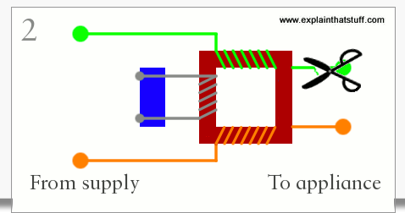

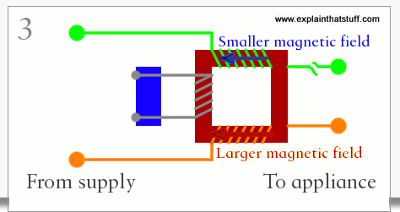

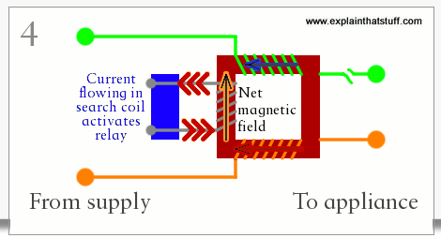

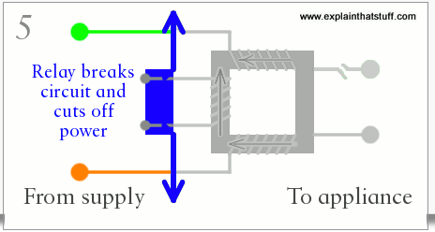

Surge protectors
If you've read our long article on electricity, you'll know that an electric current is a flow of electrons (tiny particles inside atoms) carrying energy through a metal or another substance in a loop called a circuit. You'll also know that electricity can be extremely dangerous: it's not something to mess with if you value your life. The electricity that comes to our homes from power plants travels at incredibly high voltages because that helps to save energy. Transformers in substations near to buildings turn the high voltage power into lower voltages that the appliances in our homes can safely use. Different appliances need larger or smaller amounts of electric power. Things that get hot (electric showers, toasters, and stoves) need large currents that supply a lot of power at once, whereas electronic equipment (CD players, televisions, and so on) needs much smaller currents and uses less power. All these appliances assume that the electricity coming into your home has a reasonably constant voltage.
But sometimes the voltage fluctuates because of sudden changes in the way power is supplied from the grid. Or it can happen if someone in a nearby factory switches on or off a huge appliance with a powerful electric motor inside it, which might cause a sudden surge or drop in power in the whole circuit in your home. A very brief change in voltage is called a spike. A longer-lasting change is called a surge. A spike or surge probably won't affect other big appliances, but it could harm tiny components in sensitive electronic equipment. What we need is something that smooths out any peaks in the voltage—and that's what surge protectors do.

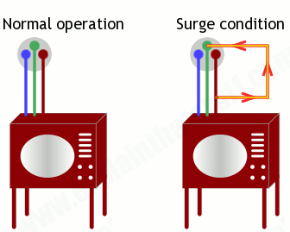
How do they work?
The appliances you use draw their power from sockets in the wall. The power from the sockets feeds straight into the appliance down a length of cable. In a surge protector, the main power line (known as the hot wire or live wire) has an extra connection (a kind of "side road") linked to it that feeds to the ground wire (sometimes also called the Earth wire; the protective wire in an electric circuit that sends any unwanted current safely into the earth). Normally, the surge connection is inactive. However, if a larger than normal voltage appears, and produces too much electric current, the excess current is diverted safely down the side road to ground. That means no more current than normal flows into your appliance, so it's better protected from harm.
How does the surge connection know when to divert the current? It is actually a device called a varistor (voltage-dependent resistor), made from a substance called a metal-oxide semiconductor, which is usually a bad conductor (carrier) of electricity. When an excessive voltage appears, the semiconductor in the varistor becomes a good conductor and starts to carry electricity normally. For as long as the surge voltage lasts, the semiconductor channels harmful current to ground. Once things return to normal, the semiconductor switches back again. All this means your appliance is not only protected during a surge—it should keep on working normally.

What is the difference between a surge and a fuse?
A fuse is designed to stop sudden large electric currents from damaging the equipment in your house. Sounds the same as a surge protector, doesn't it? But it actually works a different way. Most fuses are very thin pieces of wire designed to allow only so much current through them. The thicker the wire, the more current can flow; so fuses rated for higher currents usually have thicker pieces of wire inside them.
How does a fuse work? If there's too much current (for example, if you've put too many appliances together on one socket), the fuse literally burns out: the wire gets so hot that it melts and interrupts the circuit to protect you. Occasionally, fuses actually "blow": the current flowing through them is so great that they burn out instantly with a loud cracking noise. A fuse, then, is a very drastic form of protection: if anything happens, it shuts off the electricity completely. A surge protector is designed to smooth out smaller fluctuations in voltage and it doesn't normally shut down the circuit when a problem occurs. You need both fuses and surge protectors for good protection from electrical problems. Indeed, if you look round the back of a typical surge protector, you'll very likely find.... a replaceable fuse!

