Revision worksheet

1. Identify the charges on the following particles.
proton:
neutron:
electron:

2. If an atom loses two electrons, what would be its overall charge?

3. When a plastic ruler and a plastic rod are both rubbed with a piece of fur, what would you expect to happen when the rod is placed close to the plastic ruler? Explain why.

4. Why is carbon, a non-metal, used in electrical cells and batteries?

5. Draw the symbol for each of the following:

Ammeter voltmeter globe resistor

switch fuse cell

6. Define the following terms:

a) current -

b) voltage -

c) fuse -

7. Give the units for the following:
a) voltage -
b) current -
c) resistance -
d) frequency –

8. Connect the following components in a parallel circuit.

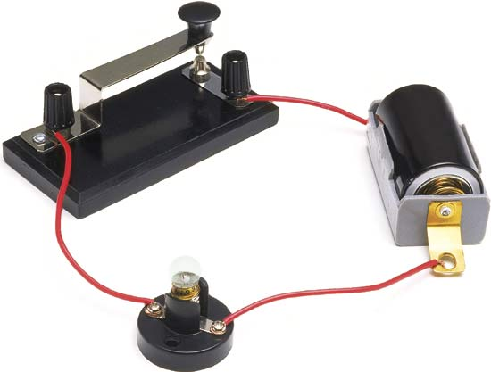



9. List four methods of producing electricity.

10. List three effects of electricity.

11. Describe the function of the following:
a) fuse -

b) earth pin -

c) rheostat -

12. Given 1 Hertz is the unit measuring once cycle per second, how many hertz does this sound wave represent?

Amplitude
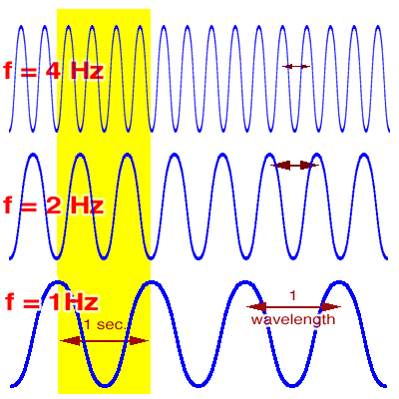

1
2
3
4
Time (second)

13. Draw a sound wave that is half as loud as the one shown but has the same pitch.

Amplitude

1
2
Time (second)

14. By looking at the following diagram answer the following questions.

1

x
y
z

2
3
4

a) if only switch 1 is closed which of the three globes will be on?

b) if only switch 3 is left open, which globes will be off?

15. A scientist wants to investigate what effect changing the resistance in a circuit using a rheostat has on the current in that circuit. She came up with the following data.

Resistance (Ohms) | 1.5 | 2.5 | 4.0 | 5.5 | 7.0
Current (Amps) | 6 | 3.6 | 2.3 | 1.6 | 1.3

a) Draw the graph.

b) What is the dependent variable?

c) What is the independent variable?

d) What is the current when resistance is 6 ohms?

e) What resistance is required for a circuit to have a current of 4 A?



