Yr 9 Science Energy & Change – Electricity TEST

1. Connect the following components in a series circuit.

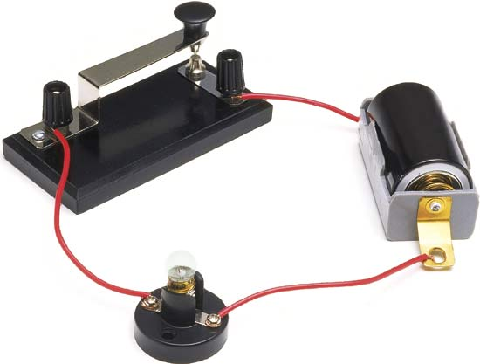

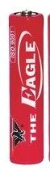

2. Connect the following components in a parallel circuit.

3. Which method of producing electricity is used in a generator?

magnetic method (Not tested)

4. List two advantages of a parallel circuit.

You can switch individual room one at a time; When one room loses power the other rooms still have power; when one globe goes off, the rest of the globes are still on.

5. Identify each method of producing electricity.

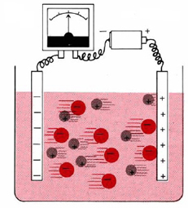


Solar chemical

6. List one disadvantage of a series circuit.

When one globe goes off the whole circuit collapses, all globes go off.

7. Identify two disadvantages of using parallel circuits.

If using a battery source the battery runs out of power very fast because more current is distributed to the globes or appliances.
Since more current is going through the circuit, more heat is generated and fire could break out.

8. Write an equation for the functioning of a motor. (Not tested)

Electricity + coil + magnet movement

9. Use the following terms to label the motor below. (Not tested)

Commutator brush armature magnet battery
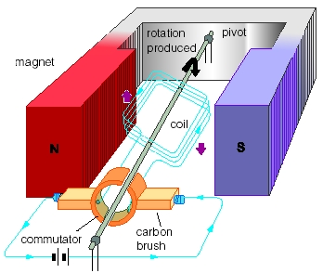

Magnet

Armature

Brush

Battery
Commutator

10. Describe two methods of safety when dealing with electricity.
Replace frayed or damaged cords; use the correct fuse because overloaded circuits can cause fire; switch appliance off before pulling the plug at a power point; make sure your appliance is properly earthed; don’t use electrical appliance close to a body of water.
11. What is the function of a fuse?
A fuse is a thin wire that is designed to melt when an overload current go through it to prevent it from damaging equipment or causing fire.
12. Calculate the voltage when a current of 0.5A is applied to a circuit that has a resistance of 3.6 Ohms.

V = I x R
= 0.5 x 3.6 = 1.8V.

13. What is the resistance of a globe that is receiving 9Volts and has 4.5A flowing through it?

R = V / I
= 9 / 4.5 = 2 Ohms.

14. Tick the following statements as True or False.

T
F
Voltage is the rate of electrons flow in a conductor.
T
F
A fuse is a thick metal strip that prevents electrons from going
through and damaging electronic equipment.
T
F
A commutator is a part of a motor that turns into a temporary
magnet and repel from the outside magnet.
T
F
The nucleus of any atom carries a positive charge.
T
F
In a short-circuit, current is increased and heat is produced.
T
F
An advantage of a parallel circuit is that the battery will run out
fast compared with a series circuit because more current is used.

