Yr 9 Revision worksheet

Q1. Fill in the correct missing words from the following word bank:

negative fuse resistor voltage current repel attract

Positively series parallel

Similar charges ____repel____________ , while opposite charge attract.

Electrons carry a _____negative___ charge, while protons are __positively___ charged.

A ____series ______ circuit is one where electrons flow only in one pathway. A

circuit that has alternate pathways is known as a ___parallel____ circuit.

A __fuse__ is a thin metal wire that acts as a circuit breaker in the case of voltage
overload.

An electric globe may be called a ____resistor____.

The force of pushing electrons across a conductor is known as __voltage__.

The flow of electrons through a conductor is known as a __current__.

Q2. Which of the following combinations of features of a coil results in the greatest
resistance?

a) Short and thin
b) Short and thick
c) Long and thin
d) Long and thick

Q3. Which of the following pairs results in an electrostatic charge buildup when rubbed?

a) Glass and wool
b) Plastic and fur
c) Iron and plastic
d) Polystyrene and cotton

Q4. Identify which equation that can describe a generator. (Not Tested)

a) Electricity + coil + magnet movement

b) Movement + coil + magnet electricity

c) Movement + metal + coil movement

d) Movement + coil + metal electricity

Q5. Draw the symbols of the following components:

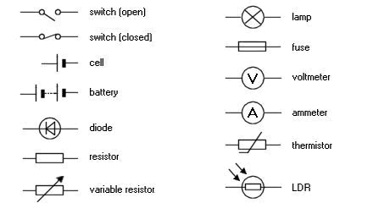
Fuse Earth
Globe Battery
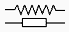
Cell Resistor

Ammeter Switch

Q6. A screwdriver connected two leads and as a result the globes went out. This could
be best explained in that:
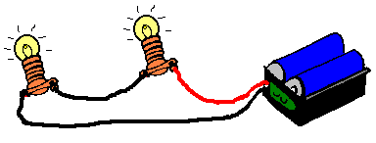
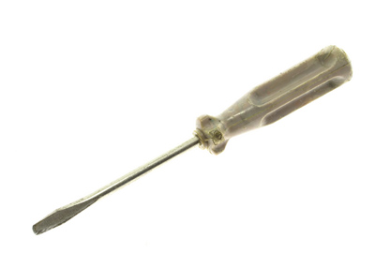

a) The globes burned down as more current went through them.
b) The globes are receiving a current too small to light up.
c) The current is directed through the screwdriver.
d) The screwdriver created a short circuit (short pathway).

Q7. Which of the following circuits (A - D) would globe 1 be the brightest? D

A B C
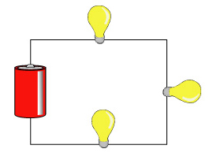

1 1 1
2 4 2

2 3 3

1

2

D

Q8. Circle the correct diagram showing a correct wiring of a parallel circuit.

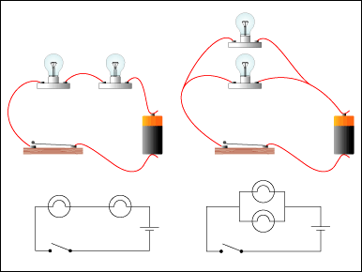

A B C

Q9. Name three safety practices to avoid electrocution (electric shock).

Don’t touch appliances with wet hands.
Replace frayed cords.
Don’t overload your circuit.
Use the correct fuse.

Q10. State the function of the ‘brushes’ in a motor. (Not Tested)

They relay electric current to the commutator.

Q11. State the function of a ‘commutator’ in a motor. (Not Tested)

To change the polarity of the magnetic field in the armature.

Q12. State the function of an ‘armature’ in a motor. (Not Tested)

To receive electricity and produce a magnetic field that will turn inside a magnet (stator)

Q13. State the function of an ‘earth pin’ in a electric plug.

Earth pin directs current to earth and prevents accidental death.

Q14. Determine the current in a circuit that provides 5 ohms of resistance and has 12.5V impressed across it.

I = V / R
= 12.5 / 5 = 2.5A

Q15. Determine the voltage across globe 1 in the following circuits.

1 1
9V 2 9V 24V
1 2 3

3 2

Voltage = __3V__ Voltage = ___4.5V__ Voltage = ___24V___

Q16. List the four methods of producing electricity.

Chemical method; magnetic method; heating method(thermocouple); solar method.

Q17. Determine which globes are on and which are off when switches are open or
closed.

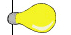
2
1

A B

3 C

A | B |  | C | 1 | 2 | 3
O | C | C |  |  |  | 
C | O | O |  |  |  | 
C | O | C |  |  |  | 
C | C | C |  |  |  | 

