Activity 7 – Feeding Pattern

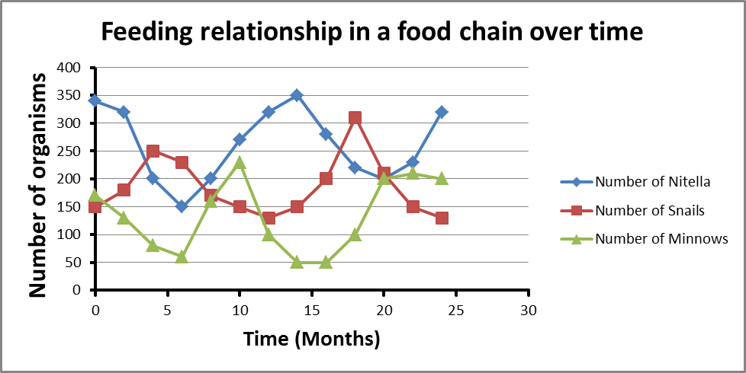
Q2. What food chain relationship exists between the three organisms?

The relationship is that of predation. One primary consumer feeding on the producer and a secondary consumer(carnivore) feeding on the primary consumer(herbivore).

Q3. Which organisms are producers, and which are consumers?

Nitella is the aquatic producer. Snails are primary consumers and minnows are secondary consumers.

Q4. Why did the snail population reach a peak after the Nitella?

There is a lag phase. It takes time for the population of snail to respond to any changes in the population of the producers. At the beginning, the population of the Nitella was decreasing but the population of the snails kept increasing because they were still feeding on the Nitella present before they experienced a decrease in food supply. There was a competition within the species of snails and only the ‘fittest’ survived and the ‘not fit’ died.

Q5. What would happen to the graph if long-necked tortoises were introduced to the pond? (Long-necked tortoises eat plants only).

Long-necked tortoises will compete with the snails for food – interspecies competition.
There won’t be enough food for the snails and their numbers will drop dramatically.
As the number of snails drops, so does the number of minnows who are dependent on the snails for their energy need.

