THE WATER CYCLE

The water cycle starts with the evaporation of water from ocean surfaces and other bodies of water. This evaporation is driven by energy supplied by the sun. The sun also provides the energy, which drives the weather systems, which move the water vapour or clouds from one place to another. Otherwise, it would only rain over the oceans.

Another source of water rising to the sky is vapour from tree leaves. Trees take up water from underground through the root system. Water then travels up the trunk to the leaves. Leaves release water due to respiration and also to cool down during the heat of the day by a process known as transpiration.

Moreover, all animals release water, also due to respiration.

Water cycle

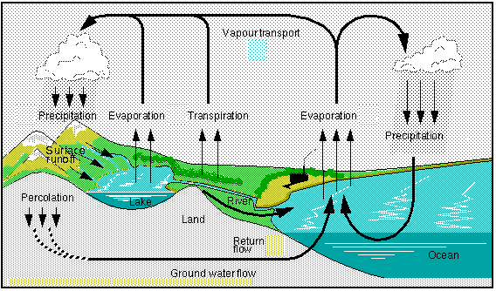
As water vapour rises it cools down(1ºC every 100m). As vapour cools down it condenses, forming larger water droplets. When the mass of water droplets is too heavy to be suspended in the atmosphere it falls down. Rain is the result. Rain is known as precipitation.

Precipitation results in water being returned to the oceans. Also, water falls over dry land, where it is soaked into the ground forming groundwater. On high peaks water is trapped as ice. When it thaws water flows down to the ground where it joins the groundwater, and/or is moved across a landscape. This form of water is called runoff.

Eventually, all forms of precipitation, runoff or groundwater will empty into oceans because oceans form a ‘basin’ where water is collected, since oceans are lower than land, gravity pulls water towards oceans.

QUESTIONS

Q1. What is meant by ‘runoff’? Identify its sources.

__________________________________________________________________________________________________________________________

Q2. Define groundwater.

__________________________________________________________________________________________________________________________

Q3. List the sources where water vapour, in the water cycle, comes from.

__________________________________________________________________________________________________________________________

Q4. Explain the water cycle using correct scientific terminology.
__________________________________________________________________________________________________________________________
__________________________________________________________________________________________________________________________
_____________________________________________________________

