The Carbon Cycle
All living things are made of carbon. Carbon is also a part of the ocean, air, and even rocks. Because the Earth is a dynamic place, carbon does not stay still. It is on the move!
In the atmosphere, carbon is attached to some oxygen in a gas called carbon dioxide.
Plants use carbon dioxide and sunlight to make their own food and grow. The carbon becomes part of the plant. Plants that die and are buried may turn into fossil fuels made of carbon like coal and oil over millions of years. When humans burn fossil fuels, most of the carbon quickly enters the atmosphere as carbon dioxide.
Carbon dioxide is a greenhouse gas and traps heat in the atmosphere. Without it and other greenhouse gases, Earth would be a frozen world. But humans have burned so much fuel that there is about 30% more carbon dioxide in the air today than there was about 150 years ago, and Earth is becoming a warmer place. In fact, ice cores show us that there is now more carbon dioxide in the atmosphere than there has been in the last 420,000 years.
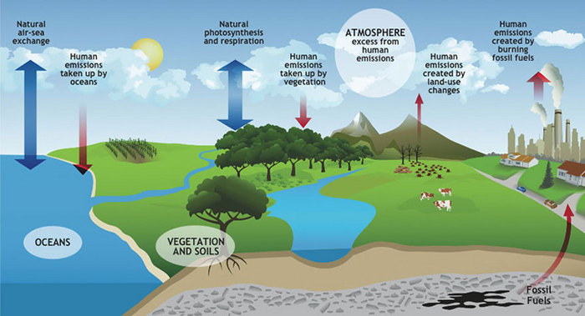
Besides acting as the first link in the food chain, phytoplankton is a critical part of ocean chemistry. The carbon dioxide in the atmosphere is in balance with Carbon dioxide in the ocean. During photosynthesis phytoplankton remove carbon dioxide from sea water, and release oxygen as a by-product. This allows the oceans to absorb additional carbon dioxide from the atmosphere. If fewer phytoplankton existed, atmospheric carbon dioxide would increase.

Phytoplankton also affects carbon dioxide levels when they die. Phytoplankton, like plants on land, is composed of substances that contain carbon. Dead phytoplankton can sink to the ocean floor. The carbon in the phytoplankton is soon covered by other material sinking to the ocean bottom. In this way, the oceans act as a sink, a place to dispose of global carbon, which otherwise would accumulate in the atmosphere as carbon dioxide. Other global sinks include land vegetation and soil. However the carbon in these sinks frequently is returned to the atmosphere as carbon dioxide by burning or decomposition. Deforestation contributes to the accumulation of carbon dioxide in the atmosphere by reducing vegetation that takes up carbon dioxide. Carbon dioxide acts as a "greenhouse" gas in the atmosphere, and therefore may contribute to global warming. Sources of carbon dioxide in the Earth's atmosphere include decomposition of organic matter (such as trees), the carbon dioxide that animals and people exhale, volcanic activity, and human activities such as the burning of fossil fuels and wood.
No one yet knows how much carbon the oceans and land can absorb. Nor do we know how the Earth's environment will adjust to increasing amounts of carbon dioxide in the atmosphere. Studying the distribution and changes in global phytoplankton using ocean colour and other tools will help scientists find answers to these questions.

QUESTIONS

- What can you add to the diagram to make the carbon cycle more comprehensive?

- Carbon dioxide diffuse into and out of the water, but some does not diffuse back; where does it go?

- What is a carbon sink? Name as many stores of carbon dioxide as you can think of.

- Why is carbon dioxide considered as the major cause of global warming?

- What is the importance of phytoplankton?

- Why do we need carbon dioxide in the atmosphere?

