Yr 9 Honours Research topics:

You have to choose ONE of the following topics and do a full detailed research with diagrams on a A2 or A1 poster.

1. Excretory system – Dialysis machine

- Draw a poster of a dialysis machine.
- Label the diagram.
- Explain how the machine can do the work of the kidney.
- Draw a miniature diagram of a dialysis machine and that of the nephron and compare structures between the two diagrams that have similar function.
- Why is it not practical to live on a dialysis machine permanently?
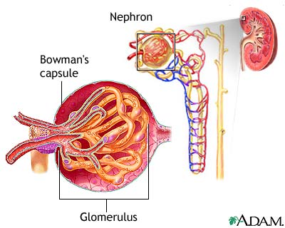
- Describe some medical conditions where the need for a dialysis machine is warranted.

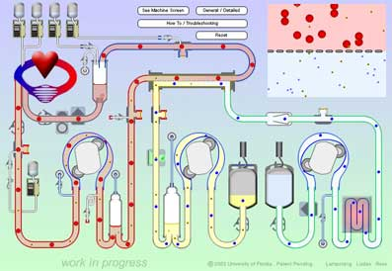

2. Ciruclatory system – Cardiogram

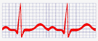
- What is a cardiogram?
- Where is it used?
- When is it used?
- How does it work(what does it tell the physician?).

3. Ciruclatory system – Myocardial infarction
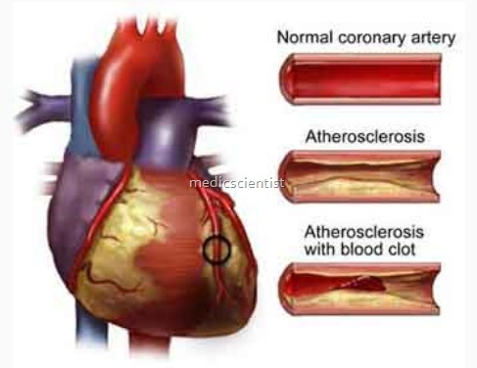
- What is myocardial infarction?
- What causes it?
- What are risk factors?
- How to diagnose it?
- How to manage/treat it?
- How it impact the sufferer?
- Other interesting applicable facts.


4. Digestive system – Adult onset diabetes

- What is diabetes?
- Signs and symptoms.
- Aetiology.
- Risk factors.
- Treatment/prevention.
- Any other interesting facts.

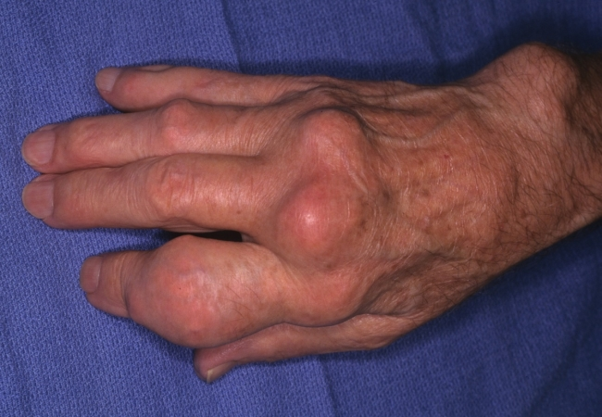
5. Digestive system – Gout

- What is it?
- Signs and symptoms.
- Aetiology.
- Prevention and treatment.
- Other interesting facts.
6. Immune system – Acquired Immuno-Deficiency Syndrome
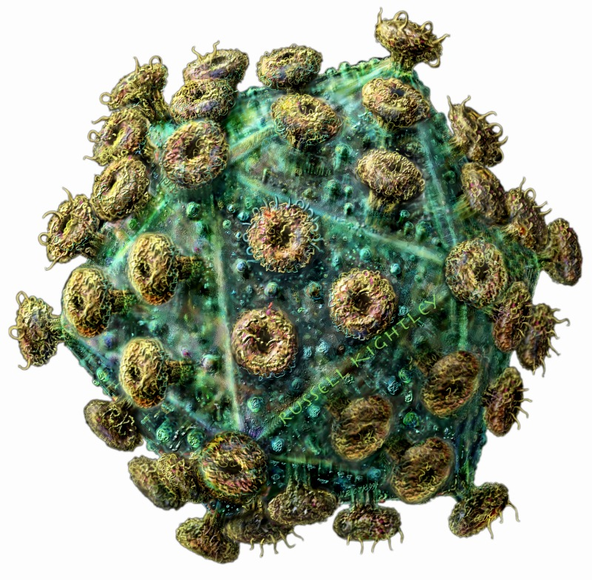
- What causes it?
- How does it affect the body?
- Signs and symptoms.
- Treatment/prevention.
- Other interesting facts.

7. Immune system – Coeliac disease

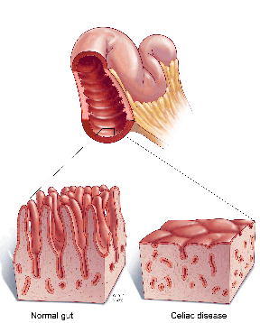
- What is it?
- What causes it?
- Signs and symptoms.
- Treatment/prevention.
- Other interesting facts.

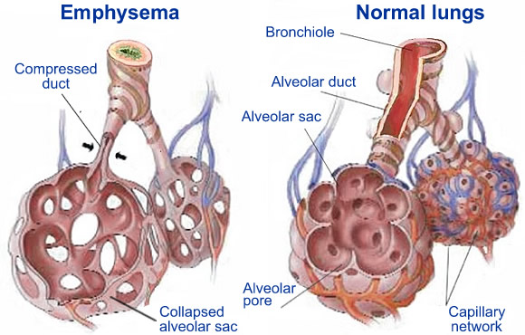
8. Respiratory system – Emphysema

- What is it?
- What causes it?
- Aetiology.
- Signs and symptoms.
- Treatment/prevention.
- Other interesting life.

9. Respiratory system –
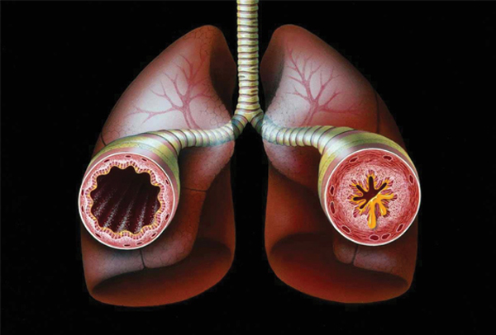
- What is it?
- What causes it?
- Signs and symptoms.
- Treatment/prevention.
- Impact on everyday life.
- Other interesting life.

10. Nervous system – Alzheimer’s disease

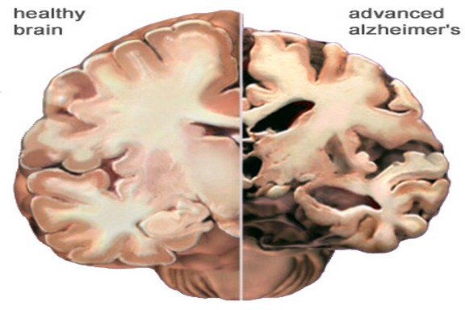
- What is it?
- Aetiology.
- How does it impact the brain?
- Signs and symptoms.
- Treatment/prevention.
- Any other interesting facts.

11. Nervous system – Parkinson’s disease
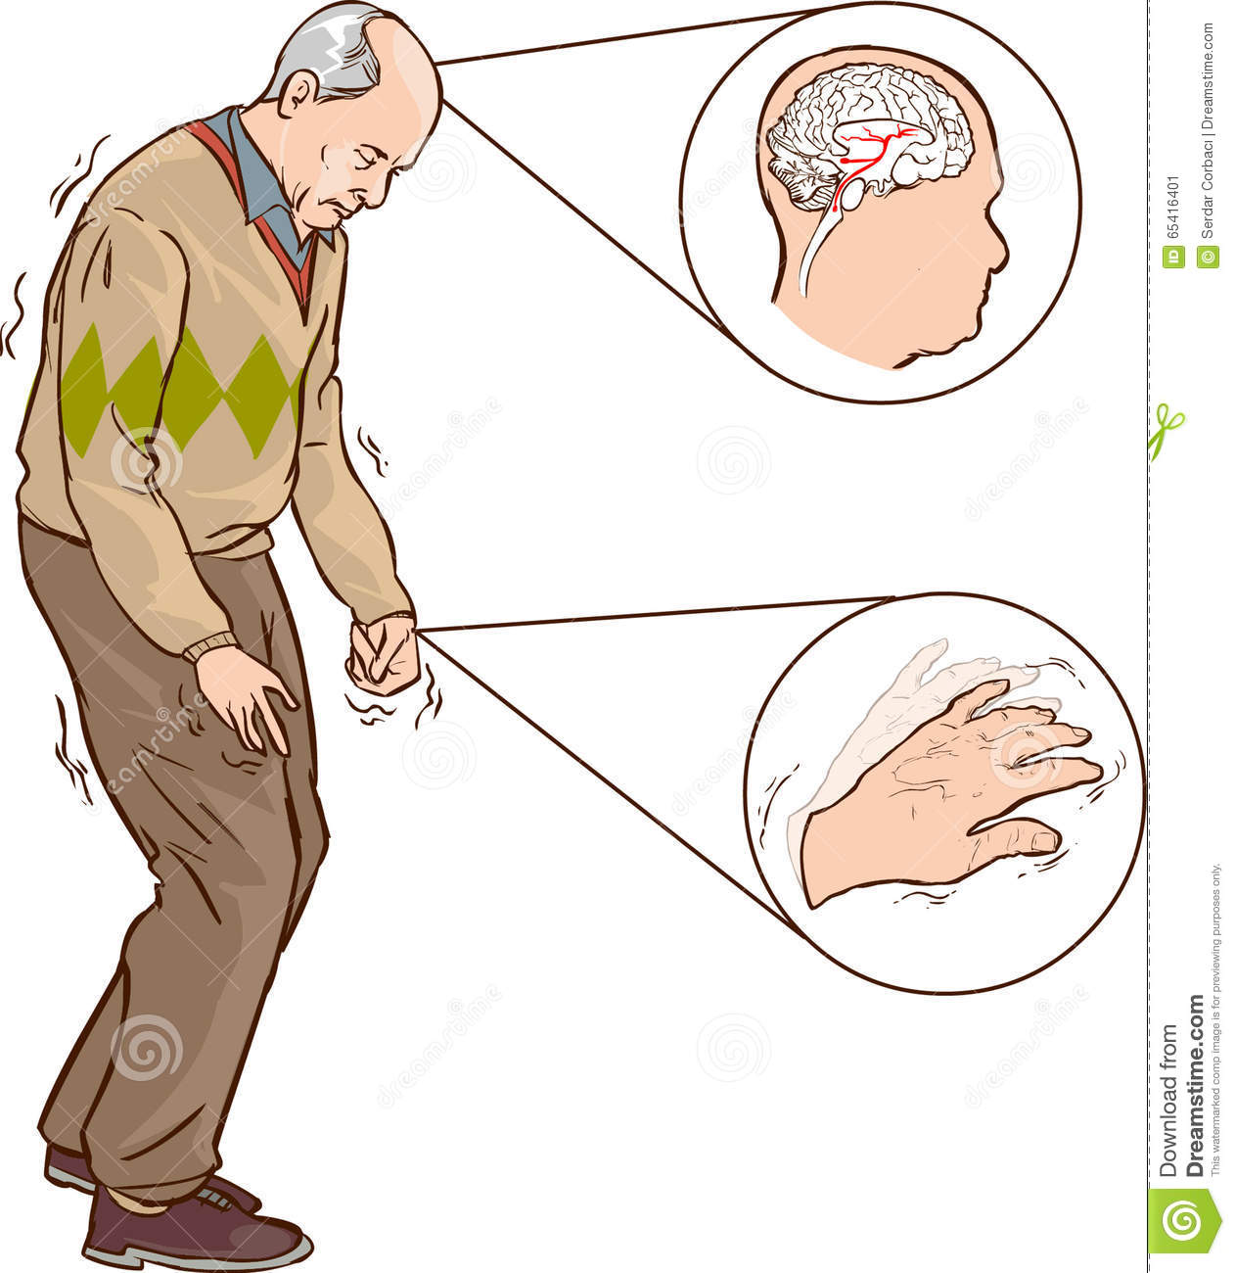
- What is it?
- Aetiology.
- How does it impact the brain?
- Signs and symptoms.
- Treatment/prevention.
- Any other interesting facts.

OR

ANY OTHER TOPICS YOU ARE INTERESTED IN DOING AND RELATES TO BODY SYSTEMS YOU HAVE STUDIED IN BODYWORKS.

