Yr 9 Science – Life and Living Research

Different organisms obtain their food in a variety of methods.
Some organisms produce their food and are therefore called producers.

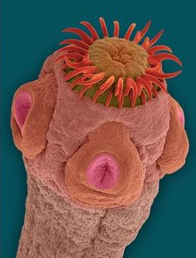
Other organisms consume food around them and are therefore called consumers.

Some organisms obtain their food by attaching themselves to a host as their source of food. They are the parasites.

There are numerous parasites that inhabit the human body. some live within the body and some live outside the body.

Research ONE parasite and explains the mechanism of how it obtains its food. Describe its life cycle and the pathway it takes to inhabit the human body.
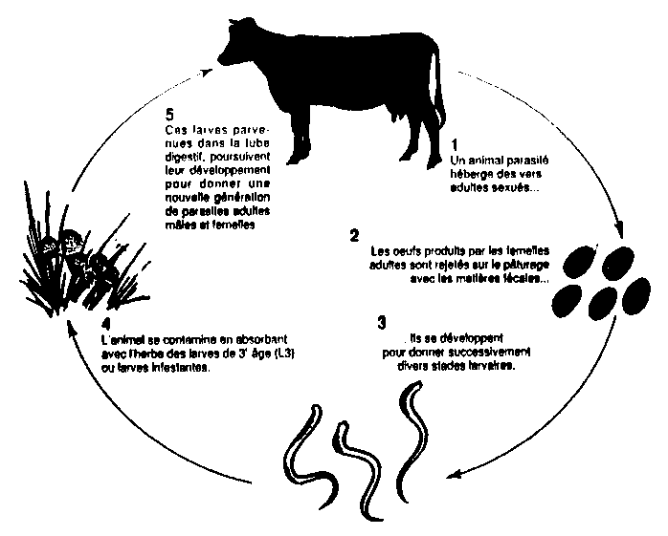

Assessment Criteria:

Poster size A1 or A2. You may insert pictures that are relevant to the organism you are researching.

Copying and pasting straight from the internet will result in deduction of marks.

