

Q1. Define the term digestion.
A: Digestion is the breakdown of large particles of food into smaller particles.

Q2. What are enzymes?
A: they are proteins that digest food chemically.

Q3. Identify the source and function of each nutrient:
1. protein; 2. carbohydrates; 3. lipids/fats;
A: 1. protein is found in meats/eggs and dairy products. Its is important for growth and building of body tissues; 2. carbohydrates are found in grains/vegetables/fruits/legumes. They are important as a source of energy to carry out life processes; 3. lipids/fats are found in oil/fats/seeds/nuts. They function as a source of energy and stores of energy.

Q4. Identify the enzyme involved in digesting each of protein, carbs and fats.
A: protein protease; carbohydrates amylase; fats lipase.

Q5. Indicate whether the following statements are true or false.
1. enzymes mechanically break up food particles into smaller particles.
2. bile chemically break down fat particles into smaller particles.
3.enzymes chemically break up food particles into smaller particles.
4. bile mechanically break up food particles into smaller particles.
5. protein, fats and carbs are chemically digested in the pancreas
6. stomach has a high pH due to high acidity required for digestion process.
7. emulsification of fats take place in the liver because it involves bile.
8. villi in the small intestines help push the food along.
A: 1. false; 2. false; 3. true; 4. true; 5. false; 6. false; 7. false; 8. false.

Q6. Name the process of muscular contractions involved in propelling food across the alimentary canal.
A: Peristalsis.

Q7. Identify the sites for the following actions/processes.
1. initial digestion of protein.
2. initial digestion of carbohydrates.
3. absorption of nutrients and water.
4. mechanical digestion of food to become chyme.
5. absorption of remaining water.
6. production of bile.
7. storage of bile.
A: 1. stomach; 2. mouth; 3. small intestine; 4. stomach; 5. large intestine; 6. liver; 7. gallbladder.

Q8. State four features of enzymes.
A: they are recycled and not consumed by the reaction; they operate at an optimum pH; they operate at an optimum temperature(37ºC); they are specific in their action and catalyse only certain nutrients.

Q9. Identify the process of physically breaking down fats droplets into smaller globules to aid in its chemical digestion.
A: emulsification.

Q10. Differentiate between arteries, capillaries and veins.
A: arteries carry blood away from the heart; capillaries is the site where diffusion of substances occur; and veins carry blood towards the heart.

Q11. Why are arteries thicker than veins?.
A: because there is a large blood pressure in arteries as blood is pumped from the heart.

Q12. What is the function of atrio-ventricular valves.
A: they prevent backflow of blood from ventricles to atria.

Q13. What keeps blood pressure in arties constant(i.e. blood flowing) when the heart is not contracting?
A: recoil mechanism of the muscle in the wall of the arteries.

Q14. Blood acts as a transport medium for some substances. Identify some of these substances.
A: water; nutrients; oxygen; carbon dioxide and other wastes(urea); as well as heat.

Q15. State which of the following statements are true or false.
1. deoxygenated blood enters the heart from the pulmonary artery.
2. oxygenated blood enters the heart through the right side of the heart.
3. deoxygenated blood returns back to the heart through the right atrium.
4. a vein brings deoxygenated blood back to the heart.
5. the tricuspid valve is found in the left side of the heart.
6. the mitral valve is also known as the bicuspid valve.
7. the vein is generally larger than the artery but thinner.
8. veins carry blood with low blood pressure.
9. the right ventricular wall is thicker than the left because of high resistance.
A: 1. false; 2. false; 3. true; 4. false; 5. false; 6. true; 7. true; 8. true; 9. false.

Q16. What separates deoxygenated blood from oxygenated blood in the heart?
A: septum.

Q17. Identify the three different forms of formed elements in the blood and describe their role.
A: erythrocytes (red blood cells): carry O2 and CO2 to and away from cells.
leukocytes(white blood cells): provide immunity and protects against diseases.
thrombocytes(platelets): are involved in blood clotting.

Q18. Identify the protein needed to transport oxygen to cells.
A: haemoglobin.

Q19. What is the liquid part of the blood called?
A: plasma.

Q20. Name two structures that blood goes through on its way out of the heart.
A: aorta and pulmonary artery.

Q21. Identify two types of circulation of blood and describe the vessels used in each circulation.
A: pulmonary circulation – deoxygenated blood leaves the heart through the pulmonary artery towards the lungs and returns as oxygenated blood through the pulmonary vein back to the heart.
systemic circulations – oxygenated blood leaves the heart through the aorta to supply body tissues with oxygen and returns to the heart as deoxygenated blood through vena cava.

Q22. Trace the path of a white blood cell the moment it enters the right ventricles.
A: right ventricle pulmonary artery lungs pulmonary veins left atrium left ventricles aorta body tissues vena cava right atrium.

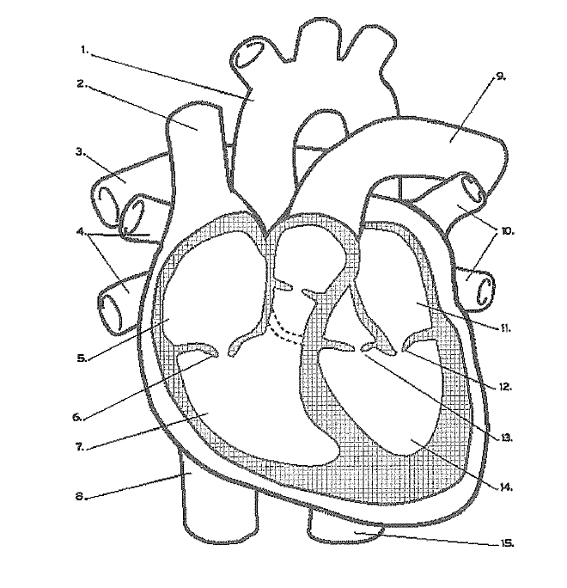
Q23. Label and give functions of structures 4, 8, 12 and 14 the following diagram.

A: 4- pulmonary vein: returns oxygenated blood back to the heart;
8- inferior vena cava: returns deoxygenated blood back to the heart.
12- left AV valve(bicuspid): prevents backflow of oxygenated blood to the left atrium.
14- left ventricle: pumps oxygenated blood to body tissues.

Q24. What is the function of cartilage in the trachea and bronchi?
A: to keep airway open.

Q25.
A:

Q26. Label and give function of structures 3, 4, 7 and 9.
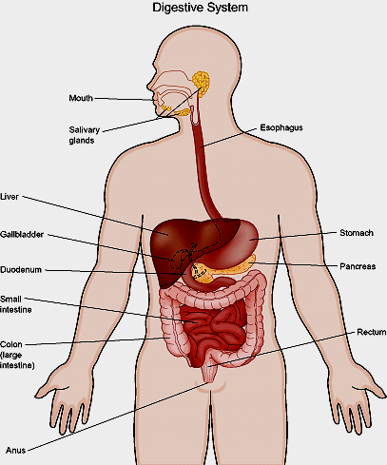
A: 3- liver: make bile.
10
2
5
7
1
3
11
8
9
6
4
4- gallbladder: stores bile.
7- pancreas: secretes enzymes into
small intestine as well as carbonate
to neutralise stomach acid.
9- large intestine: absorb remaining
water.

Q27. Label and give the function of structures 3, 7, 8 and 10
A: 3- trachea: relays air to the lungs.
7- diaphragm: contracts to help in inspiration.
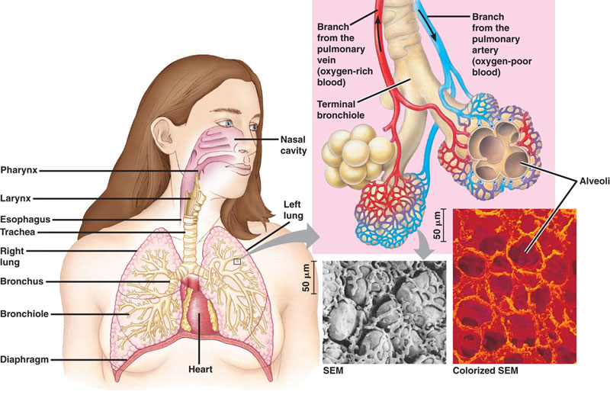
8- alveolus: air diffuses across the thin membrane
into the capillary around it.
10- nasal passage: warms, filters and moistens air.

10
1
8
2
9

3
4
5

6

7

Q28. Differentiate between cellular respiration and respiration.
A: respiration is the physical ventilation of the lungs with air. Cellular respiration is the chemical breakdown of glucose in cells in the presence of oxygen to release energy.

Q29. Identify two structures that actively work to ventilate the lungs.
A: intercostal muscles and diaphragm.

Q30. Identify the process by which gases move across the alveolar wall and describe how it works.
A: diffusion. Oxygen and carbon dioxide move from a high area of concentration to a lower area of concentration, down the concentration gradient.

Q31. Explain how water is absorbed from the small intestine.
A: water is diffused across the cells of the villi from an area of high concentration to an area of lower concentration, by a process known as osmosis.

Q22. A Year 9 student wanted to investigate the effects of different factors on the chemical digestion of milk in babies. She prepared four test tubes each containing the same amount of milk and the enzyme rennin. Test tube 1 had boiled rennin added to the milk; test tube 2 had unboiled rennin added but at 4ºC; test tube 3 had unboiled rennin added but the pH increased to 8; test tube 4 had unboiled rennin added and pH was lowered to 2 and temperature elevated to 37.5ºC. Which test tube would provide a clear reaction between milk and rennin? Explain the reason behind the lack of reaction in the three other test tubes.
A: test tube 4 would result in a clear positive reaction.
Test tube 1 had the enzyme boiled thereby denaturing the enzyme so it is not capable of reacting because its active site(where substrate interact with enzyme) has been changed.
Test tube 2 experienced a lowering of the temperature. Rennin enjoys an optimum temperature around 37ºC. Therefore, the reaction would have been slowed down dramatically. The enzyme is not denatured but works at a VERY slow rate.
Test tube 3 had its pH increased to 8. rennin does not function at a high pH. It prefers an optimum pH of around 2, similar to the pH of the stomach.

Q32. Give three features of the small intestine that makes it efficient in its role.
A: it is 6-7m long; it has folds and villi, which serve to increase its surface area, therefore maximising the rate of absorption of nutrients.

Q33. Explain the reason behind an increase in Kate’s heart rate and breathing rate following a bout of exercise.
A: when Kate exercises her cells need more glucose and oxygen for cellular respiration to take place in order to produce the energy needed by her muscles to contract efficiently. Heart rate goes up so it can deliver more glucose and breathed in oxygen to the active cells.
Breathing rate goes up too because there is a high demand for oxygen in order for cellular respiration to occur.

Q34. Why do veins in the legs possess valves?
A: veins in lower limbs have valves in order to stop blood from pooling in the legs due to gravity pulling down at the blood.

Q35. List 3 features that alveoli possess to make them efficient in gas exchange.
A: alveoli have a very thin walls (one-cell thick) which facilitates the diffusion of gases across.
Alveoli are numerous thereby providing a large surface area across which a large amount of gas can be exchanged.
Alveoli are surrounded by capillaries that are in close proximity to them; this facilitates the diffusion from alveoli to blood in capillaries and vice versa.

Q36. A technician wanted to investigate the effect of bile activity on the rate of digestion of fat by lipase. She set up six test tubes each containing 20 grams of fat/lipid. She added a constant amount of lipase to each test tube. To the first test tube she did not add any bile. To the rest of the test tubes, she added an increasing amount of bile. After 15 minutes she measured the amount of glycerol and fatty acids produced by the chemical reaction. She recorded the results as follows:

Test tube | Amount of bile (g) | Amount of glycerol produced (g)
1 | 0 | 0.15
2 | 1 | 1.0
3 | 1.5 | 2.5
4 | 2 | 4.6
5 | 3.0 | 7.0
6 | 3.5 | 11.0

a) Write a suitable hypothesis for the following experiment.
A: an increase in the amount of bile results in an increase of glycerol formation.
Or any other statement that links amount of bile to amount of glycerol produced.

b) Identify the independent/experimental variable.
A: amount of bile in grams.

c) Identify the dependent/respondent variable.
A: amount of glycerol in grams.

d) Identify two variables she controlled in her experiment.
A: any of the following: amount of fat; amount of lipase; time.

e) Identify two further variables that can be controlled.
A: any of the following: temperature of the room; type of fat; type of lipase; size and make of test tubes; measuring device.

f) What was the purpose of test tube 1?
A: test tube 1 is a control group; it is used to compare results and observe effectiveness of the independent variable.

g) Graph the above table.

Remove this panel to reveal the solution only when you have attempted it.
h) How many grams of glycerol would have been produced if 2.5 grams of bile were added to a fatty sample with lipase?
A: 5.7 – 5.8 grams of glycerol.

i) Why is it that glycerol was produced when zero bile was added to the fat?
A: because lipase is still capable of acting on the fat molecules on the outside of the fat globules; those that are exposed to the enzyme lipase.

j) Explain why no matter how much bile the technician adds to the fat sample and no matter how long the experiment goes on for, she will never obtain 20 grams of glycerol when all the fat is digested.
A: because glycerol is only a part of the fat. There are also fatty acids that make up part of the mass of the fat.

k) How can the experimenter increase the reliability of the experiment?
A: by repeating the experiment.

l) How can the experimenter increase the validity of the experiment?
A: by conducting averages to reduce errors; also by increasing sample size.

End of Revision
Good luck ☺

