

Q1. Describe the term ‘excretion’.
A: excretion is the removal of potentially toxic metabolic wastes from the body.

Q2. Name three excretory organs and describe what they excrete.
A: Kidneys – urea, creatinine and ions such as potassium;
Sweat glands in skin – water, urea and lactic acid;
Lungs – water and CO2.

Q3. What are metabolic wastes?
A: they are by-products of chemical reactions that took place in cells and are toxic to the cells and need to be removed.

Q4. What happens if the metabolic wastes are not removed from the body?
A: a high concentration of metabolic wastes can interfere with the normal functioning of the cells and cause illness and eventually death if not removed. E.g. a high concentration of urea (metabolic waste of digested proteins) can lead to brain damage; and a high concentration of CO2 in blood can lead to low pH(high acidity) of blood plasma.

Q5. What is the major component of metabolic waste in urine?
A: urea.

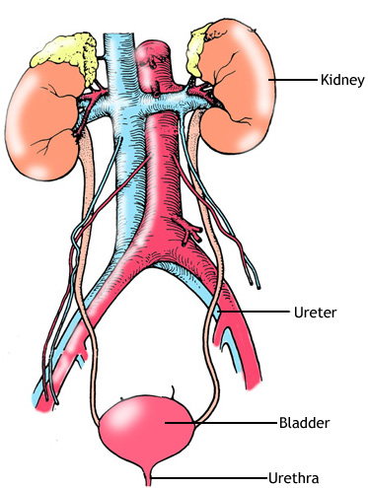
a
c
d
e
b

Q6. Label the following excretory system and describe their function.
A:
a – left kidney: make urine by filtering blood from its metabolic wastes.
b – renal artery: transports unfiltered blood to the kidneys.
c – ureter: transports urine to bladder.
d – bladder: stores urine.
e – urethra: excretes urine to the outside.

Q7. Label the following structures and describe the role of (c) and (d).
A:
a – renal vein.
b – renal artery.
c – medulla.
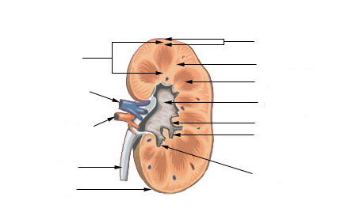
d – cortex.
a
b
c
d
e
f
g
e – pelvis.
f – ureter.
g – capsule.
(d) – filtration takes place.
(e) – collects urine.

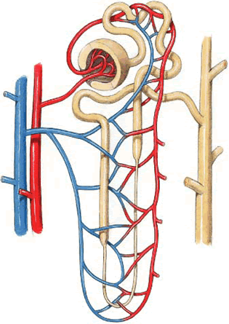
Questions 8-10 refer to the diagram below.
c
a
b
d
f
e
g

Q8. Label the following structures (a - f).
A:
a – filtration capillaries (glomerulus)
b - renal tube
c - nephron
d - reabsorption capillaries
e - filtered (clean) blood
f - unfiltered blood

Q9. Which structure is responsible for the filtration of blood?
A: structure a.

Q10. What would you find in structure g?
A: urine.

Q11. A person went for two days without drinking water. Describe what happens to the colour of his urine and explain why.
A: his urine would turn darker colour because the more water he loses from his body the higher the concentration of wastes in his urine.

Q12. Mark the following statements as true or false.

- urea is yellow.
- urea is the major component of urine.
- urine smells because of high amount of urea.
- renal artery is rich in urea.
- a nephron is the microscopic structure where filtration take place.
- the pelvis collects urine before it is stored in the bladder via ureter.
- carbon dioxide and urea are both excreted from skin and kidneys.
- medulla lies on top of the cortex.
- all the sugar is reabsorbed from the renal tubule therefore none is found in urine.

A: 1. false; 2. true; 3. false; 4. true; 5. true; 6. true; 7. false; 8. false; 9. true.

Q13. Glucose and water are said to be ‘reabsorbed’ and not ‘absorbed’ from the renal tubule back into the blood capillaries surrounding the tubule. Why?
A: glucose and water are first absorbed in the small intestine. In the kidney, they are absorbed again, therefore, the term re-absorbed is used.

Q14. What substances would you not be present in the filtrate? Why?
A: plasma protein such as albumin and globulin as well as red blood cells, because they are too big to go through blood capillaries in the nephron.

Q15. Define the term pathogen.
A: disease-causing organism such as a bacteria, virus, fungus and parasites.

Q16. What shape would streptococcus bacteria have?
A: it would be round from the term ‘coccus’.

Q17. Describe the term ‘innate defence mechanism’.
A: a defence mechanism that is present at birth.

Q18. Differentiate between non-specific and specific immune defences.
A: non-specific defence refers to the ability of the body to fight against any type of pathogen. It is immediate in its action.
Specific immune defence deals with specific pathogen. Every type of bacteria will have a specific mechanism to fight it. It is delayed in its action because it takes time to produce the cells and chemicals that can destroy the pathogen.

Q19. Label the different types of external defence systems that work as part of the non-specific immune system and state how they help protect against germs.
A:
a – tears: lysozyme kills germs.
b – nasal hairs: traps germs.
c – saliva: mucus traps and washes germs.
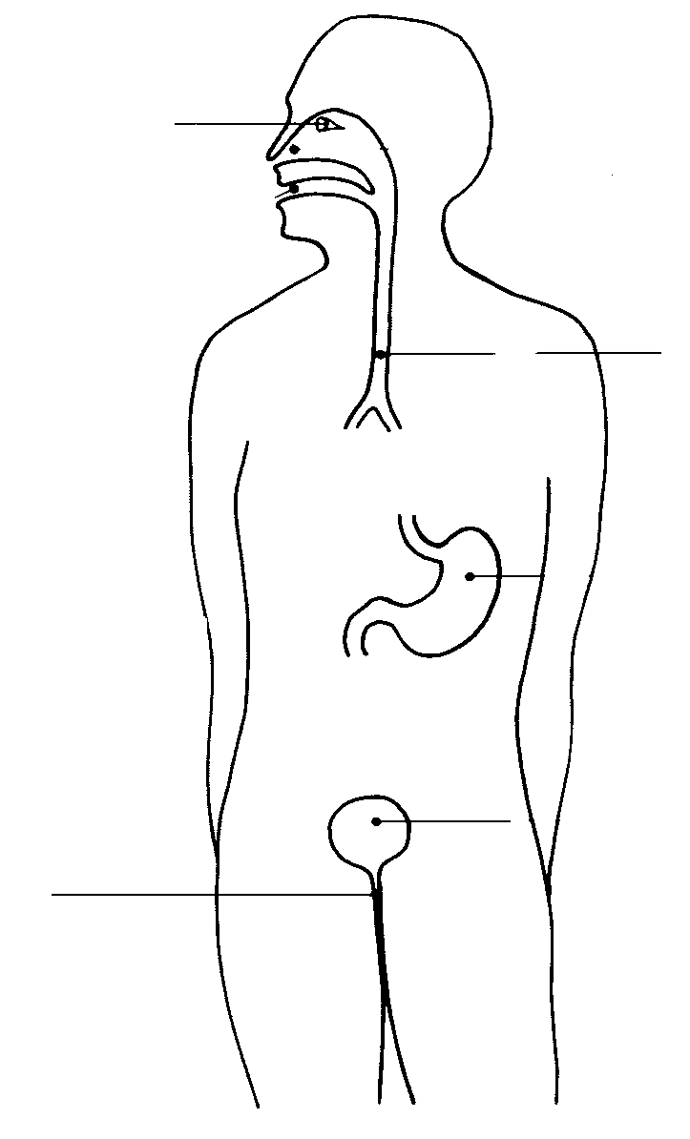
a
d – trachea: mucus traps germs and cilia pushes it
b
c
upward in the form of phlegm.
e – stomach: acid kills germs that are swallowed.
f – skin – keratin prevents entry of germs (physical barrier).
d
g – bladder: flow of urine removes germs from urethra.
h – vagina: acid kills germs.
e
f

g
h

Q20. What is pus made up of?
A: pus is made up of dead bacteria, cell debris and white blood cells.

Q21. List and describe the three major types of non-specific defences.
A:
1. external defence mechanisms: as per Q19.
2. blood clotting: when skin in injured and exposed to the outside environment clotting helps make a barrier (scab) to prevent further entry of pathogens into the body.
3. protective reflexes: sneezing, coughing, vomiting and diarrhoea all help in removing irritating and infectious substances from the body.

Q22. What is an antigen?
A: an antigen is a protein that can stimulate the production of antibodies from plasma cells, which in turn are derived from lymphocytes. Antigen could be found on the surface of the pathogen or a chemical produced by the pathogen. Antigen stands for antibody generator because it causes special cells to produce/generate antibodies.

Q23. Differentiate between immunity and immunisation.
A: immunity is the state whereby an organism has acquired a resistance to pathogens. Immunisation is the process of rendering someone immune to pathogen, for example, giving someone an antibody or injecting them with a vaccine to help their body launch an immune response.

Q24. What are antibodies
A: are proteins/chemicals made by plasma cells that have differentiated from B-lymphocytes when they were exposed to antigens/pathogens. They allow white blood cells to destroy pathogens.

Q25. Differentiate between antibodies and antibiotics.
A: antibodies are made by plasma cells that have developed from B-lymphocytes. Antibiotics are chemicals prepared in the laboratory and work only on bacterial infections. (Antivirals work on viruses; antifungal works on fungi).

Q26. Differentiate between B and T-lymphocytes.
A: B-lymphocytes and T-lymphocytes are both produced in the bone marrow, however, the B-cells mature in the bone marrow and the T-cells mature in the thymus (a gland behind the breastbone). Both types of cells are responsible for specific immunity and they both are dependent on the type of antigen they are exposed to.

Q27. What is immunisation?
A: immunisation or vaccination is a method of introducing a weakened pathogen or part of it or a substance produced by that pathogen (toxoid) into the body in order to stimulate the body’s specific immune response. The goal is to produce memory cells that will recognise the pathogen and prevent the individual from falling sick and developing the disease when exposed to the real pathogen.

Q28. When a child was given an injection of weakened bacteria, she never developed the disease later on in life. Explain why this is the case.
A: by giving the child an injection of weakened bacteria, this stimulated her body to produce antibodies against that bacterium. The bacterium is weakened, therefore, it cannot cause symptoms and disease, but the body can recognise its shape and chemical structure and launch a specific immune response against it. Once the B or T
Lymphocytes are activated by being exposed to that antigen(protein found on surface of bacterium), they multiply and produce a clone of cells to fight the pathogen. Some of clone cells become memory cells. Memory cells recognise the pathogen or antigen quickly if it re-enters the body, thereby, hastening the response to that antigen. The body will be able to produce quickly many B and T cells that will target and kill the pathogen before it has the chance to cause disease.

Q29. Describe the role of macrophages.
A: macrophages are an example of internal non-specific immune defence system. If by a chance a splinter penetrates the skin (external first line of defence), then macrophages (a type of white blood cell) will come in contact with the pathogen and engulf it before it can penetrate cells and cause disease. The process of ‘eating’ the pathogen is called phagocytosis. That’s why macrophages are also called phagocytes. Macrophages also function in the specific immune response.

Q30. How can a pathogen be transmitted to others?
A: sneezing: droplets carrying the pathogens spread out and are inhaled.
Touching: some pathogens can be caught by physical touch of an infected person.
Others can be transmitted by indirect touch such as using others’ towels, spoon, etc…
Body fluids: blood- during sport/surgery; semen- during sex.
Vectors: malaria is spread by mosquitoes which act as carriers of the pathogen.

Q31. Indicate which of the following statements are true or false.

1. an antigen is produced by white blood cells to fight pathogens.
2. an antibody is produced as a result of exposure to an antigen.
3. B-lymphocyte is produced in bone marrow but matures in thymus.
4. B and T cells are part of the specific immune response.
5. macrophages engulf pathogens by a process known as phagocytosis.
6. macrophages make a part of the internal non-specific defence system.
7. T-cells mature in the bone marrow.
8. immunisation involves exposing people to a weakened pathogen to train their immune system to make antibodies to give them immunity against that pathogen.
9. a memory cell can protect against any pathogen that might infiltrate the external line of defence.
10. B-lymphocytes prevent antigens from entering the tissues.

A: 1. false; 2. true; 3. false; 4. true; 5. true; 6. true; 7. false; 8. true; 9. false; 10. false.

Q32. Label the structures of a neuron and describe their role.
A:

a – nucleus: regulates cell activities.
a
b
c
d
f
e
g
b – dendrites: carry nerve impulses to cell body.
c – myelin sheath: insulates the neuron and protects
against damage.
d – axon: long extension of cytoplasm that carries
impulses away from cell body.
e – motor end plate: connects to other neurons or
to muscle fibres or glands.
f – node of Ranvier: speeds up signal transmission.
g – cell body: contains the nucleus and other
organelles important for functioning of neuron.

Q33. What type of nervous system does the spinal cord belong to?
A: central nervous system.

Q34. What are the three major types of neurons and describe their role.
A: three major types of neurons are:
Sensory neurons: carry signal from receptor to central nervous system (spine).
Motor neurons: carries signal from brain/spine to glands and muscle fibres.
Interneurons(AKA connector/association neurons): relay signals between sensory and motor neurons.

Q35. Explain how the breathing rate changes in an athlete as he runs.
A: as the athlete runs, she needs more oxygen for her cells to produce energy from cellular respiration. But more importantly she releases a larger amount of carbon dioxide from her cells. A high level of CO2 in her blood is detected by the chemoreceptors in the aorta and carotid bodies and a nerve signal is sent to the medulla oblongata. The medulla has a respiratory centre inside it, which, when stimulated by the receptors, it sends a signal to the diaphragm and intercostal muscles to contract faster and increase the rate of breathing.

Q36. The body is most sensitive to changes of which level of gas?
A: carbon dioxide.

Q37. Where are the receptors for detecting level of gas in plasma found?
A: aorta and carotid bodies. Also found in medulla.

Q38. What is a reflex arc?
A: is a rapid automatic response to a change in the external or internal environment.
e.g. jumping when you hear an explosion or lifting your leg when you step on a pin.

Q39. What is the importance of a reflex?
A: a reflex arc helps the body reacts quickly to a situation that could result in harm or potentially fatal outcome.

Q40. Label the following components of a reflex arc (a - e).

A:
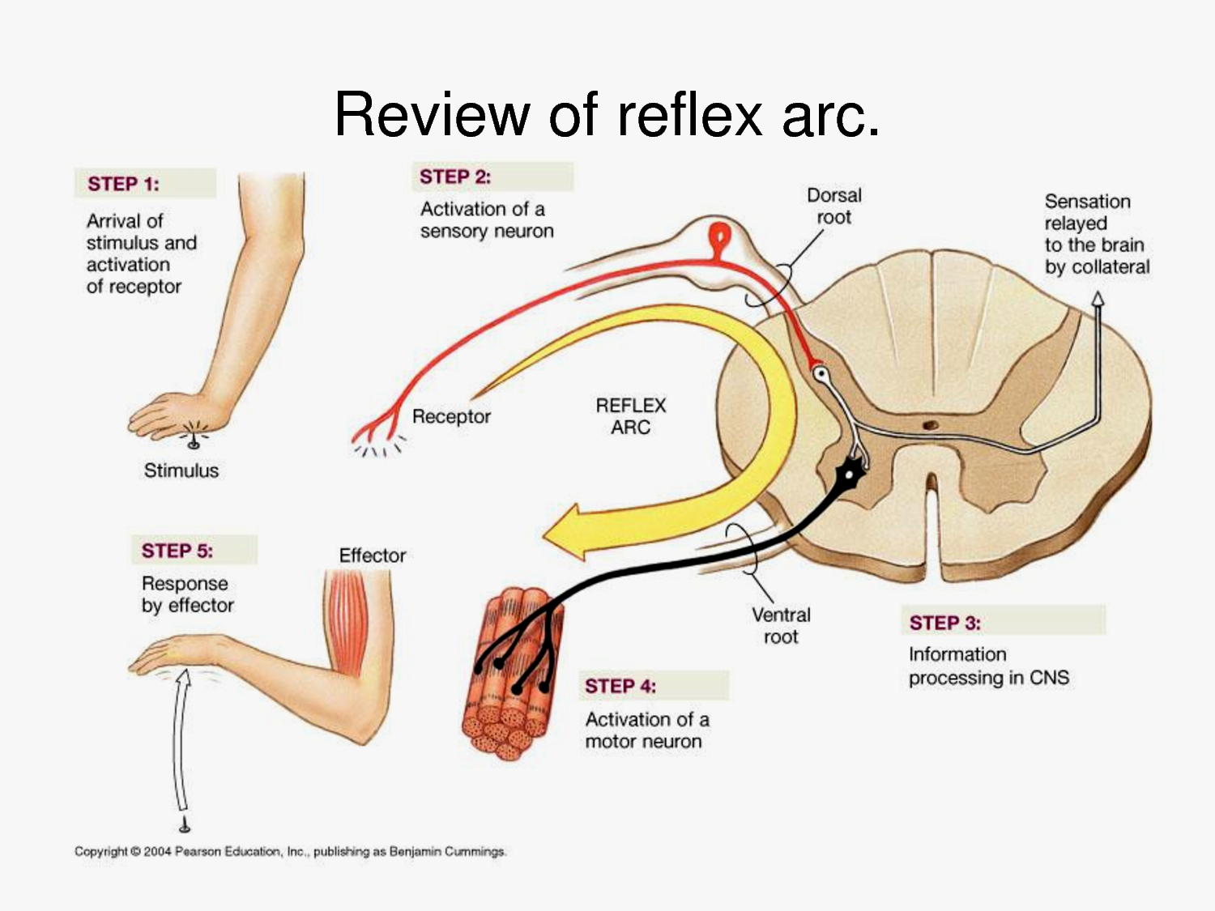
a – receptor: detects stimulus.
b – sensory neuron: carries impulse
to central nervous system.
c – interneuron: connects b to d.
b
d – motor neuron: carries impulse
c
to muscle(effector).
e – effector: receives impulse and
a
carries out appropriate response.
d

e

Q41. If reflex arc did not exist and you step on a pin what could happen?
A: it would take you longer to take your foot off the pin and by that time the pin would have penetrated deeper into your foot and caused more damage.

Q42. Explain what makes the reflex arc so effective at reducing the extent of damage sustained by the organ affected.
A: the reflex arc works by bypassing the brain. A receptor detects the stimulus (pin prick to the hand) and generates an impulse. The impulse is carried via the sensory neuron towards the spine(CNS). An interneuron connects the sensory neuron to a motor neuron. The motor neuron carries the nerve impulse to the effector (the muscle). A response takes place by lifting the hand up. This happens very quickly because it does not rely on the message going to the brain first then going back to the hand. You are still aware of the pain because inside the spine (CNS) the interneuron connects to another neuron that takes the impulse to the brain so that you are conscious of why you lifted your hand. By bypassing the brain the impulse travels from the receptor in the hand to the muscle very fast causing less damage to the tissues of the hand.

Q43. Indicate which of the following statements are true or false.

1. stimulus can generate a nerve impulse in the receptor.
2. sensory neuron carries impulse from spinal cord to effector such as muscle.
3. interneuron or connector neuron can be found in the spinal cord.
4. a nerve impulse always travel from the dendrite towards the axon.
5. a reflex involves sending an impulse to the brain before sending an impulse through the motor neuron to the effector.
6. a reflex is very rapid and is involuntary response to a stimulus.
7. The brain is part of the central nervous system and the spinal cord is a part of the peripheral nervous system.
8. the response is carried out by the effector having received an impulse from the motor neuron.
9. an axon carries an impulse towards the cell body of a neuron.

A: 1. true; 2. false; 3. true; 4. true; 5. false; 6. true; 7. false; 8. true; 9. false.

Q44. What is homeostasis?
A: is the maintenance of a constant internal environment. E.g. when the body temperature rises, the body sweats. Evaporation of the sweat removes heat from the body, thereby, lowering the body temperature and returning the body temperature to normal.

Q45. A person was driving at night while being tired. A kangaroo suddenly crossed his path. Explain why this person would take longer to bring his vehicle to a complete stop.
A: being tired he is not alert. Therefore, his perception and reaction times will be slower than normal. By the time he applies the brakes the car would have travelled a certain distance known as the reaction distance(distance travelled by car from the moment the stimulus has been perceived by the receptor until it results in a response).
The braking distance(distance travelled by car from the moment brakes are applied until it comes to a complete halt) is not affected by the condition of the driver, it is affected by the performance and condition of the car as well as road conditions.

Q46. What is an endocrine gland?
A: a gland that secretes a chemical messenger known as a hormone into the blood.

Q47. What are the two systems that help maintain homeostasis?
A: nervous system and endocrine system.

Q48. How do these two systems differ?
A: nerves produce an electro-chemical signal, whereas, endocrine glands secrete a chemical signal; nerve impulse targets muscle and glands, whereas hormones reach all cells through the blood; nerve impulse is rapid and short-lasting, whereas, hormones are slower acting and long-lasting; nerve impulse is transported by nerves, whereas, hormones are transported by blood; nervous system response is local and specific, whereas, endocrine gland response is general and widespread.

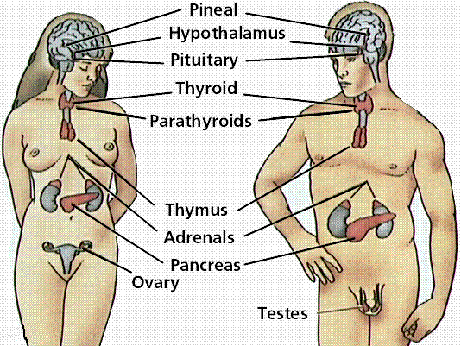
Q49. label the following endocrine glands.
a
b
c
d
e
f
g
h
i
j
A:
a – pineal
b - hypothalamus
c - pituitary
d – thyroid
e – parathyroid
f - thymus
g – adrenal
h - pancreas
i - ovary
j - testes

Q50. Match the following functions with the appropriate endocrine gland.

a

A | Pituitary | Helps body fight pathogens | 1
B | Hypothalamus | Regulates hunger, sleep, body temperature and thirst | 2
C | Thymus | Regulate sugar metabolism and minerals in blood | 3
D | Pancreas | Control all other endocrine glands | 4
E | Thyroid | Influences body hair and voice pitch and musculature | 5
F | Parathyroid | Regulates blood glucose levels | 6
G | Adrenal gland | Regulates metabolic rate in cells and energy levels | 7
H | Testes | Regulates calcium levels in blood | 8

A:

1 – C; 2 – B; 3 – G; 4 – A; 5 – H; 6 – D; 7 – E; 8 – F.

Q49. Why is it that water molecules cannot be seen even with the strongest mechanical microscope?
A: because using the mechanical microscope we rely on visible light spectrum to reflect the image of the object for it to be seen. Light spectrum have a much larger wave length then the size of the water molecule. Therefore, it cannot be reflected from the molecule, and hence, it cannot be seen.

Q50. Arrange the following types of radiation from largest to smallest in wavelength.

Radio waves; visible light waves; X-rays; infra-red; gamma rays; ultraviolet; microwaves.

A: radio wave; microwave; infra-red; visible light; ultraviolet; X-rays; Gamma rays.

Q51. Explain why X-rays are known as ionising radiation.
A: X-rays have a very small wavelength and high frequency. High frequency radiation carries a large amount of energy. The energy is enough to displace an electron from its orbit around the nucleus.

Q52. Why does the radiologist place a lead apron on your hip before taking an X-ray picture of your spine?
A: because X-rays carry enough energy that can destroy your DNA. By placing a lead apron it shields your gonads (testes and ovaries) from radiation that might cause cells to become cancerous(oncogenic) or mutated.

Q53. List four types of electro-magnetic radiation that are not classified as ionising.
A: radio waves; microwaves; visible light; infra-red.

END

☺ GOOD LUCK ☺

