Interactions
in
Chemistry
S. Holyoake

‘Interactions in Chemistry’ was written to provide opportunities for students at Rossmoyne Senior High School to address the Outcome ‘Natural and Processed Materials’
My thanks to Malcolm White and Ken Patterson for their help in proof-reading and to Ken for the formatting and layout of this booklet.

Steven Holyoake, June 2001
Revised December, 2006
Revised November, 2008

CONTENTS: INTERACTIONS IN CHEMISTRY

Elaborations for Interactions in Chemistry | 4
Cryptic Chemicals | 5
Activity 1: The Atom | 6
Activity 2: Size of an Atom | 8
Activity 3: Parts and Relative Size | 9
Worksheet: Atomic Particles and Shorthand Notation | 12
Periodic Table | 13
Activity 4: Atomic Structure and the Periodic Table | 14
Activity 5: Sweet Modelling | 18
Activity 6: Ions | 19
Activity 7: Evidence for Ions | 22
Activity 8: More Evidence for Ions | 23
Activity 9: Polyatomic Ions | 24
Activity 10: Predicting the Valency of an Element | 27
Learning Valencies | 28
Activity 11: Coming Together | 29
Activity 12: Valency and Formula | 30
Activity 13: Properties of Materials | 33
Metals Assignment | 36
Activity 14: Separating a Metal from its Ore 1. Carbon Reduction | 37
Activity 14: Separating a Metal from its Ore 2. Electrolysis | 39
Activity 15: Acids | 42
Activity 16: Bases | 44
Activity 17: The pH Scale | 46
Activity 18: pH of Some Common Substances | 48
Activity 19: Making an Indicator | 49
Activity 20: Ranging an Indicator | 51
Activity 21: Neutralization | 53
Activity 22: Acid and a Metal | 55
Activity 23: Acid and a Carbonate | 57
Activity 24: Equation Balancing (optional) | 59
What have You Learned | 61
Chemistry Review | 62
Interactions in chemistry
Elaborations:

At the completion of this unit you will have had opportunities to demonstrate that you know:

- The location, relative size and charge of the particles that make up an atom.
- Vertical columns in the Periodic Table are called groups and horizontal rows are called periods.
- The symbols for the first 20 elements and also Cr, Mn, Fe, Co, Ni, Cu, Zn, Br, Ag, Sn, I, Pt, Au, Hg, Pb.
- The difference between an atom and an ion.
- The valency of these ions: H⁺, O²⁻, F⁻, Na⁺, Mg²⁺, Al³⁺, S²⁻, Cl⁻, K⁺, Ca²⁺, Br⁻, I⁻, Cu²⁺, Zn²⁺, Ag⁺, Pb²⁺, OH⁻, NO₃⁻, CO₃²⁻, SO₄²⁻, NH₄⁺.
- The general properties of metals.
- The names and formulae of the common acids HCl, H₂SO₄, HNO₃, CH₃COOH.
- The general properties of acids and bases.
- The typical uses of the common acids and bases.

At the completion of this unit you will have had opportunities to demonstrate you can:

- Identify similarities in the properties of elements within a group of the Periodic Table.
- Describe the arrangement of electrons within an atom for the K, L and M shells.
- Predict the valency of an atom based upon:
its position within the table.
its electron configuration.
- Use the valency of the ions listed above to write the chemical formula of ionic compounds including compounds with polyatomic ions.
- Name ionic compounds including compounds with polyatomic ions.
- Describe the processes of carbon reduction and electrolysis as methods used to obtain metals.
- Use indicators to determine the acidity of a solution.
- Use the pH scale to describe the acidity of a solution.
- Describe products of typical reactions:
ACID + METAL
ACID + CARBONATE
ACID + METAL HYDROXIDE BASES
including the accurate prediction of the specific salt from any of the above.
- Write simple formulae and equations for these reactions.

CRYPTIC CHEMICALS
In each of the following statements is hidden the name of a chemical element.
For example
- Metal that removes wrinkles = iron
- A stupid trick = sili-con
- Element found in a bone rim = bromine

Try your luck at identifying these cryptic elements:
- The electricity produced by water is in general little.
- Returning from a freeze
- A very successful album.
- A relatively easy one by the sound of it.
- A middle medal.
- This element is an Asian neighbour.
- A vehicle plus what sounds like a Canadian without a container.
- This metal is found in a sting and in a can.
- Ron and I are men of steel.
- Found in an oxen.
- Initially a helicopter is not light, but it floats anyway.
- Drill over this element.
- This metal caused a rise in the population of Australia at first and is still symbolic of Australia.
- It may look like a girl’s best friend but it is always cubic.
- Sounds like a girl’s name followed by a boy’s name.
- This is definitely not money.
- After setting it ablaze? I see!
- ....um sounds like its in the back of the ship’s kitchen.
- Most of the podium was checked with a beam.
- Protected by a breastplate and helmet, which symbolically contain no chromium.
- Pamela Anderson’s element!
- Adds a nest for this mouthpart.
- In rack but not kin to half a Christmas cracker.
- Lone one glows brightly.
- A Japanese cartoon with a body joint. (for LOTE students only)
- Drugs to the mule as I see ‘em.

Select your answers from the answers below:
carbon, potassium, manganese, neon, titanium, silicon, radium, gold, silver, einsteinium, hydrogen, arsenic, zirconium, platinum, thorium, tungsten, europium, helium, vanadium, antimony, beryllium, gallium, boron, xenon, iron, tin

Activity 1: THE ATOM

The idea of matter being made up of atoms is probably not new to you.

- What is an atom really like?
- Spend a moment recollecting your thoughts about what is an atom and then compare your ideas about atoms with other people in your group.

In your notebook………
Record your current knowledge about atoms in a labelled diagram in your notes. If some of the things are difficult to represent in the form of a diagram then you may need to write brief explanations under your diagram.

Our present knowledge of the atom did not develop all at once but was built up over a long period of time. The model was altered each time a new discovery could not be properly explained by the existing model.

Note the reasons for altering the model as you read the following history of atoms.

A BRIEF HISTORY OF ATOMS
1. Earth, Wind, Fire and Water
The idea of matter being composed of atoms dates back to 400BC when a Greek philosopher called Democritus proposed his atomic theory. According to his theory of matter, all things are composed of minute, invisible, indestructible particles of pure matter (atoma, “indivisibles”), which move about eternally in infinite empty space.
The idea of matter being composed of other particles lost favour for a while, as alchemists tried to change base metals (iron or lead) into gold. They believed matter was made up of different proportions of Earth, Wind, Fire, and Water.

2. A Plum Pudding
It was not until the discovery of static electricity that a few modifications to the structure of the atom were required, so that scientists could explain why some objects developed a positive charge and others developed a negative charge when they were rubbed together. The model of the atom presented at that time is called the ‘Plum Pudding Model’, which pictured the atom as a ball whose surface was covered with positive and negative charges. During rubbing, some materials would have charge rubbed onto them, making them positively or negatively charged.

Atoms were solid spheres.
Equal numbers of positive and negative charges covered their surface.
Atoms would become positively charged if a negative charge was rubbed off them or if positive charge was rubbed onto them.
_+
+ _
+ _

3. Clouding the issue (or Target Practice)
A physicist was performing an experiment in which he fired some tiny particles at a very thin piece of gold foil. These particles were all expected to pass through the gold foil as if the gold foil was wet toilet paper and the particles were cannon balls. He was very surprised when some of these “cannon balls rebounded off the toilet paper.” To explain these findings, the physicist proposed that the mass of the atom was concentrated in a small space called the nucleus. Most of the space occupied by the atom was due to electrons orbiting the nucleus of the atom at very high speed. This model of the atom was called the Rutherford model after its inventor.
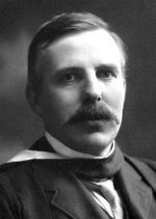
This model of the atom was made necessary because the previous model could no longer account for the facts that were known about matter. This new model could still explain how matter could be positive (atoms lose negative electrons), negative (atoms gain electrons) or neutral (atoms have the same number of electrons as protons).

Thus was born our modern view of the nature of the atom. The location of the electrons cannot be measured with much certainty and may be represented as a cloud orbiting the central nucleus of the atom. They may also be shown as travelling in orbits about the nucleus.

Try these questions………..
- Beneath the diagram of the atom you recently drew, write or sketch to show any changes in your understanding of atoms. Prepare to discuss with your partner the new things you have learned about the atom.

- Select one aspect of the history of atoms and draw a suitably captioned cartoon to illustrate the point.

- Describe one example of how new information has caused a change to our model of the atom.
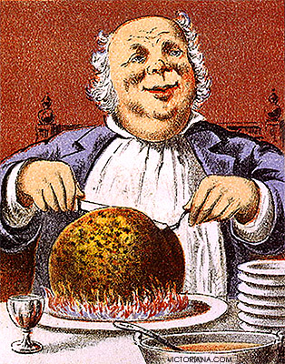

Research…………
Ernest Rutherford was very famous as a scientist. Use the library and Internet resources to find out more about his contribution to science.

Activity 2: Size of an atom

Begin with strip of A4 paper having a width of about 1cm and a good quality pair of scissors.

30cm

Cut the piece of paper in half. This is cut number 1.

Take one of the halves and cut it in half. This is cut number two.

Continue this process making sure you keep a careful check on the number of cuts you manage to make.
When you have made 12 cuts you will have a piece of paper as wide as a human hair.
When you have made 31 cuts you will have a piece of paper as wide as an atom.

If it were possible for you to make about 41 cuts you would have a piece of paper as wide as the nucleus of an atom.

In your notebook……….
- Record what you have learned about atoms in your notebook from this activity.
- Glue a half from your last cut into your book. Write the number of cut beside it.

Challenge:

How long was the piece of paper after 6 cuts? (A calculator or a very good ruler will be needed.)

Activity 3: PARTS AND RELATIVE SIZE
If we could see an atom, and the parts that make it up, we would find that it was made up of three types of particle: protons, neutrons and electrons.

protons

neutrons

electrons

The protons and neutrons are arranged in a nucleus and the electrons are orbiting the nucleus.

Did you know ………..
- If the nucleus were the size of a golf ball, then the cloud in which the electrons
orbit would be about the size of the school oval.
- If atoms could be so compressed that the electrons were squashed into the
nucleus then one matchbox full of matter would weigh about 5000kg.
- Most of matter is empty space.

Copy this chart into your notebook under the heading “Parts of Atoms”

 | protons | neutrons | electrons
charge | positive | neutral | negative
mass | 1 unit | 1 unit | 1/2000 of a unit
location | nucleus | nucleus | electron cloud

ATOMIC NUMBER & MASS NUMBER
It is convenient to introduce a couple of terms at this point:
- Atomic Number is the number of protons that there are in an atom. It is often represented with the symbol ‘Z’. The atomic number is important because it is the number of protons that determine the element. If the atom is neutral then the Atomic Number is also the number of electrons present. It is the top and smallest number for any element on the Periodic Table on Page 13 of this book.

- Mass Number is the number of protons and neutrons in an atom. It is often represented with the symbol ‘A’. The protons and neutrons are the particles that are responsible for giving an atom its mass. The number of these particles determines how heavy an atom is. It is the bottom number for any element on the Periodic Table. The mass number is always bigger than the atomic number.

- Group refers to a vertical column in the Periodic Table. Your teacher will show you the groups in a Periodic Table and explain how they are numbered.

- Period refers to a horizontal row in the Periodic Table.

In your notebook………
- Copy and complete this summary under the heading “Atomic Number and Mass Number”

Atomic Number means
Its symbol is
Mass Number means
Its symbol is
To find the number of neutrons present in an atom

- Copy a table like the following and use the Periodic Table to complete the columns.

Element | Symbol | Protons | Neutrons | Electrons
Sodium | Na | 11 | 12 | 11
Nitrogen
Carbon
Oxygen
Hydrogen
 | Al
 |  | 5
Chlorine
 | Mg
 |  |  |  | 3

Note: It is most important that you learn the names and symbols of the elements shown in bold type on the Periodic Table.

One way to do this is to make up a table like the one below and after you have learned the elements and their symbols, fold along the dotted line to cover the symbols then test yourself. Repeat the process taking extra care with the ones you get wrong.

Name | Symbol | Symbol | Symbol | Symbol | Symbol
Hydrogen |  |  |  |  | H
Helium |  |  |  |  | He
Lithium |  |  |  |  | Li
Leave lots of lines

Worksheet:
Atomic Particles & Shorthand Notation
Collect a copy of this worksheet from your teacher.
Complete this chart using your understanding of mass number and atomic number.

8

O
16

Substance | Name of | Mass N^{O} | Atomic N^{O} | Number of
 | element | p + n | (protons) | neutrons
6
C  12 | carbon | 12 | 6 | 6
N |  | 14 |  | 7
O |  |  | 8 | 8
P |  | 31 | 15
17
Cl
Do not write here
35
Ca |  | 40 |  | 20
26
Fe
56
Ag |  | 108 | 47
Pb |  |  | 82 | 125
 | gold | 197 | 79

1  H  Hydrogen  1 |  |  |  |  |  | Periodic Table |  |  |  |  |  |  |  |  |  |  | 2  He  Helium  4
3  Li  Lithium  7 | 4  Be  Beryllium  9 |  |  |  |  |  |  |  |  |  |  | 5  B  Boron  11 | 6  C  Carbon  12 | 7  N  Nitrogen  14 | 8  O  Oxygen  16 | 9  F  Fluorine  19 | 10  Ne  Neon  20
11  Na  Sodium  23 | 12  Mg  Magnesium  24 |  |  |  |  |  |  |  |  |  |  | 13  Al  Aluminium  27 | 14  Si  Silicon  28 | 15  P  Phosphorus  31 | 16  S  Sulfur  32 | 17  Cl  Chlorine  35 | 18  Ar  Argon  40
19  K  Potassium  39 | 20  Ca  Calcium  40 | 21  Sc  45 | 22  Ti  48 | 23  V  51 | 24  Cr  Chromium  52 | 25  Mn  Manganese  55 | 26  Fe  Iron  56 | 27  Co  Cobalt  59 | 28  Ni  Nickel  60 | 29  Cu  Copper  64 | 30  Zn  Zinc  65 | 31  Ga  70 | 32  Ge  73 | 33  As  75 | 34  Se  79 | 35  Br  Bromine  80 | 36  Kr  84
37  Rb  85 | 38  Sr  88 | 39  Y  89 | 40  Zr  91 | 41  Nb  93 | 42  Mo  96 | 43  Tc  99 | 44  Ru  101 | 45  Rh  103 | 46  Pd  106 | 47  Ag  Silver  108 | 48  Cd  112 | 49  In  115 | 50  Sn  Tin  119 | 51  Sb  122 | 52  Te  128 | 53  I  Iodine  127 | 54  Xe  131
55  Cs  133 | 56  Ba  137 | 57  *La  139 | 72  Hf  178 | 73  Ta  181 | 74  W  184 | 75  Re  186 | 76  Os  190 | 77  Ir  192 | 78  Pt  Platinum  195 | 79  Au  Gold  197 | 80  Hg  Mercury  201 | 81  Tl  204 | 82  Pb  Lead  207 | 83  Bi  209 | 84  Po  (209) | 85  At  (210) | 86  Rn  (222)
87  Fr  (223) | 88  Ra  226 | 89  **Ac  (227) | 104  Rf | 105  Db | 106  Sg | 107  Bh | 108  Hs | 109  Mt | 110  Uun | 111  Uuu | 112  Uub
*Lanthanide  Series |  |  | 58  Ce  140.1 | 59  Pr  140.9 | 60  Nd  144.2 | 61  Pm  (145) | 62  Sm  150.4 | 63  Eu  152.0 | 64  Gd  157.2 | 65  Tb  158.9 | 66  Dy  162.5 | 67  Ho  164.9 | 68  Er  167.3 | 69  Tm  168.9 | 70  Yb  173.0 | 71  Lu  175.0
**Actinide  Series |  |  | 90  Th  232.0 | 91  Pa  231.0 | 92  U  238.0 | 93  Np  237.0 | 94  Pu  (244) | 95  Am  (243) | 96  Cm  (247) | 97  Bk  (247) | 98  Cf  (251) | 99  Es  (254) | 100  Fm  (257) | 101  Md  (258) | 102  No  (255) | 103  Lr  (256)

NOTE:
- Periods are the horizontal rows
- Groups are the vertical columns
Atomic Nº.
Z
X
A
(Number of protons)

Symbol
Mass Nº
(Number of neutrons +protons)
Periods Groups
You need to know the elements shown in bold type in the shaded cells.

Activity 4: ATOMIC STRUCTURE AND THE PERIODIC TABLE

The Periodic Table provides an excellent way of organizing what we know about matter. If we start in the top left of the table and work our way across from left to right,
the Atomic Number (number of protons) increases by one for each new element.
It is the number of protons present in its atoms which makes one element different to another one

Just as the atomic number increases as we go across the Periodic Table, so does the Mass Number (protons plus neutrons) of the element, although not as steadily as the atomic number.

The arrangement of the electrons in the atoms also increases in a regular pattern as we move across the Periodic Table.
Our understanding of the atom is that electrons orbit the nucleus in regions called shells.
Each shell can hold a definite number of electrons. The outermost shell of electrons is called the valence shell. Each valence shell is given a name. The first three are called, in order, the K, L and M shells. The number of electrons that fit into the first shell is 2. There are 8 electrons that fit into the second shell and 8 fit into the third shell before the fourth shell starts to fill.

Shell | Number of electrons it can hold
K | 2
L | 8
M | 8

This pattern can best be seen if we show the electrons in a series of circular orbits, or shells with each shell a little further from the nucleus than the previous one.

Electron

Nucleus

ATOMIC STRUCTURE AND THE PERIODIC TABLE

- Use the Periodic Table on Page13 and the diagrams of atoms shown on Page 16 to complete a table like the one below for the atoms shown. You may need to refer to the previous activity (Activity 3) to find out how to calculate the number of neutrons.

Symbol | Electrons | Protons | Neutrons
H | 1 | 1 | 0
He | 2 | 2 | 2
Li
 | 11 more lines needed

- Answer this question when you have finished the table:
Why is the number of protons always the same as the number of electrons in each of the atoms you listed?

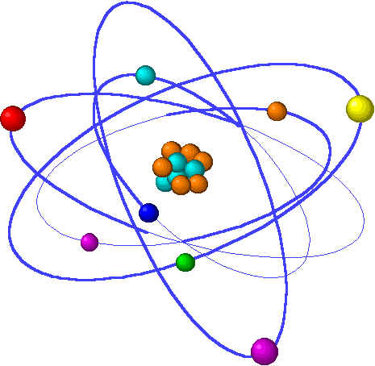

Hydrogen |  | Helium
lithium | beryllium |  | boron
carbon | nitrogen |  | oxygen
fluorine | neon |  | sodium
sulfur | chlorine |  | argon

In your notebooks……..
      - Complete a table with headings similar to this:

Symbol of Element | Group in the Periodic Table | Electrons in outer shell | Number of shells with electrons | Period of element
H | 1 | 1 | 1 | 1
 | 13 more lines needed

2. What pattern do you notice between the group or vertical column in the periodic table and the number of electrons in the outer valence shell?

- Predict the number of electrons in the outer shell of:
- Bromine
- Calcium
- Potassium

4. Can you see a pattern between the period (horizontal row in the Periodic Table) of an element and the number of shells that contain electrons?
Record your ideas in your notebook.

5. Why do you think that the first period has only two elements in it but the second and third periods have 8?

- Draw a diagram of a potassium atom similar to the diagrams in the table.

Challenge:
Draw a sketch of the following atoms.
Iodine (I) Strontium (Sr) Krypton (Kr)

Do NOT show every electron; only show the electrons in the outer shell. Shells that are full of electrons can be represented with circles. For example:

Magnesium

Activity 5: SWEET MODELLING

AIM: To demonstrate your knowledge of atomic structure by preparing a model atom.

MATERIALS: (per group)
margarine or honey 3 circular biscuits e.g. gingernuts
10 Smarties 10 sultanas
10 M&Ms 10 cachous
paper toweling ‘plates’

PROCEDURE:
Your teacher will direct you to construct a model of an atom of either:
- Nitrogen
- Oxygen or
- Fluorine.

In your notebooks……

When your model has been constructed justify the
- Number
- Type
- Location of the various parts to your atom.
(A little lateral thinking and a sense of humour, although not essential will certainly help!)

  - What are 2 ways your model fails or is limited in representing an atom?

When you have answered these questions, eat any unused sub-atomic particles.

Have your model checked by the teacher who will then advise you of the most appropriate way of disposing of the used materials.

Activity 6: IONS

The number of protons and electrons in a neutral atom are the same………

………they must be to balance the positive and negative charges. Sometimes atoms can lose or gain electrons. This usually happens when an element from the left of the Periodic Table combines with an element from the right of the table.
An ion is an atom that has a different number of protons and electrons.

If an atom was to gain an electron then the number of negative charges will exceed the number of positive charges by one. This gives the entire atom an overall negative
charge. For example:
- If a chlorine atom, Cl, was to gain an extra electron it would form a negative
chloride ion Cl⁻.
- If an oxygen atom, O, was to gain two electrons it would form a negative Oxide ion O²⁻.

Note how the name of the negative ion is changed to end with IDE so we can tell the difference between the ion and the atom.

When an atom loses electrons it will form a positive ion. Positive ions are named in
exactly the same way as the atoms but show the charge (valency) that they have.
For example, if a sodium atom, Na, loses an electron it will have one more positive
charge than negative charge. It will form a sodium ion Na⁺.

e⁻
Na
Cl
I’m positive I don’t need this.
At the risk of being negative, Ide be delighted to have it.

In your notebooks………
1. Copy the following table then use your Periodic Table to complete the table for each ion shown below:

Ion | Symbol | Protons | Neutrons | Electrons
Hydrogen | H⁺ | 1 | 0 | 0
 |  | 3 |  | 2
 | O²⁻ |  |  | 10
Chloride | Cl⁻
Magnesium | Mg²⁺
 | Na⁺
Sulfide |  |  |  | 18
Fluoride |  |  |  | 10

2. Below is a list of some of the ions that you will be expected to know:

H⁺, O²⁻, F⁻, Na⁺, Mg²⁺, Al³⁺, S²⁻, Cl⁻, K⁺, Ca²⁺, Br⁻, I⁻.

3. Copy the ions into a table similar to the one below:

+1 Ions Name and symbol | +2 Ions Name and symbol | +3 Ions Name and symbol | -2 Ions Name and symbol | -1 Ions Name and symbol
 |  |  |  | Fluoride F⁻

QUESTIONS:
- Look at where each group of ions is found in the Periodic Table.
What pattern(s) do you notice? Write out a rule that applies.

- Use your rule to predict the valencies of the ions formed by
Lithium (Li) Beryllium (Be) Barium (Ba) Boron (B) Rubidium (Rb)

Some of the other elements, whose valency you will be expected to know do not exactly follow the rules you have developed. A more detailed knowledge of chemistry is needed before you can predict the valency of these elements.

- Add these ions to the proper column in your table.
Cu²⁺, Zn²⁺, Ag⁺, Pb²⁺

- Copy and complete the following summary. Use the words or phrases below.

Ions and the Periodic Table.
- The atoms on the far-left side of the table tend to make ions. Their
valency is or . That is, the same as their number.
- The atoms on the far-right side tend to make ions. Their valencies
are usually 8 minus their number.
- The metal atoms in the middle of the Periodic Table tend to make ions but we cannot predict their valencies.

two, positive, negative, group, one

Challenge:
What is the valency of: Carbon Silicon Nitrogen

Activity 7: EVIDENCE FOR IONS

AIM: To observe some reactions that suggest ions exist.

MATERIALS:
- power supply
- 3 leads with alligator clips
- 2.5 V globe and holder
- 2 carbon electrodes
- NaCl
- sugar
- teaspoon
- 100 mL beaker
- distilled water

PROCEDURE:
- Connect the circuit as shown below.
- Set the power supply to 4V DC.
- Half fill the 100mL beaker with distilled water. Observe what happens to the globe.

DC
4 V

2.5 V globe

- Observe the light globe as 1 teaspoonful of salt is added to the water while stirring.

- Repeat the process but this time use a solution made of 1 teaspoonful of sugar dissolved in 50 mL of distilled water.

In your notebooks……..
- How do your observations of the light globe connected to electrodes in the salt
solution suggest the presence of ions?
- Do you think sugar is ionic (i.e., forms ions in solution)?

Activity 8: MORE EVIDENCE FOR IONS

AIM: To observe some reactions that suggest ions exist.

MATERIALS:
- Dropper bottles of
0.1M lead nitrate solution
0.1M silver nitrate solution
0.1M copper sulfate solution
- 6 cm of magnesium ribbon
- steel wool
- 3 Petri dishes

PROCEDURE:
- Polish the piece of magnesium ribbon with the steel wool.
- Break the magnesium into three equal sized pieces and place one piece into each
of the three Petri dishes.
- Add lead nitrate, silver nitrate and copper sulfate to each of the Petri dishes to a
depth of about 3 mm.

RESULTS:
- After about 10 minutes, record your observations into a suitable table.
- In what ways does the activity suggest that there were ions present?
(Hint: metal atoms are not soluble)

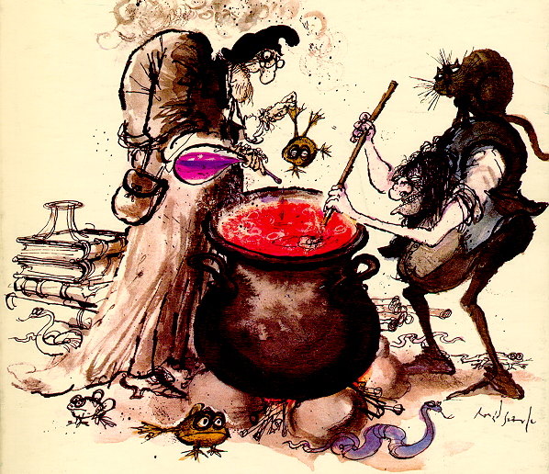

Activity 9: Polyatomic ions

Atoms sometimes clump together and the clump of atoms will lose or gain electrons. This causes the clump of atoms to form a positive or negative ion. These ions are called poly (many) atomic because they are made up of several atoms.

Some polyatomic ions you will need to know are:

- Hydroxide OH⁻
- Nitrate NO₃⁻
- Carbonate CO₃²⁻
- Sulfate SO₄²⁻
- Ammonium NH₄⁺
Add these to your chart of ions from Activity 6.

RULES FOR NAMING AND WRITING FORMULAE

- When writing the formula of a compound the positive ion (the left most element in
the periodic table) is written first. E.g.
NaCl CaS MgO CuCO₃

- The first ion is named as if it was an element. E.g.
NaCl CaS MgO CuCO₃
Sodium chloride calcium sulfide magnesium oxide copper carbonate.

- Elements forming negative ions will end in ide. E.g.

NaCl CaS MgO KBr
Sodium chloride calcium sulfide magnesium oxide potassium bromide

- The small numbers in a chemical formula indicate the number of the atom or ion
immediately in front of the number. For example:
Na₂S means 2 sodium ions and 1 sulfide ion
CuI₂ means 1 copper ion and 2 iodide ions
Al₂O₃ means 2 aluminium ions and 3 oxide ions

- Polyatomic ions remain grouped in a formula. E.g., CuCO₃
- When there is more than one polyatomic ion in a formula, the polyatomic ion must have brackets around it and the number of the ion present is shown by a small number after the brackets. For example:
(NH₄)₂S means 2 ammonium ions and 1 sulfide ion
Cu(NO₃)₂ means 1 copper ion and 2 nitrate ions
Al₂(SO₄)₃ means 2 aluminium ions and 3 sulfate ions
In your notebooks……….
Under the heading: ‘Ionic Formulae and their Names’:
- Copy a table like the one below and list the number and type of ions in each of the following formulae:

Formula | Number and type of ions | Formula | Number and type of ions
CaO |  | (NH₄)₂O
Ag₂O |  | Al₂(SO₄)₃
PbO |  | NaNO₃
CaSO₄ |  | Zn(NO₃)₂
MgCO₃ |  | Na₂CO₃
Al₂O₃ |  | Ca(OH)₂

- List the number of oxygen atoms in each of the following formulae:

For example:
List the number of oxygen atoms in Al₂(SO₄)₃
- There are three (SO₄²⁻) ions
- Each ion has 4 oxygen atoms
- Therefore there are 12 oxygen atoms altogether (3 lots of 4).

Formula | Nº of oxygen  atoms | Formula | Nº of oxygen  atoms
CaO |  | (NH₄)₂O
H₂O |  | Al₂(SO₄)₃
PbO |  | NaNO₃
CaSO₄ |  | Zn(NO₃)₂
MgCO₃ |  | Na₂CO₃
Al₂O₃ |  | Ca(OH)₂

- Copy and complete this table in your notebooks.

Formula of compound | Name of compound | Formula of compound | Name of compound
CaO |  | CaSO₄
Zn(NO₃)₂ |  | Na₂CO₃
(NH₄)₂S |  | CuSO₄
MgCO₃ |  | Al₂(SO₄)₃
NaNO₃ |  | Ca(OH)₂
(NH₄)₂SO₄ |  | NH₄Cl

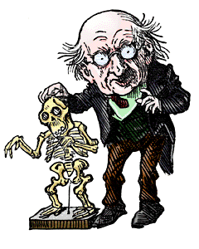

Activity 10: Predicting the valency of an element

After watching a video on the Periodic Table you will need to answer the following
questions.
- What common features are shared by elements in the same group (vertical column in the Periodic Table)?

We have previously talked about the electrons around the nucleus existing as a cloud. How do we now believe the electrons to be arranged?

- How does the valency of an atom relate to the element’s position in the Periodic Table?

A note-taking table is often useful. Copy this table into your notebook before the video starts.
Write key words and ideas that are relevant to the question being answered in the left column. At the end of the video complete your answer in the right column.

Key words and phrases | Answer
Common features in groups

Electron arrangement

Valency and position

Challenge:

Use your answer to question 2 above to draw a diagram showing the arrangement of the electrons in a magnesium atom Mg and a magnesium ion (Mg²⁺).

Learning Valencies

Below is a list of the ions you are required to know.
Obtain a copy the table shown below from your teacher. When you think you have learned the list of valencies, fold the sheet so you cannot see the valencies and try to write them from memory in the first blank column.

Name | symbol | symbol | symbol | symbol | symbol | symbol
Hydrogen ion |  |  |  |  |  | H⁺
Sodium ion |  |  |  |  |  | Na⁺
Chloride |  |  |  |  |  | Cl⁻
Oxide |  |  |  |  |  | O²⁻
Hydroxide |  |  |  |  |  | OH⁻
Calcium ion |  |  |  |  |  | Ca²⁺
Sulfide |  |  |  |  |  | S²⁻
Nitrate |  |  |  |  |  | NO₃⁻
Fluoride |  |  |  |  |  | F⁻
Ammonium  Do not write here |  |  |  |  |  | NH₄⁺
Carbonate |  |  |  |  |  | CO₃²⁻
Silver ion |  |  |  |  |  | Ag⁺
Zinc ion |  |  |  |  |  | Zn²⁺
Copper ion |  |  |  |  |  | Cu²⁺
Lead ion |  |  |  |  |  | Pb²⁺
Sulfate |  |  |  |  |  | SO₄²⁻
Aluminium |  |  |  |  |  | Al³⁺
Magnesium ion |  |  |  |  |  | Mg²⁺
Bromide |  |  |  |  |  | Br⁻
Iodide |  |  |  |  |  | I⁻
Potassium |  |  |  |  |  | K⁺

If you do not get the valencies correct, refold the paper and try again.

Activity 11: COME TOGETHER

Your teacher will give you a piece of paper with some information on it. The information will be about an element, the Periodic Table or electrons.

Find other people with RELATED information on their sheets. (NOTE: do not look for people with the same information as yours). Groups will be of either 3 or 4 people.
Discuss with the other group members how the pieces of information are linked together.

Record the names of the other people in your group and the information that they had, as well as your own piece of information. Show how all of pieces of information are related.

A good answer will not just show how each piece of information points to the one element, but will also show the relationships between valency, electron configuration and the position of the element in the Periodic Table.

You may refer to a chart of the Periodic Table to help you with this task.

To the teacher…….
The “Come Together Information Sheet” can be found in the 8342 Folder on the Shared Directory.

Activity 12: VALENCY AND FORMULA

AIM: Use the valency of different ions to write the formulae of ionic compounds.

BACKGROUND:
The rectangles with pieces cut from them represent atoms that have lost electrons. They are positive ions.
The rectangles with pieces added to them represent atoms that have gained electrons.
They are negative ions.

When ions join together to make compounds, all of the cut out pieces on a rectangle must be exactly filled as shown below.

MATERIALS:
- valency cut-out sheet
- scissors

METHOD:
Obtain a copy of the Valency Cut-Out Sheet from your teacher
Cut out each of the shapes above and trim off any shaded parts.
Use the cut out shapes to construct the compounds that would form between the following pairs of ions.

1  2  3  4  5  6  7  8  9 | hydrogen and chloride  hydrogen and hydroxide  hydrogen and sulfate  hydrogen and carbonate  hydrogen and sulfide  calcium and sulfate  calcium and sulfide  calcium and hydroxide  calcium and carbonate | 10  11  12  13  14  15  16  17  18 | calcium and chloride  calcium and oxide  copper and chloride  copper and carbonate  copper and sulfide  copper and oxide  copper and hydroxide  copper and sulfate  zinc and hydroxide | 19  20  21  22  23  24  25  26  27 | zinc and sulfide  zinc and sulfate  zinc and carbonate  zinc and chloride  aluminium and chloride  sodium and hydroxide  sodium and carbonate  sodium and chloride  sodium and sulfate

In your notebooks……….
Under the heading ‘Valency and Formula Writing’, draw a suitable table, similar to
the one below, to record the:
- Ions that combined
- Formula of the compound formed
- Name of the compound formed

Positive ion | Negative ion | Formula | Name
Cu²⁺ | NO₃⁻ | Cu(NO₃)₂ | Copper nitrate
 | 27 lines required

QUESTIONS:

- Develop a rule about the way ions combine.

- Use the rule to decide how ions such as aluminium and sulfide combine.

Challenge:
Could you design shapes similar to the ones above that would show the compound formed from aluminium and sulfur?
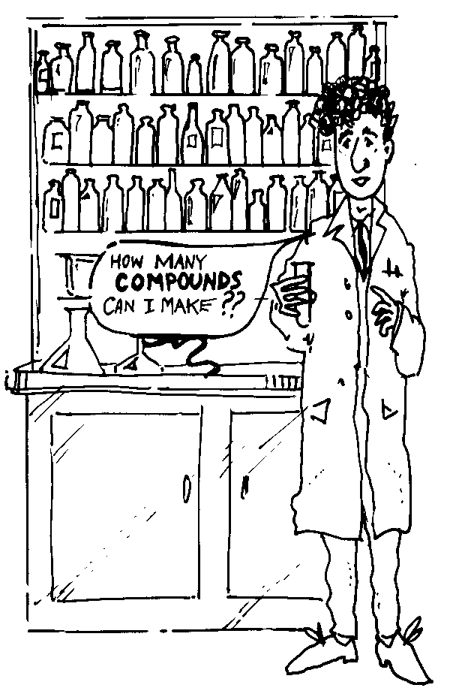

VALENCY CUT-OUT SHEET

H⁺
H⁺
Na⁺
Mg²⁺
Ca²
⁺
Zn²⁺
Cu²⁺
OH⁻
O⁻²
Al³⁺
H⁺
Na⁺
Zn²⁺
Cu²⁺
Ca²⁺
OH⁻
Cl⁻
Cl⁻
Cl⁻
S⁻²
SO₄⁻²
CO₃⁻²

Activity 13: PROPERTIES OF MATERIALS
AIM:
To investigate the chemical and physical properties of some elements from different parts of the Periodic Table.

MATERIALS: (demonstration Part A)
lithium (optional) carbon powder ceramic tile
sodium sulfur powder deflagrating spoon
potassium magnesium universal indicator
calcium scalpel tweezers
matches

METHOD: Part A – Teacher Demonstration
Your teacher will demonstrate the properties of a number of elements for you.
Caution! Your teacher will use only small pieces of these elements in a well-ventilated area. You must wear safety glasses! It is harmful to breathe the smoke from these metals when they react with water. STAND BACK!!!!

RESULTS:
- Copy and complete the table below under the heading ‘Properties of Materials’.
Element | Reaction with water | Reaction with air | Hard or soft | Heavy or light | Indicator Colour
Lithium
(Li)
Sodium
( )
Potassium
( )
Calcium
( )
Magnesium (Mg)
Sulfur
( )
Carbon
( )

- Is there a pattern between an element’s position in the Periodic Table and the properties it shows?

Challenge: Predict the properties of the rare element Francium(Fr).
Give reasons for your answer.
MATERIALS: Part B (per group)
sulfur rolled 3 leads with alligator clips
power supply set of density cubes (large)
carbon rod electronic balance
12V light globe and socket

METHOD: Part B
Test the samples of elements that you have been provided with for their conductivity as shown in the diagram below.
globe
Power supply

test sample

- Record your conductivity results in a table like the one below.
- Measure the mass of the 2cm metal cubes using an electronic balance and
record your results in a table similar to the one drawn below.
- The density of a metal sample is found by dividing the metal’s mass by its volume (8cm³). Calculate the density of each element and record it in your table.

Material | Conductivity (good/bad) | Mass (g) | Volume(cm³) | Density = M  V g/cm³
Aluminium
Lead
Zinc
Copper
Iron
Brass
Sulfur |  |  |  | 2.07 g/cm³
Carbon |  |  |  | 2.26 g/cm³

QUESTIONS:
- What can you conclude about the conductivity of metals from those tested?
- The conductivity of sulfur is typical of MOST non-metals. What did you find
out about the conductivity of carbon?
- Compare the density of metals with that of non-metals.
- Write down the names of two metals from the previous activity that had a low
density.
- Why is there no chemical symbol for brass?

Challenge: How could you determine the density of an irregularly shaped
piece of sulfur?
Try out your ideas.

METALS ASSIGNMENT

Select a metallic element of your choice (a common metal will be easiest) and answer the following questions about the element:

- Where is the element mined? (If the element is widely mined all over the world then gives the major locations it is mined in Western Australia or Australia).

- What is the name of the ore of the metal that is mined?

- What processing happens to the ore before the element is in a useable form?

- Give uses of the element and explain the properties that make it suitable for that use.

- What are three properties that the chosen element shares with most metals?

- Describe one property of the chosen element that makes it a bit unusual compared to most metals.

Each question is worth, two marks. In addition, three marks will be allocated to your notes made in the library. Write these on A-4 paper.

An explosion chart is a useful note-making framework.
Titanium
Location:
Ore type:
Heading:
Heading:
Heading:
Heading:

Activity 14: SEPARATING A METAL FROM ITS ORE
1. Carbon Reduction

BACKGROUND:
Most metals are removed from the ground in the form of an ore. The ore is often a mixture of metal oxide and other rock. One way to refine the ore is to heat the ore in the presence of carbon. The oxide ions attached to the metal ions are attracted more strongly to the carbon to form carbon dioxide. The pure metal is left behind.

This method is most suitable when large quantities of metal are needed and the metal is not very reactive. Carbon reduction would not work for a very reactive metal like sodium, but for less reactive metals like iron and lead it works well.

AIM: to produce metal from a metal oxide using carbon reduction.

MATERIALS: per group
popsticks lead oxide (PbO) copper oxide (CuO)
zinc oxide (ZnO) powdered charcoal crucible
steel can without ends 100ml beaker of H₂O Bunsen and heat-proof mat
matches

METHOD A:
- Take the popstick and using a Bunsen burner ignite the
last couple of centimetres of wood on the popstick.

- Dampen the burnt end of the popstick by dipping it
into a beaker of water.

- Dip the moist tip of the popstick into the lead oxide.

- Place the burnt tip of the popstick containing the
lead oxide into a luminous flame taking care
not to allow the popstick to catch fire. After a short
heating time look for any evidence of a metal being formed.

- Do not continue heating once metal has formed.

- Repeat the procedure above using the other samples of metal oxide.

In your notebooks……..
Record the AIM of the experiment in your notes and complete a labelled diagram of the METHOD you used in this experiment. Record your OBSERVATIONS and RESULTS.
(Note that not all of the metal oxides will be converted to a metal by this method).

METHOD B
- Select a metal oxide that did not form metal particles in Part A.

- Place about 0.5g of the metal oxide in a crucible and mix it well with a similar volume of carbon powder.

- Set the crucible in a clay pipe triangle and place an open steel can over the crucible.

- Heat vigorously for a few minutes and then allow cooling.

- Empty the cool contents of the crucible into a 600mL beaker about half-filled with water.

- Look carefully for any evidence of metal formation.

Steel can

5 minutes
tongs

Step 1 2 3 4

RESULTS:
- Record a labelled diagram showing the second method of carbon reduction.
- Note whether there is any evidence of a metal being produced.

- If no metal was formed, what does this suggest about the reactivity of the metal you were trying to refine?

Challenge: The history of the discovery of metals is strongly linked to their reactivity. Why do you think this is so?

Cryptic: What single word would replace ‘metals made pure in fire den’.

Activity 14: SEPARATING A METAL FROM ITS ORE
2. Electrolysis
BACKGROUND:
Electrolysis is the process of passing an electric current through a solution that contains dissolved ions. The ions in the solution are attracted to the electrodes that have an opposite charge. The process of electrolysis is useful for the extraction of metals from their ores.

AIM: To use electrolysis to obtain some metal from its ore.

MATERIALS (per group):
- 100mL beaker
- 2M H₂SO₄
- filter paper
- stirring rod
- power pack
- 2 carbon electrodes
- 2 alligator leads
- metal ore (CuCO₃ + sand)

METHOD:
1g of ore
- Take about 1g of the ore and place it in the 100mL beaker.

- Slowly add acid until there is no further evidence of reaction.
- Filter the solution to remove the waste material present in
the ore but retain the liquid.

- Add water, if required, so that there is at least 50mL of liquid
present.
2M H₂SO₄

- Connect the carbon electrodes to the positive and negative
terminals of the power pack.

- Place the electrodes into the 100mL beaker taking care that
they do not touch.

- Set the power supply to 2V and observe what changes occur
over a period of a few minutes.

2 V

DC

In your notebooks………..
Record an appropriate AIM for the experiment, draw an appropriate DIAGRAM and then list your OBSERVATIONS.

Try to infer why the changes you observed happened. Some points that may help are:

- Things that carry the same kind of electrical charges repel one another.
+
+

- Things that carry different kinds of electrical charges attract one another.
_
+

- The colour of Cu²⁺ ions is blue.

Extension……..
Your teacher may provide you with other salts and ask you to try to produce the metals by electrolysis. These might include soluble compounds of silver, nickel, and lead, e.g., 0.1M solutions of AgNO₃, NiSO₄, and Pb(NO₃)₂.

Challenge:
Electrolysis is suitable for recovering many metals from their ores but the process that you have used would require some modification before it is suitable for obtaining reactive metals such as sodium and potassium. Why do you think there may be difficulty in obtaining these metals by the method you have used?

Use library and Internet resources to find out how these metals are refined.

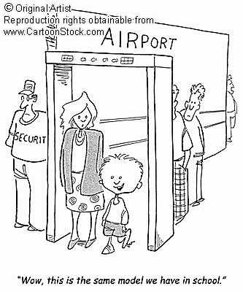

Activity 15: ACIDS

BACKGROUND:
Acids are a very important group of compounds. They share common properties because they all contain HYDROGEN. This hydrogen is able to break away from the acid as an ion (ionise) and involve itself in some chemical reactions.

You will have to learn the names and formulae of these acids:
NAME OF ACID | FORMULA
- Hydrochloric acid | HCl
- Ethanoic (acetic) acid | CH₃COOH
- Sulfuric acid | H₂SO₄
- Nitric acid | HNO₃.

You will also have to remember the properties that acids have in common.

AIM: To investigate some of the properties of acids.

MATERIALS:
Dropper bottles containing 0.1M solutions of:
ethanoic acid 5 test tubes
citric acid 5 pieces of red and blue litmus paper
hydrochloric acid 5 labels
sulfuric acid 5 small pieces of magnesium ribbon
tap water (control) tweezers
Universal Indicator and test card test tube rack

PROCEDURE:
- Write a suitable Aim and copy the Observations table into your notebook.

- Label the test tubes with the names of the solutions to be tested.

- Place 1 cm of each solution into its labelled test tube.

- Use the tweezers to dunk a piece of red and blue litmus paper into each of the solutions, recording your observations.

- Empty the test tubes and refill them with the acids.

- Add two drops of Universal Indicator and record your observations.

- Empty the test tubes and refill them with the acids.

- Drop a piece of magnesium into each test tube and record your observations.

RESULTS:

Name of Solution | Effect on  red litmus | Effect on  blue litmus | Effect on  Magnesium | Observation with  Universal Indicator

QUESTIONS:

1. What effect do acids have on litmus paper?

2. What effect do acids have on reactive metals such as magnesium?

3. What gas do you think was produced when the acids reacted with the magnesium? Why did you choose this gas?

4. Which do you think was the weakest acid and why?

- Do you think water is an acid? Explain your answer.
- From this experiment make a list of properties that are common to acids.

Use a suitable text reference to find:
- The major uses of hydrochloric, sulfuric and nitric acids.
- The natural source of: malic acid, formic acid, tartaric acid and tannic acid.

The acid test………..
Your teacher may provide you with a few crystals of citric acid to taste. It is dangerous to taste many of the other acids.

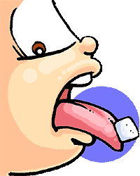

Activity 16: BASES
BACKGROUND:
Bases are another important group of chemicals. They share common properties because they all produce hydroxide ions when they dissolve. Any compound with an OH⁻ ion in its formula can be considered a base.
AIM: To investigate the effect of some common bases on litmus and Universal
Indicator.

_{OH}- _{OHOH}-

MATERIALS:
- Dropper bottles containing 0.1M solutions of
NaOH
Ca(OH)₂
KOH
NaHCO₃
Tap water
- Red and Blue litmus paper
- Universal indicator and colour chart
- Wax pencil
- Depression tile

METHOD:
- Copy the aim and results table into your notebook.
- Add enough of a test solution to half fill a cavity on the depression tile.
- Immerse a small piece of red and also blue litmus to the test solution.
- Record the effect of the solution on the litmus paper in a table like the one
below.
- Add 1 drop of Universal Indicator to the solution in the cavity and record its
colour.
- Repeat the process until you have tested the reaction of litmus paper and Universal Indicator with each solution.

RESULTS:

Substance | Effect on  red litmus | Effect on  blue litmus | Effect on Universal Indicator
NaOH
Ca(OH)₂
KOH
NaHCO₃
Tap water

QUESTIONS

- Summarize the effect of the bases on litmus.

- Summarize the effect of the bases on Universal Indicator.

- All compounds that contain hydroxide ions are bases, but do all bases contain hydroxide ions?

- Did some of the bases seem more powerful than others?

Use a suitable reference book to find answers to the following questions.

- What are the properties common to bases?

- List some of the major uses of bases.

H⁺ meets OH⁻ for a drink of HOH

Activity 17: THE pH SCALE

BACKGROUND:
The pH scale is a way that chemists describe the strength of an acid or a base. In a solution an acid produces H⁺ ions and a base produces OH⁻ ions. An H⁺ and an OH⁻ ion will readily combine to form HOH, or H₂O as it is more commonly known. A base will tend to cancel the effect of an acid.

Strong bases
Neutral
solution
Strong
acids

0
9
7
5
14
13
11
1
3

The pH scale

Note: Any neutral solution will have a pH of 7.
All acids have a pH less than 7.
All bases have a pH greater than 7.

AIM: To find the pH of some common acids and bases using Universal Indicator.

MATERIALS:
- Dropper bottles of:
0.1M HCl
0.01M HCl
0.01M CH₃COOH
tap water
0.1 M NaOH
0.01M NaOH
0.01M NaHCO₃
- Depression tile
- Wax pencil
- Universal Indicator and colour cards

METHOD:

- Place 3-4 drops of each solution in separate cavities on the depression tile.
- Label the cavities 1-7. Add 1 drop of indicator to each cavity.
- Record your results in a table like the one shown on the next page.

In your notebooks……….
- Write an Aim for this activity.
- Draw a scientific diagram to summarize the method used.
- Copy and complete the following Results table.
RESULTS:

 | Solution | pH | Indicator colour | Acid or base?
1 | 0.1M HCl
2 | 0.01M HCl
3 | 0.01M CH₃COOH
4 | Tap water
5 | 0.1M NaOH
6 | 0.01M NaOH
7 | 0.01M NaHCO₃

QUESTIONS:

- Which of the solutions tested was the most acidic?

2. Which of your results support the statement that “stronger acids or bases have larger concentration numbers in the front i.e. 0.1M and 0.01M.”

3. Which of your results suggest that the concentration is not the only factor that determines the strength of an acid or base?

QUICK QUIZ:
Test yourself on these questions then check your answers below.

- What is the pH of a neutral solution?
- A solution has a pH of 5. Is it acidic, basic or neutral?
- Is a solution with a pH of 3 more or less acidic than a solution having a pH of 5?
- The pH of a swimming pool is too high. Does it require more or less acid?
- What substance could you add to an acidic solution to reduce its acidity?
- What colour is Universal Indicator in acid?
- What colour is Universal Indicator in base?
- What colour is Universal Indicator in tap water?

Activity 18: pH OF SOME COMMON CHEMICALS

AIM: To measure the pH of some common chemicals using Universal Indicator.

MATERIALS:
- Dropper bottles of
Vinegar solution
Lemonade or Coca Cola
Milk
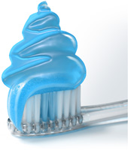
Lemon juice
Swimming pool water
Toothpaste solution
Soap solution (Lux – not detergent)
Glass cleaning solution (Windex)
Vitamin C tablet dissolved
Health salts solution
- Chinagraph or felt tip marker pen (permanent)
- Universal Indicator and test card
- Depression tile

METHOD:
- Place about 1 cm of each of the solutions to be tested into separate cavities on the depression tile.

- Add two drops of Universal Indicator to each of the cavities.

RESULTS:
Record your results in an appropriate table.

CONCLUSIONS:
- Use your results to rank the solutions from the most acidic to the most basic.

- What general group of chemicals seems to be mainly bases?

Investigation……………

We sometimes hear a comment that Coca Cola™ is very corrosive.

Design an experiment to investigate this claim.

Activity 19: Making an indicator

BACKGROUND:
The coloured matter in the petals and other tissues of plants is called pigment. Many pigments obtained from plants will change colour when they are placed in an acidic or basic solution. Chemicals that change in acids and bases are called indicators. Tea and cabbage both show slight differences in colour depending upon the pH of the solution that they are in.

AIM: To extract a pigment from a plant that will change colour when it is in acidic or basic solution.

MATERIALS:
Polygala flowers two test tubes
Hibiscus flowers test tube rack
Brown onion skin 250mL beaker
Red cabbage leaf tripod
Rhubarb wire gauze
Beetroot Bunsen burner & matches
Azalea flowers (red, white, pink, and purple) heat proof mat
0.1M HCl in a dropper bottle filter funnel
0.1M NaOH in a dropper bottle filter funnel stand
Mortar and pestle cotton gauze for filtering
1 large test tube and stopper labels

METHOD:
Plant material + 100mL of water
- Take a small amount of the plant material assigned to your group and break it into small pieces using your fingers or a mortar and pestle.

- Add the plant material to a 250mL beaker and add about 100mL of water.

- Gently boil the liquid for about 5 minutes, stirring constantly. Then allow it to cool in the beaker.

- When the solution has cooled, use the cotton
gauze to filter the liquid from the remaining
Cotton gauze
plant material.

- Place about 3 – 4 cm of filtrate into two
test tubes.

- Collect the remaining liquid in the large test
tube and stopper this. Label this test tube with
your name and the plant material you used.
(This is to be retained for the next activity.)

- To one of the test tubes that containing the filtrate, add one eyedropper full of 0.1M HCl.

- To the other test tube of filtrate, add one eyedropper full of 0.1M NaOH.

- Record the colour your indicator in
- acid
- base.

Activity 20: RANGING AN INDICATOR

BACKGROUND:
Many substances behave as indicators telling us whether a solution is acidic or basic. Universal Indicator also tells us the extent to which a solution is acidic or basic. Universal Indicator is actually a mixture of different indicators that change their colour at different pH’s. In this activity you will find out the range of pH over which your indicator changes colour.

AIM: To find the range of pH over which an indicator changes colour.

MATERIALS:
- plant extract from the previous activity
- 0.1M HCl in a dropper bottle
- 0.1M NaOH in a dropper bottle
- 13 test tubes and 2 test tube racks
- 10 mL graduated cylinder
- 100 mL beaker
- labels
- Pasteur pipette

METHOD:

- Place about 5 cm of 0.1M HCl into a test tube and label it ‘pH 1’.

- Add 9 mL of water to a 10mL graduated cylinder then use a Pasteur pipette to remove 1 mL from the pH 1-test tube. Add this to the graduated cylinder so that it contains 10 mLs.

- Transfer the contents of the graduated cylinder to a test tube and shake it well to mix the solution. Label this test tube ‘pH 2’.

+ = Now + = etc.

9 mL water
1 mL of pH 1
10 mL of pH2
9 mL water
1 mL of pH 2
10 mL of pH 3

- Add 9 mL of water to a 10mL graduated cylinder then use a Pasteur pipette to remove 1 mL from the pH 2-test tube. Add this to the water in the graduated cylinder so that it contains 10 mL altogether.

- Transfer the contents of the graduated cylinder to a test tube and shake it well to mix the solution. Label this test tube ‘pH 3’.

- Repeat this dilution process until you have a test tube labelled ‘pH 6’.

- Add tap water only to the next test tube and label it ‘pH 7’.

- Place about 5 cm of 0.1M NaOH into a test tube and label it ‘pH 13’.

- Add 9 mL of water to a 10 mL graduated cylinder then use a Pasteur pipette to remove 1 mL from the pH 13-test tube. Add this to the graduated cylinder so that it contains 10 mL.

- Transfer the contents of the graduated cylinder to a test tube and shake it well to mix the solution. Label this test tube ‘pH 12’.

- Repeat this process, reducing the pH by 1 each time, until you have a test tube labelled ‘pH 8’.

- Add about 1cm of your previously prepared indicator solution to each of the test tubes.

RESULTS:
Record the pH range over which your indicator changes colour and the colour of the indicator at each pH value.

QUESTIONS:
- Would your indicator be able to measure whether a solution had a pH of more than 4?

Challenge 0.1M HCl has a pH of 1.
Each time it is diluted with water by a factor of 10 the pH increases by 1, because the solution is becoming more like water.

What will be the pH of each of these solutions?
    - 0.01M HCl
    - 0.001M HCl
    - 0.00001M HCl

Activity 21: NEUTRALIZATION
BACKGROUND:
When an acid is mixed with a base, a reaction called neutralization occurs.

- H⁺ ions from the acid react with the OH⁻ ions from the base to produce WATER.
H⁺ + OH⁻ H₂O

- The positive ion from the base combines with the negative ion from the acid to form a SALT.

HCl + NaOH NaCl + H₂O

AIM: To neutralize an acid.

MATERIALS:
- Dropper bottles of
0.1M HCl
0.1M NaOH
- Universal Indicator and colour card
- test tube and rack

METHOD:
- Place 5 eyedroppers full of HCl into a test tube.

- Add 2 drops of Universal Indicator.

- Add 4 eyedroppers full of NaOH to the test tube, then slowly add NaOH drop at a time until you obtain a neutral solution.

- If you go past a neutral green solution and the liquid in the test tube goes blue then add acid to make it green.

QUESTIONS:
- Write the chemical formula of the two substances formed when the solution was green.

- Copy this table then write the chemical formula of the salt formed when the following acids and bases are mixed.

Acid | Base | Salt
Hydrochloric | Potassium hydroxide
Hydrochloric | Calcium hydroxide
Nitric | Sodium hydroxide
Sulfuric | Sodium hydroxide
Sulfuric | Calcium hydroxide
Sulfuric | Ammonium hydroxide
Sulfuric (for experts) | Aluminium hydroxide

- Copy and then complete this general statement that summarizes the neutralisation reaction:

Acid + Base

- Why do you think this reaction is called ‘neutralization’?

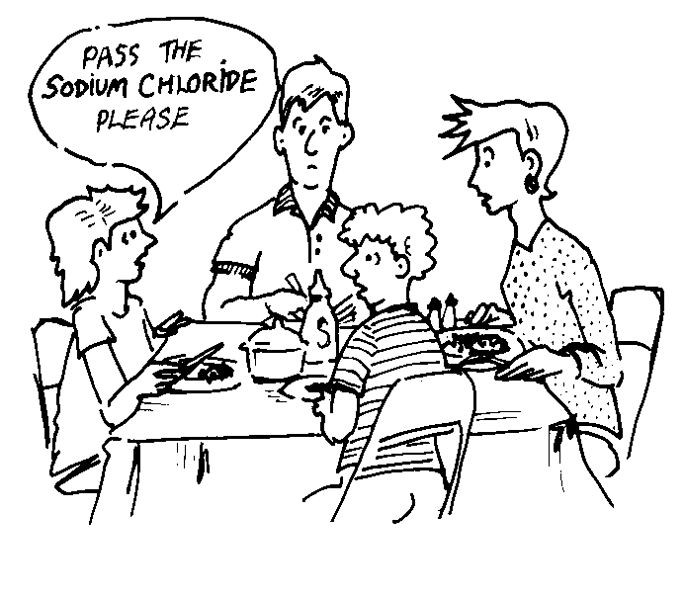

Activity 22: ACID AND A METAL

BACKGROUND:
When an acid combines with a metal, the products are hydrogen gas and a salt. The hydrogen gas forms from two hydrogen ions in the acid. The salt is formed from the positive ions from the piece of metal and the negative ions left over from the acid.
Acid + Metal Salt + Hydrogen gas

AIM: To predict the products from an acid reacting with a metal.

MATERIALS:
- Dropper bottles containing
2M HCl
2M H₂SO₄
- Magnesium ribbon 2 x 2cm
- Zinc granulated
- Copper strip
- 7 test tubes and rack
- Splints
- Matches

METHOD:
- Place 2M HCl to a depth of 4 cm in a test tube. | 2M HCl
- Add a piece of magnesium ribbon to the test tube.  Magnesium | 2M HCl
- Collect any gas produced in an inverted test tube. Collect the gas for at least a minute or until the magnesium has disappeared before testing the gas.

- Test the collected gas with the pop test.

In your notebook……

- Copy and complete the table below:

Metal | Observations with HCl | Name of salt formed | Observations with H₂SO₄ | Name of salt formed
Magnesium
Zinc
Copper

QUESTIONS:

- In the test tubes where a reaction occurred, what other substance was produced apart from the salt?

- Could copper be used to make containers to store hydrochloric acid?

- What salt would be produced if nitric acid reacted with sodium?

- What chemicals could you mix together to make a reaction resulting in Zn(NO₃)₂ being formed?

Activity 23: ACID AND A CARBONATE

BACKGROUND:
When an acid reacts with a metal carbonate, the products are a salt, water and carbon dioxide. The salt is formed from the metal ion in the metal carbonate and the negative ion of the acid.
acid + carbonate salt + water + carbon dioxide

The presence of carbon dioxide gas can be shown using the Limewater Test. Limewater will turn milky when carbon dioxide is bubbled through it.

AIM: To predict the products of a reaction of an acid with a metal carbonate.

MATERIALS:
- Dropper bottles containing
2M HCl
2M H₂SO₄
- CaCO₃ (marble chips)
- CuCO₃
- Na₂CO₃
- Limewater
- Test tubes
- Delivery tube

METHOD:

- Add about 0.5 cm of one of the test carbonates to a test tube. Then add about 2 cm of acid to the carbonate. | Limewater Test
- Quickly fit the delivery tube and bubble the gas produced into a second test tube containing a few centimetres of limewater.  Test carbonate and acid  Limewater | Limewater Test
- Observe the reactions between other combinations of acids and carbonates so that you can fill in a results table like the one shown on the next page.

In your notebooks……..
Draw a diagram of the experiment and then copy the following results table.

RESULTS:

 | Observations with HCl | Formula of salt formed | Observations with H₂SO₄ | Formula of salt formed
CaCO₃
CuCO₃
Na₂CO₃

QUESTIONS:

- What was the name of the gas produced in each of the reactions?

- Suggest a reason why the other products were not so easily observed.

- Which other chemical would need to be reacted with K₂CO₃ to produce KNO₃.

- Record a summary equation that shows what happens when an acid and a carbonate react.

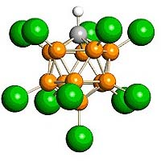

Activity 24: EQUATION BALANCING……….Optional

Until now we have been describing chemical reactions in terms of what is reacting and the products that are formed. In a neutralization reaction we know:

Acid plus base gives a salt and water

Chemists sometimes need to describe the ratio in which chemicals combine. This is what a balanced chemical equation describes.
The steps to writing a balanced chemical equation are:

STEP 1: Identify what type of chemicals the products will be, for example:

Acid plus a base gives a salt and water
STEP 2: Write down the formula of all reactants and products. (Your knowledge of valency will help you write the formula correctly).

EXAMPLE 1:
Hydrochloric acid plus sodium hydroxide gives sodium chloride and water.

HCl + NaOH → NaCl + H₂O

STEP 3: Write numbers in front of the reactant and product molecule so that there is the same number of each type of atom on both sides of the equation.

The example above has the same number of each type of atom on both sides of the equation and therefore is BALANCED. Many chemical reactions, like the example below, require a bit more work before they balance.

EXAMPLE 2:
Balance the equation for the reaction between sulfuric acid and sodium hydroxide.

STEP 1: The reaction is between an acid and a base so the products will be a salt (positive ion from the base and negative ion from the acid) and water.

STEP 2: The salt will be sodium sulfate and since sodium is 1+ and sulfate is 2-, there will be 2 sodium ions to 1 sulfate ion.

H₂SO₄ + NaOH → Na₂SO₄ + H₂O

STEP 3: There are 2 Na⁺ ions on the right side but only one on the left so we need to place a 2 in front of the NaOH. This will tell people that there are 2 NaOH units.
There are 6 oxygen atoms on the left side but only 5 on the right so we put a 2 in front of the H₂O. This will also cause the hydrogen to balance.

H₂SO₄ + 2NaOH → Na₂SO₄ + 2H₂O

The general reactions, which you are expected to know, are:

- Acid + base → salt + water
- Acid + metal → salt + hydrogen gas (H₂)
- Acid + carbonate → salt + water + carbon dioxide (CO₂)

In your notebooks……….
1. Make a copy of the general reactions shown above.
- Try using the steps previously outlined to write balanced chemical equations for the reactions that would occur between the following chemicals:

- Hydrochloric acid + magnesium
- Sulfuric acid + zinc
- Sulfuric acid + magnesium
- Nitric acid + sodium
- Hydrochloric acid + sodium carbonate
- Hydrochloric acid + sodium hydroxide
- Hydrochloric acid + potassium hydroxide
- Sulfuric acid + copper carbonate
- Sulfuric acid + sodium hydroxide
- Hydrochloric acid + calcium carbonate
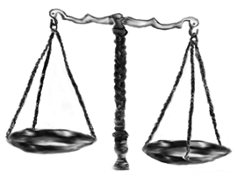
- Sulfuric acid + calcium carbonate

Worksheet: What have you learned?

STATEMENT | TRUE/FALSE
1. The atomic number of an atom is its number of protons
2. The mass number is found by adding the number of protons and neutrons
3. A vertical column of elements in the Periodic Table is called a group
4. Elements in the same group have similar properties
5. Neutrons have a negative charge
6. A normal atom carries no electrical charge
7. An atom that gains an electron becomes a positive ion
8. Ionic solids will form ions when they are in solution
9. An oxygen atom has eight electrons in its outer shell
10. If the formula of a substance is XCl, the valency of X must be +1
11. All non-metals are bad conductors of electricity
12. All metals have a high density
13. Density is calculated by dividing mass by volume
14. All metals can be extracted from their ores by carbon reduction
15. All acids form hydrogen ions in solution
16. All bases form hydroxide ions in solution
17. Sulfuric acid mixed with sodium hydroxide will form sodium sulfate
18. Acids have a pH less than 7
19. A neutralisation reaction always forms a salt
20. Carbon dioxide is given off when a metal reacts with an acid

CHEMISTRY REVIEW
Obtain a copy of this sheet from your teacher and, working in groups, write what you recall about each topic in the boxes.
When two boxes are joined with arrows try to show how the ideas in these boxes are linked together.

Periodic Table
Metals
Electron configuration

Chemical formula
Valency
pH, acids and bases

Chemical reactions

