YEAR 9 FINANCIAL MANAGEMENT
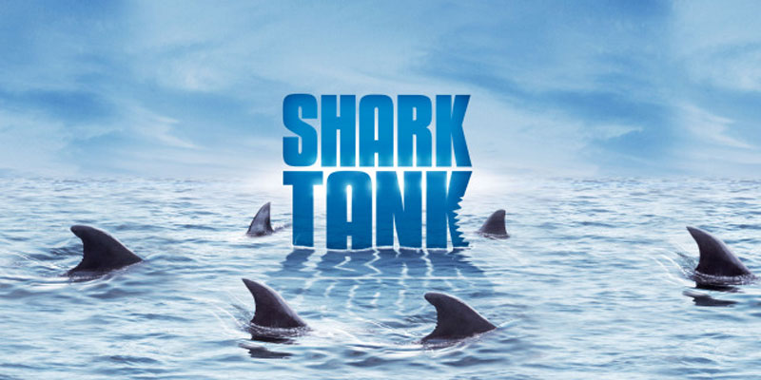
Shark Tank Task

Task
You will be creating a product/service and a business proposal as if you were planning to pitch your idea to the entrepreneurs on the TV show, Shark Tank.
As you create your product/service, think about the episode of Shark Tank we’ve watched in class. What products did the sharks invest in? Why? What products did the sharks reject?

Procedures and Requirements
- You may work individually, or in a group
- Create a unique product/service idea
- Things to consider in your pitch
  - What is your company called?
  - What is your product/service called?
  - Explanation of product/service
  - How much would it cost to manufacture this product?
  - How much would you sell it for?
  - What you expect your profits to be?
  - Who are your target consumers?
  - Who is your competition, and why are you better?
  - Why should the sharks invest in your company?

- Come up with a creative way to pitch your idea to the sharks (class)
- Your presentation will be only 3 minutes
- State how much you require from the sharks (max $500,000) and percentage of business you are willing to offer in return
- Be prepared to answer questions from the sharks (class)

