Biological Science: ECOLOGY NAME
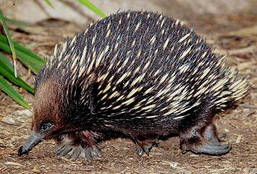

1. Identify what type of adaptation is found in an echidna. How does this adaptation help it to survive?

Physical/structural adaptation. It prevents predators from feeding on it.

The spikes deter predators.
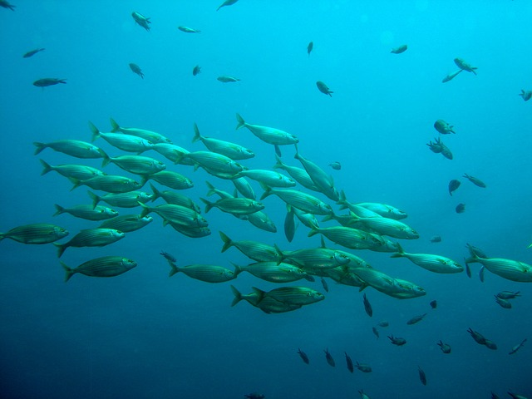

2. What type of adaptation is displayed in a school of fish? How does this adaptation help it to survive?

Behavioural adaptation. Staying in groups minimises the chance

of a fish becoming prey to a predator.

3. Tick which of the following combinations of items from each column correctly describe each type of symbiosis.

a) Mutualism | 1) One organism benefits while the other is unharmed. | i) Leech
b) Parasitism | 2) One organism benefits while the other is harmed. | ii) sucker fish and shark
c) Commensalism | 3) Two organisms benefit each other. | iii) Sea anemone and clown fish

a), 2) and iii) a), 3) and ii)

b), 1) and i) c), 1) and iii)
✓
c), 1) and ii)

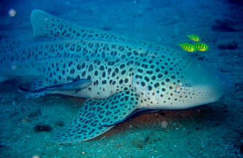
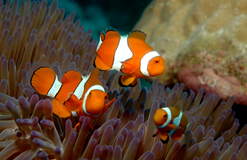
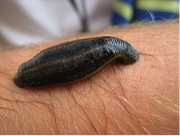
Shark and sucker fish
Sea anemone and clown fish
Leech

- Name each process of the water cycle as indicated by the number. A process may be repeated more than once.

Evapotranspiration condensation percolation
precipitation Evaporation infiltration
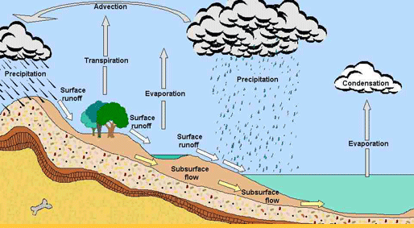
1
2
3
4
5
6
7
8
9

1
2
3
Evaporation condensation precipitation
4
6
5
evaporation transpiration precipitation
9
run-off infiltration percolation
7
8

5. Looking at the food web below, write down ONE food chain that has a Grub in it.

Bird Frog

Spider

Snail Grub Beetle

Fennel Mint
Mint grub spider frog OR mint grub spider bird OR fennel grub spider bird OR fennel grub spider frog

6. What changes would occur in the above food web if the beetle were to disappear?

Population of frogs will be reduced and more mint will grow.

7. Match the following ecological terms with the appropriate definitions, by placing the correct letter in the second column.

Abiotic factor | D | Living component of an environment. | A
Adaptation | F | An organism relying on other food sources to survive. | B
Biotic factor | A | A community together with the abiotic factors, which affect members of the community. | C
Carnivore | J | Non-living part of the environment. | D
Community | E | Interacting populations of different species in a particular place at a particular time. | E
Consumer | B | A feature that helps in survival of an organism. | F
Decomposer | L | Changes made to an environment by one community which allows another community to establish and replace the first community. | G
Producer | I | The position of an organism in a food web. | H
Ecosystem | C | An organism capable of making its own food. | I
Habitat | N | An organism feeding on living animals. | J
Succession | G | Study of interactions between organisms and their surroundings. | K
Trophic level | H | An organism that feeds on decaying matter. | L
Ecology | K | Interacting individuals of one species in a particular place at a particular time. | M
Population | M | An organism’s living place where all its needs are met. | N

8. The interaction of organisms with each other and their environment is known as:

a) interdependence.
b) ecological succession.
c) ecosystem. ✓
d) biosphere.

9. An organism feeds mostly on vegetation and occasionally on insects. It is known as

a) a herbivore.
b) a carnivore.
c) an omnivore. ✓
d) a decomposer.

10. A Community is best described as:

a) one species of organisms living in a particular place.
b) many species living together in a particular place.
c) one species living in a particular place at a particular time.
d) many species living together but not interacting. ✓

11. List two sources of salinity in Australia.

Land clearing and salt blowing from the ocean carried by cyclones.

12. Explain how land clearing can result in salinity.

Trees take up water from the soil and releases it into the atmosphere by transpiration. When trees are cut down, water table under ground rises. With it comes salt dissolved and carried by the water to the surface.

- Explain why it is safer to eat sardine than a shark in a polluted ocean.

Because shark is at the top of the food chain and toxins will accumulate in tissues of every organism across every trophic level and will reach their highest levels or concentrations in the tissues of the apex predator.

- Name a decomposer and state its importance in the food chain.
A fungus or bacterium. It is responsible for recycling nutrients back into the soil for uptake by producers.

- A population can exist in an ecosystem as long as resources are available. Name two other conditions that can affect the size of the population beside resources.
Concentration of toxin in the environment; lack of space; disease; fire.

- Write down a chemical or word equation for photosynthesis.

Sunlight
CO₂ + H₂O C₆H₁₂O₆ + O₂

- Where does the energy come from in the process of respiration?

From the sugar molecule. The energy is stored in the chemical bonds.

- What keeps the size of a population in check so it does not explode?

The presence of predators; food sources; disease; space and build-up of waste.

- What are abiotic factors? Give examples.

Abiotic factors are non-living aspect of the environment. E.g. soil, water, temperature, humidity, rocks, wind, acidity, salinity.

- Decomposers recycle energy from dead organisms. What is wrong with this statement?
Matter is recycled not energy.

- Why biological control is preferable to pesticides?

Pesticides have negative impact on the environment and other living organisms.

- What are some good features of a biological control?

A biological control could be controlled; it does not harm other organisms; it is safe for the environment; it is specific for the pest it is intended to destroy, and it could be engineered so as not to become a pest itself.

- Define biological control and give an example of a successful application.

A biological control is a method of using a living organism to reduce the number of a introduced / pest population. E.g.
Cactoblastis cactorum is used to control the spread of cactus.
Dung beetle is used to control the spread of bush flies.

- Define the term ecology.

The study of organisms in an ecosystem and how they interact with each other and their abiotic environment.

- A farmer wanted to estimate the number of rabbits on his farm. He captured 52 rabbits in one day and tagged them all and released them. Two weeks later he recaptured 75 of which 12 were tagged. How many rabbits did he estimate to have on his farm?

Using the Lincoln index, number of organisms in the first capture is multiplied by number of organisms in the second capture (recapture) then divided by the number of organisms tagged in the second capture. (52 ×75) ÷ 12 = 325 rabbits.

- A farmer is using too much fertiliser on his land. His land is situated 200m from the river. Explain the consequences of his actions on the health of the river.
Overuse of a fertiliser results in the leaching of nutrients into the water and an increase in the population of algae that can grow out of control (algal bloom). This leads to lack of oxygen in the water and death of organisms in the water. Decomposers break down dead organisms thereby using the remaining oxygen in water. Life is not longer supported and collapse of the ecosystem occurs. This process is called eutrophication.

- Explain the effects of land clearing by relating it to the carbon cycle.

Less trees translates to less oxygen produced by photosynthesis;
Less trees means less carbon sinks and therefore more CO₂ in the atmosphere.
Less trees means less habitats present for the organisms and less food resource.
Less trees means rising of water table and therefore salinity.
Less trees means soil erosion as the roots holds the soil together.

- Turtles lay down hundreds of eggs. Why then the ocean is not filled with them?
Because most of the eggs don’t make it to adulthood; instead they get eaten by predators.

- Describe a disadvantage of using biological control.

It can get become a pest itself if it does not have a natural predator to keep its numbers in check.

- The graph below shows three populations of a weed, a grasshopper and a frog. Identify which line represents which population.

A

B

C
Represents frog. Represents weed. Represents grasshopper.

Number of population
Time
A
C
B

23b. Comment on the interaction of populations A and C.
As the population of grasshoppers is decreasing the population of frogs is still on the increase. This is because there is a lag phase before the predator (frog) responds to the declining population of the prey (grasshopper).

24a. Describe the following population size graph
a population inhabits a new habitat, consume resources and expands exponentially, then it stabilises.

No. of population

Time

24b. List three factors that led to the levelling of the curve.
Lack of resources, build-up of toxins and lack of space.

