Yr 9 Revision worksheet

Q1. Fill in the correct missing words from the following word bank:

negative fuse resistor voltage current repel attract

Positively series parallel

Similar charges repel , while opposite charges. attract

Electrons carry a negative charge, while protons are positively charged.

A series circuit is one where electrons flow only in one pathway. A

circuit that has alternate pathways is known as a parallel parallel circuit

A fuse is a thin metal wire that acts as a circuit breaker in the case of voltage
overload.

An electric globe may be called a resistor .

The force of pushing electrons across a conductor is known as voltage.

The flow of electrons through a conductor is known as a current .

Q2. Which of the following combinations of features of a coil results in the greatest
resistance?

a) Short and thin
C
b) Short and thick
c) Long and thin
d) Long and thick

Q3. Which of the following pairs results in an electrostatic charge buildup when rubbed?

a) Glass and wool
B
b) Plastic and fur
c) Iron and plastic
d) Polystyrene and cotton

Q4. Draw the symbols of the following components:

Please remove the see the answer behind

Please remove the see the answer behind
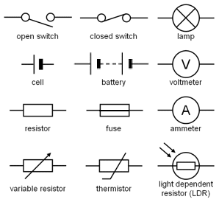
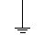
Fuse Earth
Globe Battery
Cell Resistor
Ammeter Switch

Q5. A screwdriver connected two leads and as a result the globes went out. This could
be best explained in that:
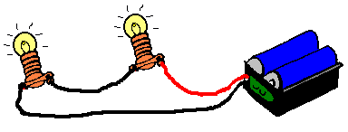
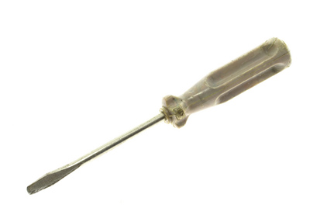

a) The globes burned down as more current went through them.
b) The globes are receiving a current too small to light up.
D
c) The current is directed through the screwdriver.
d) The screwdriver created a short circuit(short pathway).

Q6. Which of the following circuits (A - D) would globe 1 be the brightest?

A B C
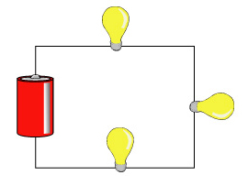

1 1 1
2 4 2

2 3 3

D is the answer. As electrons leave one end of the cell to the other end, current only goes through globe 1 because the wire will provide a path of least resistance for the electrons so they don’t have to go through globe 2 that offers a higher resistance.
D
1

2

Q7. Circle the correct diagram showing a correct wiring of a parallel circuit.

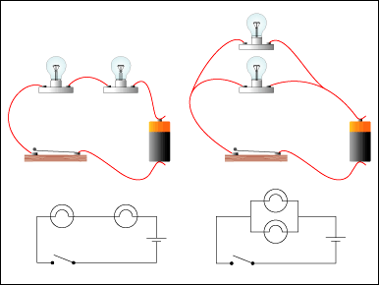

A B C

B is the answer. The cell, switch and globe are all connected in one loop. Then the second globe is connected in parallel to the first globe and the third is connected in parallel to the second globe.

Q8. Name three safety practices to avoid electrocution (electric shock).

Don’t touch an electric tool with wet hands.

Replace frayed electric cables.

Make sure every electric tool is earthed or double insulated.

Q9. State the function of an ‘earth pin’ in a electric plug.

The earth pin provides an alternate pathway for current to go through, therefore, it directs

the current away from your body down to earth, which offers least resistance.

Q10. Determine the current in a circuit that provides 5 ohms of resistance and has 12.5V impressed across it.

V = I x R, therefore, I = V / R; I = 12.5 / 5
I = 2.5 A

Q11. Determine the voltage across globe 1 in the following circuits.

1 1
9V 2 9V 24V
1 2 3

3 2

Voltage = 3 V Voltage = 4.5 V Voltage = 24 V

Q12. List the four methods of producing electricity.

Using a magnet. Move the magnet through a coil and electrons will flow through the coil.

Use the sun. Sunlight is converted to electric energy using a photovoltaic cell.

Use chemicals. Different metals when dipped into a chemical produce electric current.

Use a thermocouple. Heat a thermocouple at one end where two wires are touching and a potential difference will be created that allows a current to flow from one metal end to the other.

Q13. Determine which globes are on and which are off when switches are open or
closed.

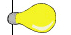
2
1

A B

3 C

A | B |  | C | 1 | 2 | 3
O | C | C |  | Off | Off | Off
C | O | O |  | Off | Off | Off
C | O | C |  | Off | Off | Off
C | C | C |  | Off | Off | Off

14. Given 1 Hertz is the unit measuring once cycle per second, how many hertz does this sound wave represent?

Amplitude
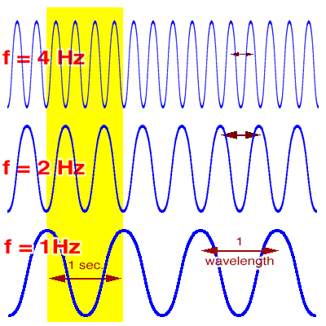
3 cycles per second or 3Hz

1
2
3
4
Time (second)

15. Draw a sound wave that is half as loud as the one shown but has the same pitch.

Amplitude
Amplitude

1
2
1
2
Time (second)
Time (second)

16. By looking at the following diagram answer the following questions.

1

x
y
z

2
3
4

None
a) if only switch 1 is closed which of the three globes will be on?

b) if only switch 3 is left open, which globes will be off?
X and Z are on

17. A scientist wants to investigate what effect changing the resistance in a circuit has on the current in that circuit. She came up with the following data.

Resistance (Ohms) | 1.5 | 2.5 | 4.0 | 5.5 | 7.0
Current (Amps) | 6 | 3.6 | 2.3 | 1.6 | 1.3

a) Draw the graph.
Current
b) What is the dependent variable?
Resistance
c) What is the independent variable?
1.5 A
d) What is the current when resistance is 6 ohms?
2.28 or 2.3 Ohms
e) What resistance is required for a circuit to have a current of 4 A?

