Yr 9 Science – Term 3 Biology Quiz

- Insert the appropriate terminologies from the following word bank into the correct column to show which enzymes act on what substrate and what are the final products.
Fats
Protein
Amylase
Carbohydrate

Lipase
Amino acids
Fatty acids & glycerol
Protease
Glucose

Enzyme | Substrate | Product
Amylase | Carbohydrates | Glucose
Lipase | Fats | Fatty acids & glycerol
Protease | Protein | Amino acids

- Identify the term used to describe organic catalysts.

Enzymes

- Lists four factors that affect the function of enzymes. Describe how 2 of these factors affect rate of reactions.

Temperature; pH (level of acidity); concentration of enzymes; concentration of
substrates.
1) pH: high acidity or low acidity prevents enzymes from working since it affects the binding of enzyme to substrate.
2) Temperature: low temperature slows down the reaction so much that it not noticeable anymore. High temperature denatures the enzyme and changes its structure so the substrate doesn’t fit into its active site.

- Describe the importance of enzymes in the body.

Enzymes speed up the rate of reactions and they are in charge of converting big molecules into smaller ones (for example proteins into amino acids), or making complex molecules from simple ones. Glucose from water and carbon dioxide in photosynthesis.

- Explain what this graph is showing.

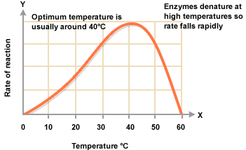

This graph shows how the reaction rate of an enzyme speeds up as temperature increases. But, when it rises past its optimum temperature, the enzyme is denatured and is no longer capable of carrying out its function and the rate of reaction falls.

- Indicate which of the following equations is an example of an anabolic reaction and which is catabolic reaction. Explain your answer.
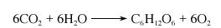
a)

This reaction is an example of an anabolic reaction because it is converting smaller compounds into larger ones. Carbon dioxide and water are chemically bonded together to produce glucose.

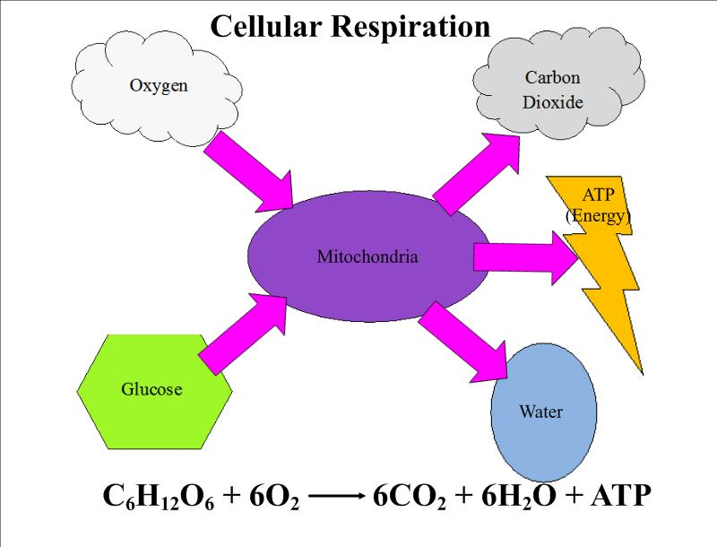
b)

This is an example of a catabolic reaction since it shows a big molecule being broken down to two simpler molecules. Chemical bonds in glucose are broken down to produce carbon dioxide and water.

- Explain how body systems work together to deliver oxygen and glucose to the cells for cellular respiration.

The respiratory system is responsible for bringing oxygen into the lungs.
Oxygen diffuses from the alveoli in the lungs into the blood capillaries.
the circulatory system then carries oxygen in the blood to the cells where it diffuses into the cell.

Glucose is produced as in the digestive system. It diffuses into the villi found in the small intestine. From there it diffuses again into the blood capillaries of the circulatory system and is carried towards the cells where it diffuses into the cell.

Once glucose and oxygen are present in the cell, cellular respiration can be carried out.

- Distinguish between diffusion and osmosis in the following diagrams and state how can you differentiate between the two.
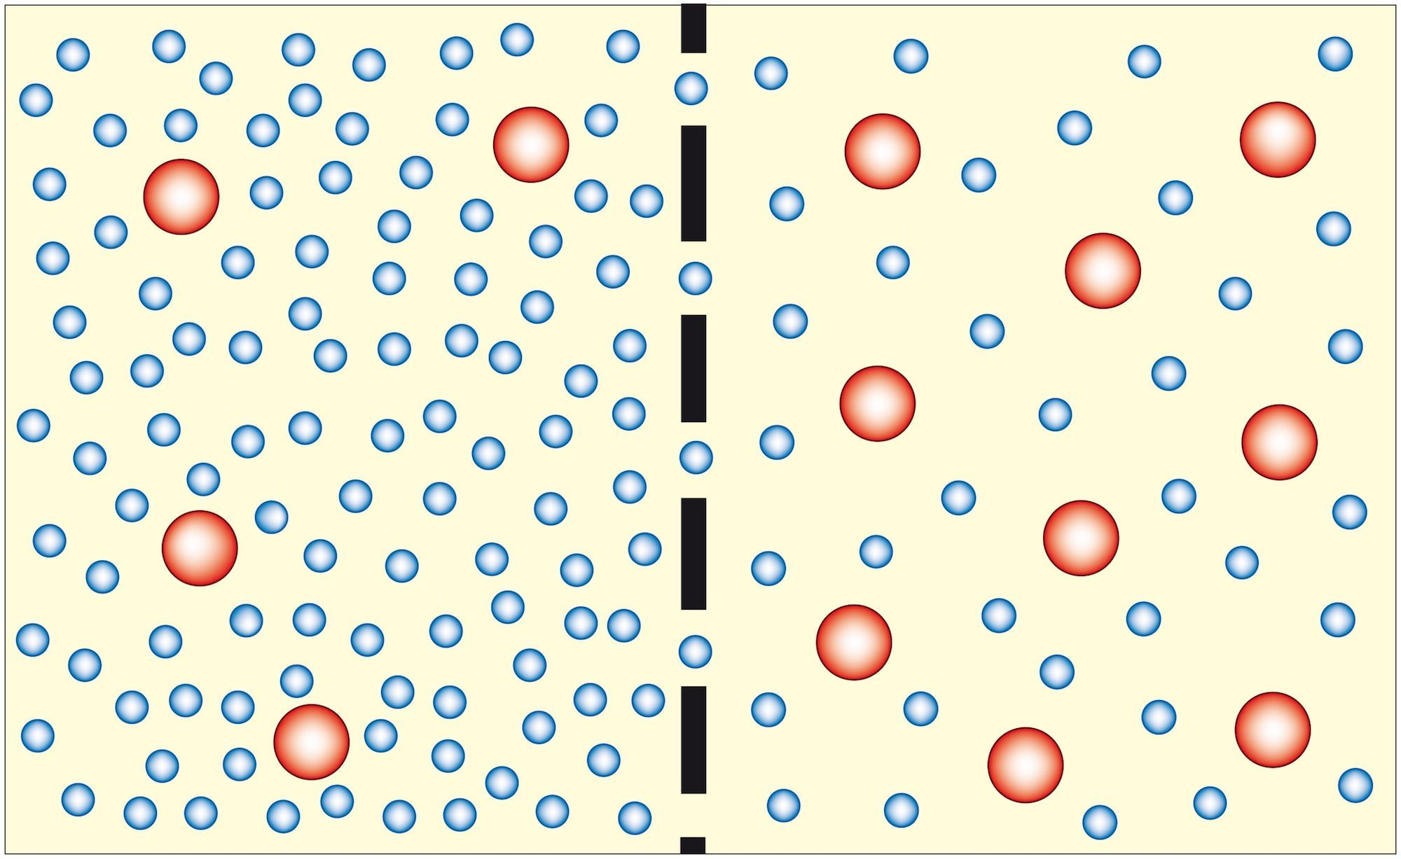
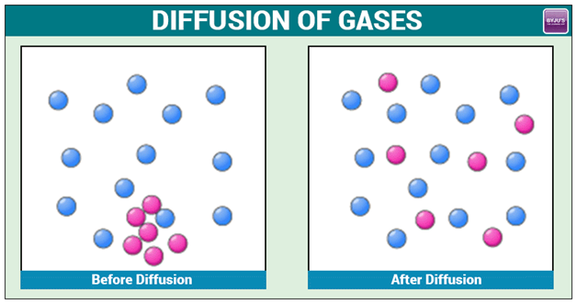
Before
After
A
B
Water
Solute

Figure A. shows movement of small particles of water from an area of high concentration of an area of low concentration across a semi-permeable membrane; therefore it is an example of osmosis.
Figure B. shows movement of particles from an area of high concentration to an area of low concentration, therefore, it is an example of diffusion.

9. Explain what this diagram is trying to tell you.

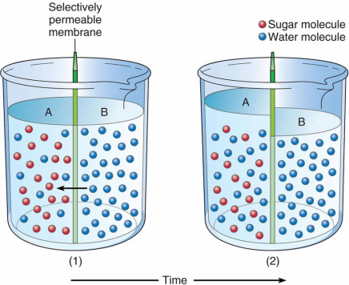

The green membrane is a semi-permeable membrane; it selects what goes through it and what does not. The water (blue) particles in area B in Jar 1 diffuse across the membrane into area A. As a result the volume of the solution in area A increases as shown in Jar 2. This is an example of osmosis.

