HUMAN DIGESTIVE SYSTEM
A flap of skin closes the windpipe as you swallow so that food goes to your stomach, not your lungs.
Chewing mechanically breaks up food into smaller pieces. This exposes more food surfaces for digestion.

TEETH
1
EPIGLOTTIS
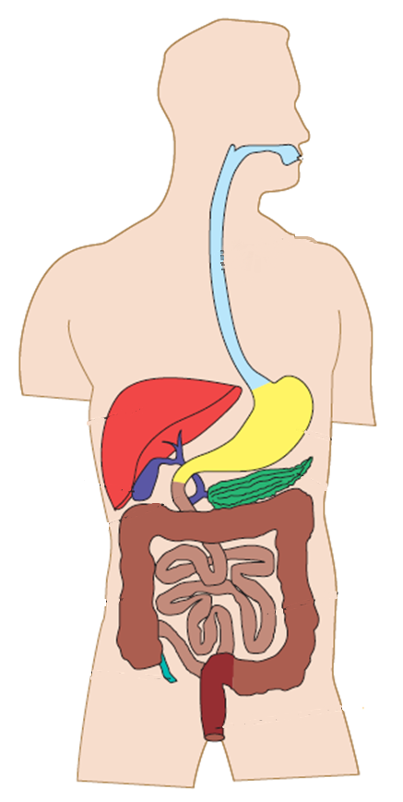
PANCREAS
Not part of digestive tract
8
ANUS
7
6
5
4
3
2
MECHANICAL DIGESTION
CHEMICAL DIGESTION
CONSISTS OF
PERISTALSIS
PERISTALSIS
ABSORPTION
STORES
REABSORPTION
BACTERIA
FOLDS which increase the surface area of the inner wall. Intestine is shorter (1.5m) than small intestine but a lot wider.
Water and vitamins are absorbed into blood stream. Consequently the contents become more solid. Mucus is secreted .for lubrication
Live In the intestine and break down remaining organic compounds. Some produce vitamins which are absorbed.
LARGE INTESTINE
SECRETES
DUODENUM
Start of Small Intestine
RECEIVES
PRODUCES
SMALL INTESTINE
SECRETES
SECRETES
MUSCLES
LINED WITH

No apparent digestive function in humans.
Its muscular wall continues to squeeze and churn food mixing it and breaking down further.
BILE through bile duct and

PANCREATIC JUICE through pancreatic duct.
INTESTINAL JUICE which contains enzymes which break down sugars, fats and peptides.
BILE: a greenish liquid which breaks up fat like a detergent does when washing dishes. Secreted into Duodenum.
APPENDIX
Not part of digestive tract
EXPELS

Lumps of faeces known as stools.

STORES
RECTUM
GALL BLADDER
Not part of digestive tract
STOMACH
LIVER
Not part of digestive tract
OESOPHAGUS
The long muscular tube carries food from mouth to stomach. The muscles contract rhythmically pushing the bolus downwards.
Glucose, Fatty acids, Glycerol & Amino acids are absorbed into blood stream. Intestine is long and narrow (6m in length)
VILLI which are microscopic fingers. They are well supplied with blood vessels and increase surface area of the wall.
PANCREATIC JUICE which contains enzymes which break down starch, sugars, fats and proteins.
GASTRIC JUICES which contains Hydrochloric acid, mucus and enzymes which break down proteins.
Waves of contraction churn food mechanically. Stores food as it is eaten and absorbs some drugs including alcohol.
Forms food into a rounded lump called a bolus and pushes it to the back of the mouth for swallowing.

MOUTH
SALIVA
Contains salivary enzymes, which begin starch digestion and mucus, to lubricate food. Dissolved food can be tasted.
TONGUE

