ACIDS and BASES

Acids are chemicals that contain at least one hydrogen atoms. Examples are:

Source | Name | Formula
Stomach | Hydrochloric acid | HCl
Soft drink | Carbonic acid | H₂CO₃
Yoghurt | Lactic acid | C₃H₆O₃
Citrus | Citric acid | C₆H₆O₇
Vinegar | Ethanoic acid | CH₃COOH
Grapes | Tartaric acid | C₄H₆O₆
Green apples | Malic acid | C₄H₆O₅
Rhubarb | Oxalic acid | C₂H₂O₄
Vitamin C | Ascorbic acid | C₆H₈O₆
Car battery | Sulfuric acid | H₂SO₄

Properties of acids:

Acids are sour in taste and can burn if they are strong.
They turn blue litmus paper red.
They turn universal indicator red.
They react with metals to produce hydrogen gas.
They react with bases to produce water and salt.

Strong acids | Weak acids
Hydrochloric acid | Ethanoic acid
Nitric acid | Phosphoric acid
Sulfuric acid | Carbonic acid

Bases are chemicals that are mainly the oxides, hydroxides and carbonates of metals. They are regarded as the ‘opposite’ of acids.

Use | Name | Formula
Mortar | Calcium hydroxide | Ca(OH)₂
Soap | Sodium hydroxide | NaOH
Glass cleaner | Ammonia | NH₃

Properties of bases:

Bases are bitter in taste and feel slippery to touch.
They turn red litmus paper blue.
They turn universal indicator blue.
They react with acids to produce water and salt.

pH scale

The pH indicates whether the substance is acidic, neutral or alkaline.
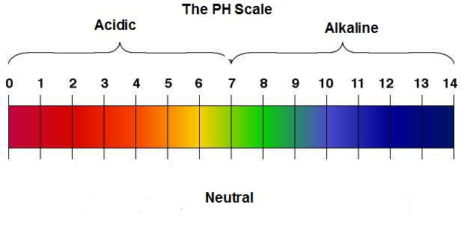

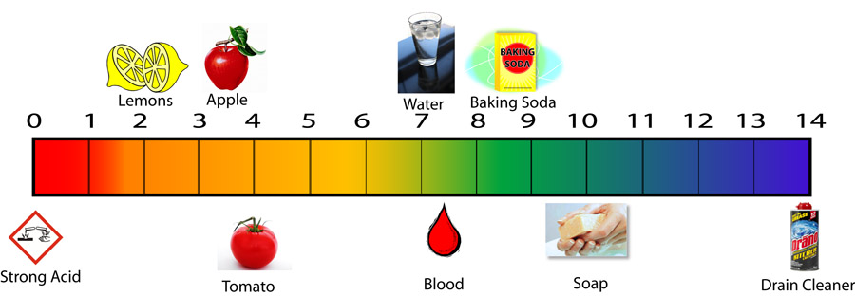

Questions

- List four properties of acids.

- Write down Four types of acids and where you would find them.

- What makes and acid an acid?

