Radioactivity

- List two features of radioactive decay.

- Define a radioactive element and give an example.


- What type of radioactive particle does the following diagram represents? Justify your answer.

- Using your periodic table, determine which of the following radioactive isotopes (a) or (b) decay to release a beta particle? How can you prove it?
241
93
237
14
14
6
7
95
Am
C
Np
N
(a)

(b)

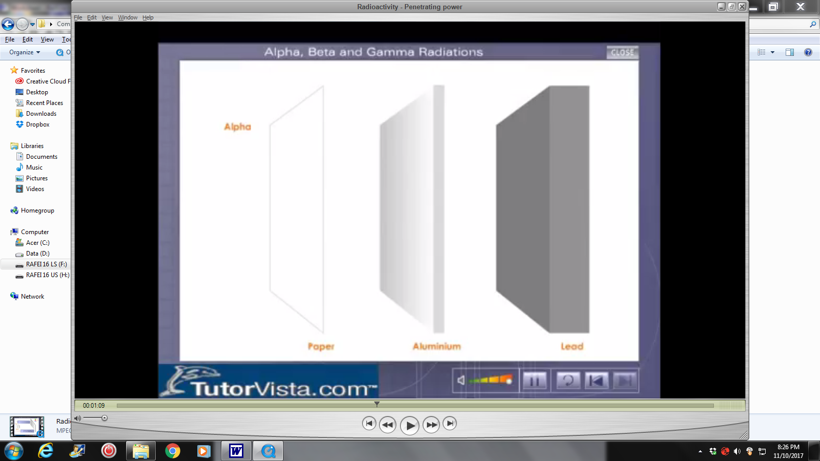
- Draw three arrows to demonstrate how far can alpha, beta and gamma radiation travel.
Paper aluminium lead
α
β
γ

- Describe the reason behind alpha’s inability
to penetrate objects.

