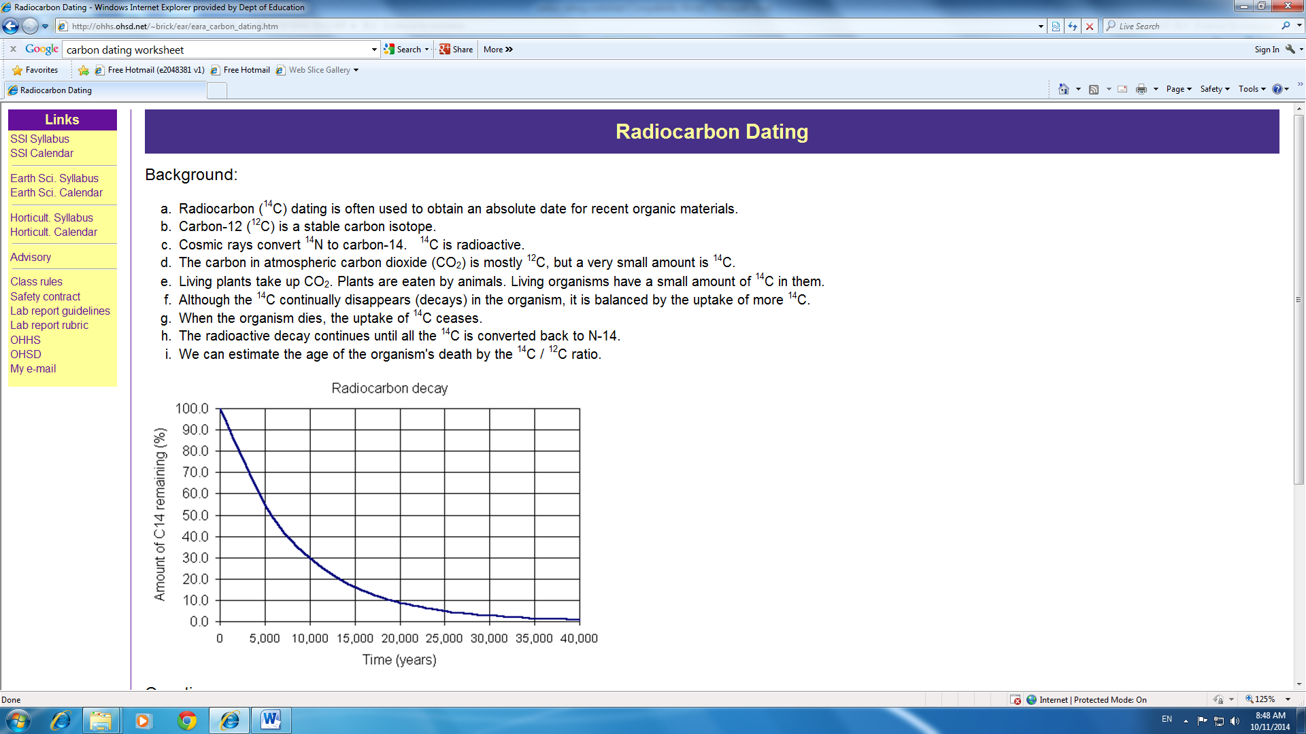
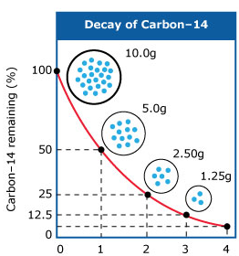
RADIOACTIVITY

When radioactive isotopes decay they do so at a constant rate.
Carbon-14 decays into nitrogen-14 releasing a beta (β) particle (electron).
A half-life is the period of time taken for half the carbon-14 to decay into nitrogen.
The half-life of carbon-14 is 5730 years. Therefore, every 5730 years, half of the radioactive material decays and 50% remains. After another 5730 years, 50% of the remaining radioactive isotope decays and 25% remains.

DATING METHOD
Using a decay graph, it is possible to calculate the age of a fossil by determining the ratio of carbon-14 to carbon-12. This will give us the percentage of carbon-14 remaining. By drawing a horizontal line from the Y-axis until it makes contact with the curve then extending the line perpendicular to the X-axis you can tell the period of time that has elapsed since the death of an organism. This is known as the carbon-14 dating method.

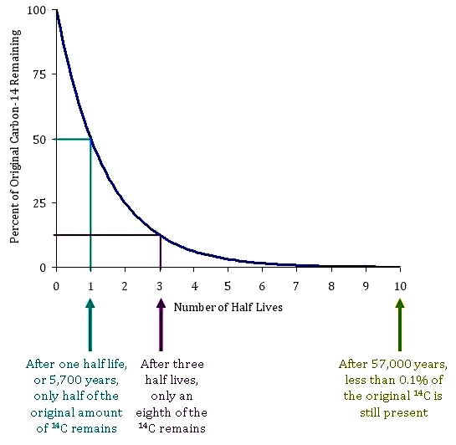

Figure 1. Carbon-14 decay curve.

Questions

- What is meant by the term ‘half-life’?

- How many years does it take for 50% of carbon-14 to decay?

- How many years until only 10% of carbon-14 is left?

- If you have a plant specimen with 25% of its carbon-14 left, how many half-lives have passed?

- How old in years would this plant specimen be?

- Explain why is it that carbon-14 cannot be used to date a fossil older than 70000 years.

