Chemistry Test Revision

1. Find the atomic number and mass number for each of the following elements.

186 atomic number: 75
Re mass number: 186
75 number of electrons: 75
number of neutrons: 111

238 atomic number: 92
U mass number: 238
92 number of electrons: 92
number of neutrons: 146

2. Write down the symbols and valencies of the following ions:

Carbonate CO32- Nitrate NO3-

Hydroxide OH- Oxide O2-

Sulfate SO42- Chloride Cl-

Sulfide S-2 Iodide I-

Ammonium NH4+ Acetate CH3COO-

3. Write down the symbols and valencies of the following metal ions:

Potassium K⁺ Aluminium Al3+

Calcium Ca2+ Lead Pb2+

Silver Ag+ Lithium Li+

Magnesium Mg2+ Sodium Na+

Zinc Zn2+ Iron Fe2+

Copper Cu2+ Manganese Mn2+

4. Find the name of an element in the periodic table that is located in:

group 2, period 4 Calcium group 6, period 3 Sulfur

group 7, period 4 Bromine group 7, period 2 Fluorine
5. Complete the table by putting in the formulae. The first one has been done for you.
 | Negative Ions
Positive Ions | Chloride | Oxide | Carbonate | Nitrate | Sulfide
Potassium | KCl | K₂O | K₂CO₃ | KNO₃ | K₂S
Ammonium | NH4Cl | (NH4)2O | (NH4)2CO3 | NH4NO3 | (NH4)2S
Calcium | CaCl2 | CaO | CaCO3 | Ca(NO3)2 | CaS
Lead | PbCl2 | PbO | PbCO3 | Pb(NO3)2 | PbS
Aluminium | AlCl3 | Al2O3 | Al2(CO3)3 | Al(NO3)3 | Al2S3

6. What is an isotope?

An isotope is an element with same number of protons but different number of neutrons.

7. Given that Isotopes of an element possess the same number of protons, draw the three isotopes of carbon with their nucleus and electron shells, given carbon-12 has 6 protons and 6 neutrons.

Remove to reveal answer
Remove to reveal answer
Remove to reveal answer

Carbon-12
Carbon-13
Carbon-14

8. List four features of acids.

They have a low pH

They donate hydrogen ion

They taste sour

They turn universal indicator / litmus paper red

9. What is a pH scale?

10. Complete the following table

Symbol | Name | Atomic  Number | Mass Number | Number of Neutrons | Number of electrons | Electron configuration
14  N  7 | Nitrogen | 7 | 14 | 7 | 7 | 2,5
23  Na  11 | Sodium | 11 | 23 | 12 | 11 | 2,8,1
23  Na⁺  11 | Sodium ion | 11 | 23 | 12 | 10 | 2,8
35  Cl⁻  17 | Chloride | 17 | 35 | 18 | 18 | 2,8,8
27  Al³⁺  13 | Aluminium ion | 13 | 27 | 14 | 10 | 2,8

11. Write the formula for these ionic compounds

a) sodium chloride NaCl f) aluminium sulfide Al₂S₃

b) silver carbonate Ag₂CO₃ g) copper(II) nitrate Cu(NO3)22
c) calcium iodide CaI₂ h) potassium oxide K₂O

d) lead hydroxide Pb(OH)2 i) aluminium sulfate Al2(SO4)33

e) zinc oxide ZnO k) magnesium fluoride MgF₂

12. Identify the following as acidic, neutral or alkaline.

pH 6.5 acidic pH 11.9 alkaline
pH 12.3 alkaline pH 2.5 acidic
pH 7 neutral pH 7.9 alkaline

13. Name these compounds

a) MgCl₂ magnesium chloride

b) NH₄NO₃ ammonium nitrate

c) ZnI₂ zinc iodide

d) Pb(NO₃)₂ lead nitrate

e) (NH₄)₂CO₃ ammonium carbonate

f) KOH potassium hydroxide

g) CuS copper sulfide

14. Balance the following chemical equations by inserting the correct coefficient.

2 H₂ + 1 O₂ 2 H₂O

2 Na + 2 H₂O 2 NaOH + 1 H₂

1 N₂ + 3 H₂ 2 NH₃

2 HCl + 1 Mg(OH)₂ 1 MgCl₂ + 2 H₂O

15. Write the formula for three strong acids.

sulfuric acid (H₂SO₄)
nitric acid (HNO₃)
hydrochloric acid (HCl)

16. Acid can be diluted or concentrated. Which of the following is a concentrated acid?

1M HCl 0.5M HCl 4M HCl Answer: 4M HCl

17. Which solution will be more acidic, 1M HCl (hydrochloric acid) or 1M CH₃COOH (acetic acid)? Explain your answer.

1M HCl is more acidic because it is a strong acid, meaning it will release all the hydrogen ions
making the solution more acidic with low pH.
1M CH₃COOH is less acidic because it releases less hydrogen ions meaning not all the hydrogen
ions are released from the acid molecule, thus making the solution less acidic than 1M HCl.

18. List three common household items that are acidic.

Any of these: lemon, apples, vinegar, soft drink, yoghurt, tomatoes and vitamin C tablets.

19. List three common household items that are alkaline.

Any of these: bleach, caustic soda, baking soda, ammonia, detergent, soap.

20. Calculate the atomic and mass numbers of each of the following elements after decay.

238
U undergoes alpha decay atomic number: 90 mass number: 234
92

14
C undergoes beta decay atomic number: 7 mass number: 14
6

241
Am undergoes alpha decay atomic number: 93 mass number: 237
95

137
Cs undergoes beta decay atomic number: 56 mass number: 137
55

21. Complete the following decay equations to show what type of radiation is emitted.

60
60
Co Ni Beta
27
28

222
218
Ra Rn Alpha
88
86

22. Describe the structure of an:

Alpha particle: made up of two neutrons and two protons.

Beta particle: made up of an electron

23. Describe the type of chemical reaction this graph is depicting and explain your choice.
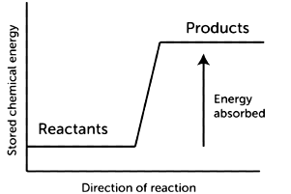
This is an illustration of an endothermic reaction. This is because energy is absorbed by the reactants from the surroundings in order to make the products. The products have a higher energy level than the reactants.

24. Assign electrons to these elements using your knowledge of electrons shells and configuration.
Remove to reveal answer
Cl
Cl

Al
Al
Remove to reveal answer

25. Fermium-253 is a radioactive element with a half-life of three (3) days. That means after three days half the amount of Fermium atoms will decay. A scientist obtained a sample of fermium and found out that it contains 10540 atoms.

- How many atoms would remain after one half-life? (10540/2 = 5270 atoms).

- How many atoms would remain after 15 days? (15/3= 5 half-lives = 329.4 atoms).

- How many half-lives have passed if only 1/16th of the amount remained? 4 half-lives.

26. The following decay graph is for carbon-14. Using the graph answer the following questions.
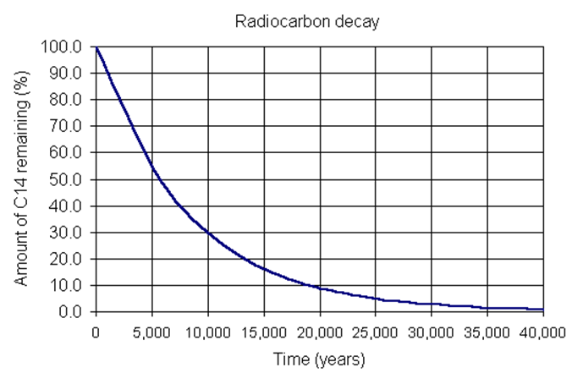

Given the half-life of carbon-14 is 5730 years,

(a) What percentage of carbon-14 remains after 17190 years? (17190/5730=3 ∴ 12.5 %)
(hint: you don’t have to use the graph to get the answer.)

(b) How many years have passed for 40% of carbon-14 to remain? ≈7500 years.

(c) how many years have passed when 70% of carbon-14 have decayed? 10000 years.

(d) How much carbon-14 remains after 3700years of decay? 65%

END

