FUELS
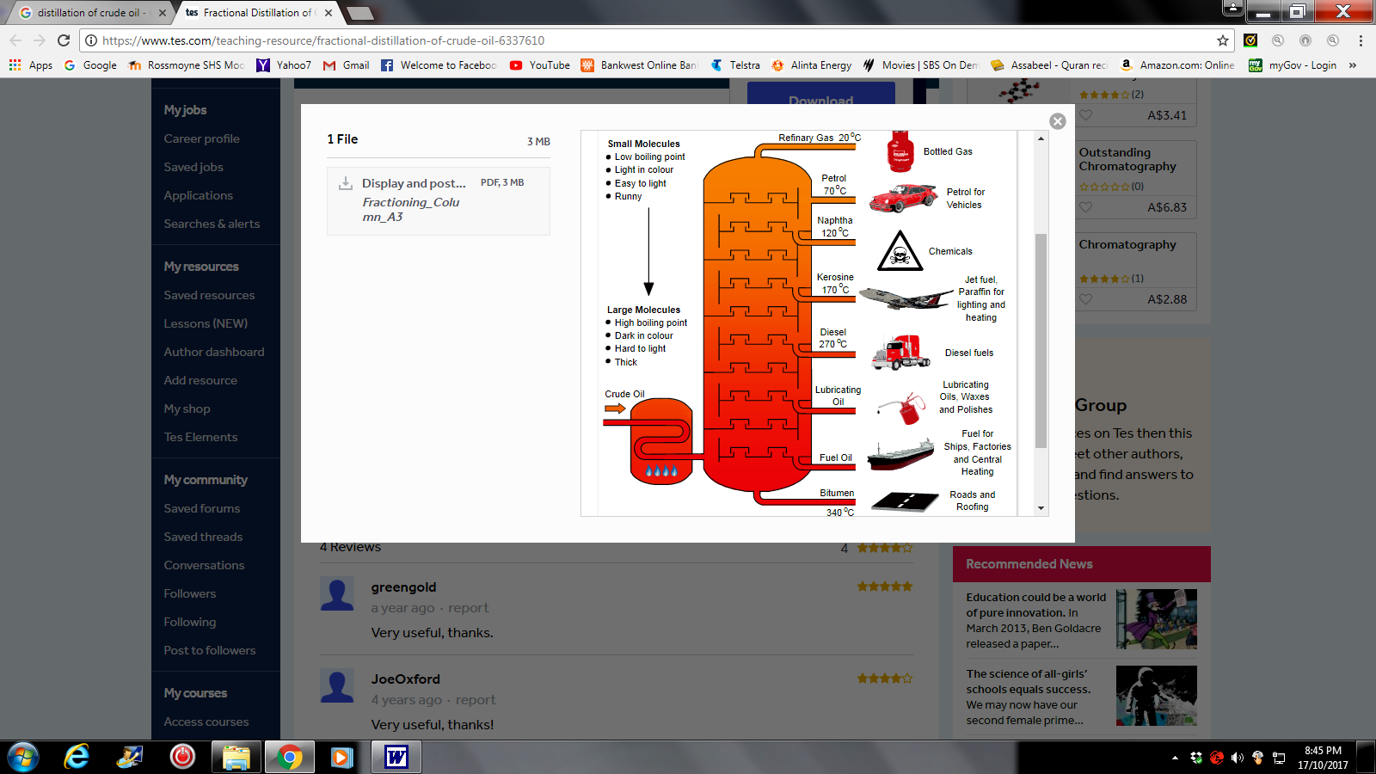
Fuels are substances that are burnt to produce energy and heat, generate electricity and run motors and generators as well as vehicles.

Fuels are a class of hydrocarbons. They are made of carbon and hydrogen atoms.

Crude oil is a fossil fuel that can be distilled to produce other types of fuels such as: petrol, diesel, kerosene and methane gas to name a few.

Natural gas is used in stoves and hot water systems, whereas, petrol, diesel and kerosene are used in vehicles, generators and aircraft.
Power stations use coal and natural gas to heat water to steam, which is used to turn turbines that generate electricity.

Alcohol and Biofuel
Alcohol is used in car fuels and can make up to 10% of the natural gas. The simplest forms of alcohol are methanol and ethanol. Both are made up of carbon, hydrogen and oxygen.

Alcohol combust just like natural gas to produce water, carbon dioxide and energy.
Ethanol + Oxygen carbon dioxide water Energy
C₂H₅OH(l) + 3O₂(g) 2CO₂(g) + 3H₂O(g) + (ATP)

An advantage of using alcohol as a fuel is that it is a ‘clean’ fuel that does not produce pollutants; only water and carbon dioxide. Another advantage is that it is renewable resource and can be obtained any time.
Alcohol can be produced by fermentation of sugars in the sugar cane as well as plant material such as wheat stubble and cornhusks. This is known as Biofuel because it is made from biological processes rather than oil, which, is made by geological processes.

Disadvantages of Biofuels are loss of agricultural land, which can result in food insecurity, hunger and poverty, and, the loss of trees that are cleared to make space for the Biofuel crops.

Questions

- What is a fuel?

- How alcohol is produced?

- Classify the following as hydrocarbons, alcohol or neither.

CH₄ H₂
C₄H₁₀ C₂H₅OH

- Petrol and ethanol were originally derived from living plant material. However, only ethanol is described as a Biofuel. Explain why.

- What are two advantages of Biofuels?

- What are two disadvantages of Biofuels?

