Some human variations
INHERITED CHARACTERISTIC | MY PROFILE | NUMBER OF STUDENTS WITH THIS FEATURE WITHIN THE CLASS | PERCENTAGE OF MY CLASS HAVING THIS CHARACTERISTIC
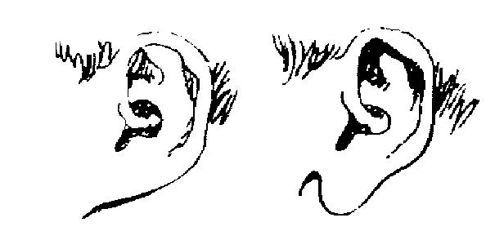

Ear lobe attached unattached
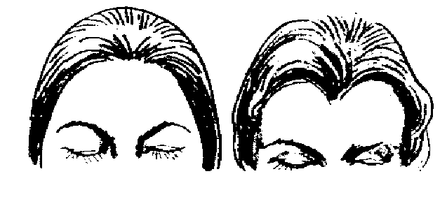

Widow’s peak absent present
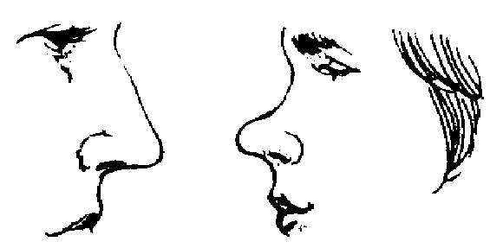

Straight nose Upturned
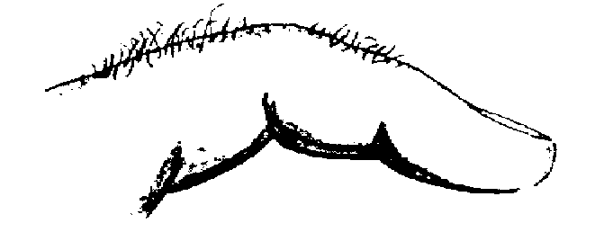

Hair between 1st & 2nd finger joints
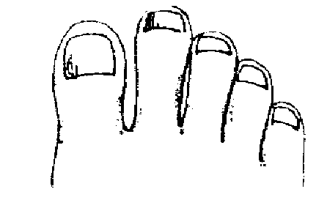

Second toe longer than big toe
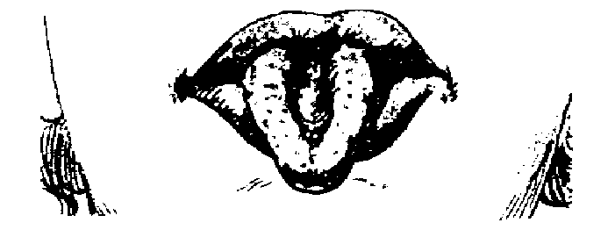

Tongue rolling ability present/absent
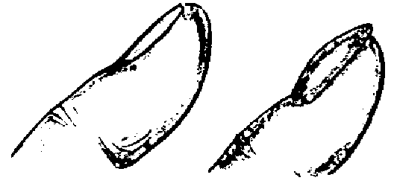

Flat fingernails Domed
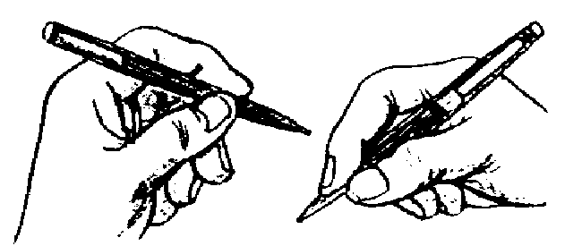

Left handed Right handed

