Mitosis

Background
Cells in your body have only a limited life-time. They are constantly wearing out and dying and have to be replaced. The replacement cell has to be much the same as the original cell because it has to do the same job. Mitosis is the process that produces these replacement cells.
Mitosis is also the process by which all single celled plants and animals reproduce asexually

Objectives
After finishing this exercise you should be able to:
- Describe the sequence of events that happen during mitosis.
- Explain the importance of mitosis.

The process of mitosis can be described according to the behaviour and appearance of the chromosomes. IPMAT is a mnemonic to help you remember the names for the stages of mitosis.

Interphase is when the cell is going about its normal functions. During this time of normal functioning, the chromosomes are making a copy of themselves but they are not coiled and can not be seen.

Prophase is when the chromosomes coil tightly and become thicker and visible. Spindle fibres grow from the centrioles and they move to either side of the nucleus.

Metaphase is when the spindle fibres attached to the centrioles of the chromatids pull the chromosomes to the center of the nucleus.

Anaphase is when the pair of chromatids which make up each chromosome are pulled apart allowing one of each chromosome copy to be drawn to each side of the nucleus.

Telophase is when the nuclear membrane encapsulates each of the two groups of chromosomes in the cell.

Cytokinesis then takes place where the cell membrane moves in through the center of the cell trapping a nucleus in each of the daughter cells that form.

Questions
- What is the name is given to the identical parts of each chromosome?
- What is the name of the central part of a chromosome which holds the two identical threads together?

- Look at the photograph of human chromosomes to see how chromosomes really appear.
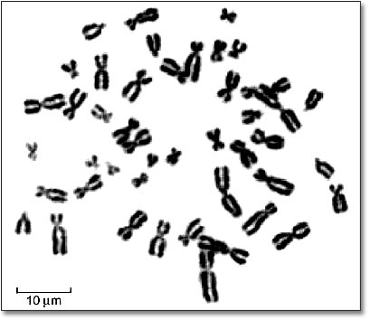
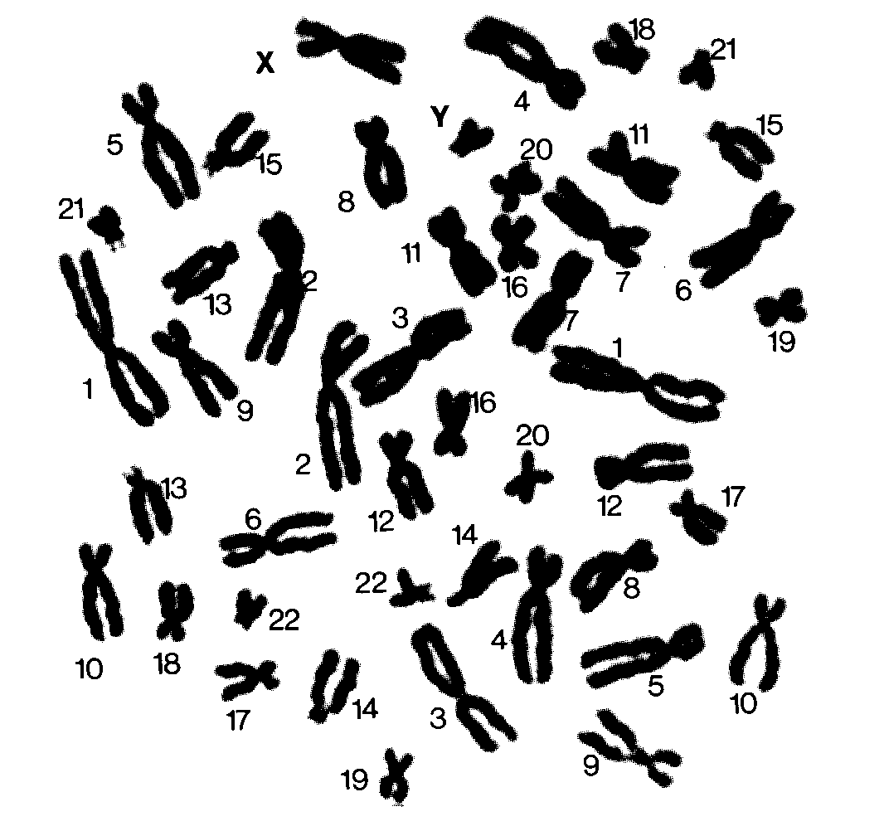

1. Chromosomes of a human male 2. Chromosomes of a human female

- How many chromosomes are there in a normal human cell?
- In a human cell, how many chromosomes would you expect to see across the equator of a
cell during the metaphase stage of cell division?
- Mitosis forms two daughter cells. How do they compare with the parent in terms of the number of chromosomes present?

- Why is it important that each daughter cell is an accurate copy of the parent cell?

Move the pictures so they show the correct sequence of mitosis

I | 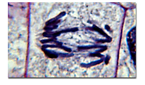
P | 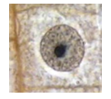
M | 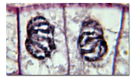
A | 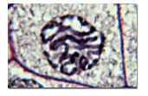
T | 