Dividing Cells

Livings things that are made up of only one cell are called unicellular (uni means one). Bacteria are an exapmle of a unicellular organism. Other living things such as humans are made of millions of cells. They are called multicellular organisms (multi means many).
In multicelluar organisms, all the cells work together but they do not all do the same thing. Cells are specialised to perform a special task in the body.

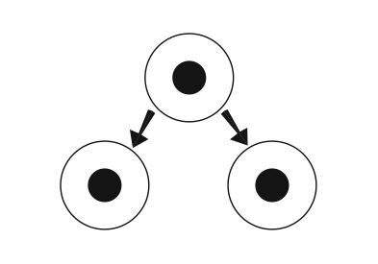
Unicellular organisms reproduce by their cell dividing to produce two identical cells. This results in two new organisms. Multicelluar organsisms grow because existing cells can divde to produce new cells. This type of cell division is called mitosis.

From Cells to Organisms

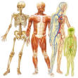

Finish the sentences below using the word list: system, living things, organ, tissue.
- Cells are the basic building blocks of all .
- Groups of cells that carry out a specialised job are called .
- Many tissues working together make up an .
An example of this is the lungs.
- A lot of different organs working together make up a .
The circulatory system is an example of this.

Fill in the blank spaces in the following table of systems in the human body:

Systems in the human body
Name of system | Main organs in the system | Main functions
digestive system | gut, liver, pancreas, and gall bladder
respiratory (breathing) system |  | to take in oxygen and get rid of carbon dioxide
circulatory (blood) system |  | to carry oxygen and food around the body
excretory system | kidneys, bladder and liver | to get rid of poisonous waste substances
sensory system |  | to detect stimuli
nervous system | brain and spinal cord | to conduct messages from one part of the body to another
musculo-skeletal system | muscles and skeleton
reproductive system | testes and ovaries | to produce offspring

What is meant by saying an animal or plant is multicellular?

In what ways can cells be different from each other? Why are they different?

