Respiratory Worksheet

Q1. Tick each sentence whether it is true or false.

Oxygen diffuses twice to get into the cells.

When the diaphragm contracts it moves upwards, compressing the lungs.

The trachea, bronchi and bronchioles all have cartilage in their lining.

The more alveoli present in the lungs the more surface area for gas diffusion.

The rate of breathing increases when you are exercising.

The air exhaled does not contain oxygen.

The air reaches the larynx first before the pharynx when breathing in.

Emphysema is a condition whereby surface area is increased.

Q2. Rearrange the following sentences in the correct order to illustrate the process of exhalation .

This in turn places a large amount of pressure inside the lungs.

Diaphragm muscle and intercostals muscles relax.

Air escapes from mouth and nostrils.

There is a reduction of volume of the thoracic cavity.

Diaphragm assumes it dome-shaped structure.

Air pressure in lungs is higher than air pressure outside lungs.

Air flows from high to low pressure gradient.

Q3. By referring to the two diagrams below A and B, state which diagram shows inhalation and which shows exhalation by writing on the provided space.

A
B

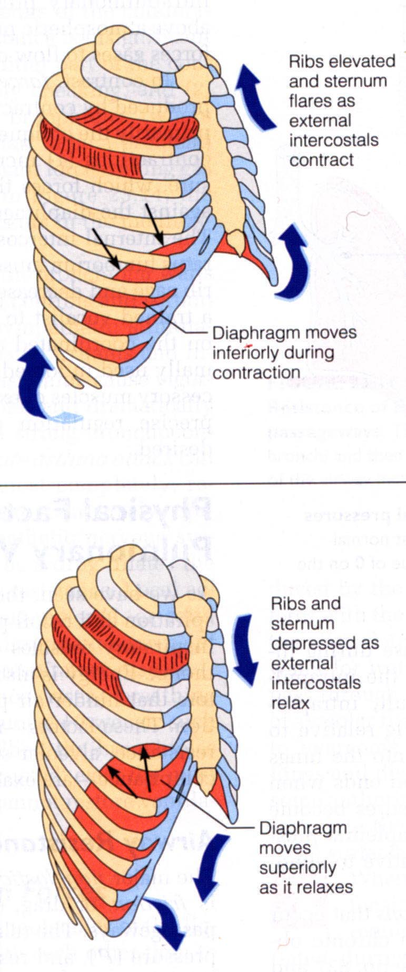

__________________________ __________________________

Q4. Using the terms diaphragm, volume and pressure explain how air gets into the lungs when a person inhales.

__________________________________________________________________________________________________________________________________________
__________________________________________________________________________________________________________________________________________

__________________________________________________________________________________________________________________________________________

