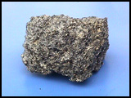
Types of Rocks
Fundamentals of Science 1, page263-264

There are three types of rocks: I , s and m .

I__________________ Rocks
I rocks are formed by the cooling of m earth materials.
Molten material beneath the Earth’s surface is called . Molten material on the Earth’s surface is called . M and lava to form igneous rocks.

What to look for.

Examples: Fast Cooling – P and O .
Slow cooling – G .

S_____________ Rocks
S rocks are formed from together down materials from rocks.

What to look for.
- G of s .
- l .
- f .

Examples: L , s and sh .

M__________________ Rocks
M Rocks are formed when other rocks experience h or p or both.

What to look for:
- L D Coloured C

Examples:

Original Rock | Metamorphic Rock
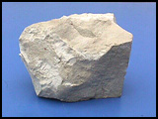  Limestone | 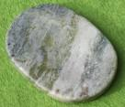
Granite  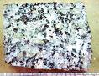 | 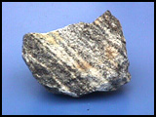
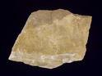 | Quartzite  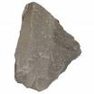
Shale or Mudstone  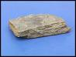 | 