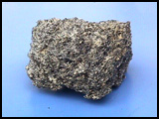
Types of Rocks
Fundamentals of Science 1, page263-264

There are three types of rocks: Igneous, Sedimentary and
Metamorphic.

Igneous Rocks
Igneous rocks are formed by the cooling of molten earth materials.
Molten material beneath the Earth’s surface is called magma. Molten material on the Earth’s surface is called lava. Magma and lava cool to form igneous rocks.

What to look for.
- Interlocking crystals
- Hard and compact

Examples: Fast Cooling – Pumice and Obsidian.
Slow cooling – Granite .

Sedimentary Rocks
Sedimentary rocks are formed from cementing together broken down materials from old rocks.

What to look for.
- Grains of sand
- Layers of silt
- Fossils

Examples: Limestone, sandstone and shale.

Metamorphic Rocks
Metamorphic Rocks are formed when other rocks experience heat or pressure or both.

What to look for:
- Layers of Different Coloured Crystals (called lines of foliation)

Examples:

Original Rock | Metamorphic Rock
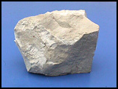  Limestone | Marble  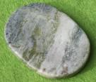
Granite  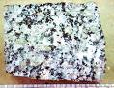 | Gneiss  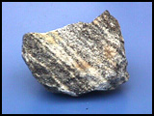
Quartz sandstone  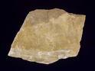 | Quartzite  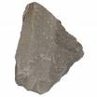
Shale or Mudstone  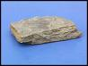 | 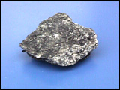  Schist

