8.2 Chemical Sciences

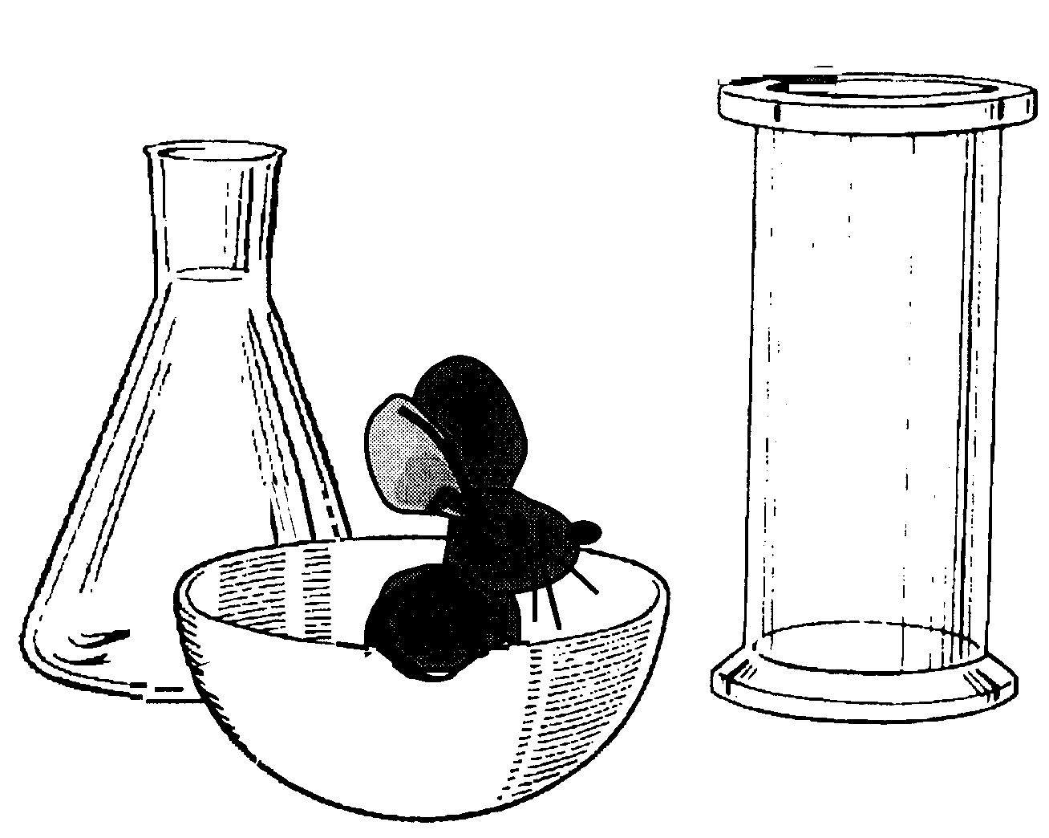

Chemical Sciences
COURSE DESCRIPTION:
This course extends the study of chemistry by looking at the following:

- The properties of the different states of matter can be explained in terms of the motion and arrangement of particles
- Differences between elements, compounds and mixtures can be described at a particle level
- Chemical change involves substances reacting to form new substances
CONTENTS
Chemical Sciences Learning Objectives 2
Activity 1: Matter for a Chemist 3
Activity 2: Changing a Solid to a Liquid 4
Activity 3: Changing a Liquid to a Gas. 5
Kinetic Theory of Matter 7
Activity 4: Iced Bananas 8
Activity 5: Elements and Atoms 10
Activity 6: Symbols for the Elements 11
Activity 7: The Periodic Table 13
Activity 8: Molecules 15
Activity 9: Mixtures & Compounds 16
Activity 10: Review of Elements, Mixtures & Compounds 20
Activity 11: Chemistry in Short 22
Activity 12: Rules for Naming Compounds 23
Activity 13: Formulae of Compounds 24
Activity 14: Physical and Chemical Changes 25
Activity 15: Observing Some Chemical Reactions 27
Activity 16: Changing Partners! 29
Activity 17: Preparation of Carbon Dioxide 31
Investigation: Speedy CO₂! 33
Activity 18: Preparation of Oxygen Gas 34
Activity 19: Preparation of Hydrogen Gas 38
Activity 20: Oxygen and Rust 40
Review: Chemical Sciences 41

Chemical Sciences Learning Objectives

After you have completed this course you should have an awareness of the following:

The properties of the different states of matter can be explained in terms of the motion and arrangement of particles:
- explaining why a model for the structure of matter is needed
- modelling the arrangement of particles in solids, liquids and gases
- using the particle model to explain observed phenomena linking the energy of particles to temperature changes

Differences between elements, compounds and mixtures can be described at a particle level:
- modelling the arrangement of particles in elements and compounds
- recognising that elements and simple compounds can be represented by symbols and formulas
- locating elements on the periodic table

Chemical change involves substances reacting to form new substances:
- identifying the differences between chemical and physical changes
- identifying evidence that a chemical change has taken place
- investigating simple reactions such as combining elements to make a compound
- recognising that the chemical properties of a substance, for example its flammability and ability to corrode, will affect its use

VOCABULARY LIST

Melting
Boiling
Evaporating
Condensing
Energy
Temperature
Separation
Sublimation
Element
Atom
Compound
Molecule
Physical
Chemical
Lattice
Formula
Equation
Reaction

Activity 1: DO SOMETHING NEW!

Activity 2: Changing a Solid to a Liquid

When a substance changes from a solid to a liquid then to a gas, a change of state is said to have occurred.
AIM:
To observe what happens when a solid changes to a liquid.

MATERIALS:
- test tube | - Bunsen burner
- test tube holder | - matches
- piece of candle wax | - bench mat
- vial containing dry sand | - safety glasses

PROCEDURE:
1. Record your observations of
- the colour
- the feel of the solid wax.
  - Place your wax sample in the test tube and gently heat it in the
Bunsen flame. Observe closely as the heat affects the wax.
Briefly describe what happens as the wax begins to melt.
  - Continue to heat the wax until it has all melted. Describe the shape
of the surface of the wax. Why it is shaped like this?
Do not continue heating after melting has occurred.
  - Gently tilt the test tube. What happens to the wax inside?
Explain your observations.
  - Gently tilt a sealed vial of dry sand. How is the behaviour of the
sand grains similar the behaviour of the molten wax?
  - How could you change the wax back to a solid again?
  - Write down at least three other examples of situations or processes
where common substances change from solid to liquid.

TEACHER DEMONSTRATION:
Your teacher may demonstrate how glass tubing can be shaped after it has been strongly heated. Can you explain what happens to the glass particles as they become hotter?

Activity 3: Changing a Liquid to a Gas.
AIM:
To find out where the heat energy goes when a liquid changes to a gas.
MATERIALS:
- thermometer 0 -110ºC | - safety glasses
- 250 mL beaker | - watch glass
- waterproof felt pen | - bench mat
- tripod & gauze mat | - Bunsen burner
- ruler | - matches
- salt | - stopwatches

PROCEDURE:
- Add about 200 mL of water to the beaker.
- Use a waterproof felt pen to accurately mark the level of water in the
beaker.
- Place the beaker on the gauze mat on the tripod.
- Light the Bunsen burner, then heat the water strongly for at least 10
minutes.
- Each minute record the temperature of the water.
6. Make a note of the time when boiling begins.

Important: When taking temperature readings make sure the bulb of the
thermometer is above the bottom of the beaker.
Don’t touch the hot beaker!

RESULTS:
- Enter your measurements in a table like the one drawn below:
HEATING TIME (minutes) | WATER LEVEL DROP  (mm) | WATER TEMPERATURE  ºC
0
1
2
Continue for 10 minutes

- Mark the new water level on the side of the beaker with the felt pen.
- Draw a line graph showing how the water temperature changed during
heating. Use a vertical line to show the time when boiling began.
- On the same graph, using an axis on the right hand side, show how the water level dropped over the time of heating.


Remember the rules of graphing ? ??

 use an equal interval scale.

the dependent variable is plotted on the vertical axis.

label the axes.

give a title.

- What happened to the water level during the heating process?
- Explain any changes in the water level.
- What happened to the temperature of the water during heating?
- On your graph show the time when boiling began.
- At what temperature did the water begin to boil?
- Once boiling began, what happened to the extra heat that was being added?

 CHALLENGE
  - If the water was boiled for a longer period of time or a hotter flame was used, would it be possible to make the water hotter than its
boiling point? Explain.
  - How would adding a substance, like salt, affect the temperature at
which water boils? Test your ideas.
  - Predict what would happen if a dry watch glass was placed over the boiling water. Test your prediction.

Kinetic Theory of Matter

The Kinetic Theory of Matter states:
“The particles that make up substances are always moving”.
The tightly packed particles that form a solid are always vibrating. When a solid is heated the particles of the substance begin to move faster and faster, i.e., they gain energy. If there is enough energy, the particles are able to escape from their attraction to other particles and enter a different state of matter. They form a liquid. In a liquid the particles are able to slide freely over one another. If they gain enough energy they can break free completely and become particles of a gas.
SOLID LIQUID GAS
Particles tightly Particles sliding Particles moving
packed & vibrating freely over one free of one
in one place another another

As the particles lose energy they return to a lower energy state. The Kinetic Theory of Matter helps us to explain the changes in state that you have
observed.
SUMMARY:
Copy the diagram below then answer the questions that follow.

SOLID LIQUID GAS

A B

C D

- Name the processes represented by the arrows at A, B, C and D.
- What is needed before changes A and B take place? Show this on your
diagram.
Sublimation:
Not all substances behave this way. Some, like the element iodine, can skip a step. This is called sublimation. Your teacher may demonstrate to you how iodine sublimes on being very gently heated and then cooled. Write a short paragraph to describe what you observe. Add arrows to your diagram to show sublimation.

Three Dimensional Kinetic Theory Models

Equipment:
- Plasticine
- A4 sheet of paper (x5)

Optional Equipment:
- Plastic beaker
- Toothpicks

Procedure
- In a group of three, assign one student to solid, one to liquid and one to gas.
- Create a particle model of your state of matter using the plasticine. Using the plastic beaker and toothpicks may help to show how your particular state of matter behaves.
- Place your model in the middle of the A4 sheet and write the following information describing your state of matter around the model:
  - Name
  - Separation of particles
  - Movement of particles
  - Energy of particles
- Line up your group’s three models in order of coldest to hottest. In between each model place another piece of paper. On these sheets add the following information:
  - The name of the process to go from one state of matter to another (in both directions)
  - Whether the state of matter is heated or cooled during this process
  - How the separation of particles changes during this process
  - How the energy of the particles changes during this process
- Take a photo of your work and add it to your notes.

An idea of the final layout is shown below:
Model 1
Model 2
Model 3

Activity 4: Iced Bananas
AIM:
To show how the properties of matter can be changed by extreme cold.
MATERIALS:
- vacuum flask of liquid nitrogen | - 2 large plastic beakers
- banana | - large test tube
- rose flower | - tongs
- nail and piece of pine wood | - balloon

METHOD:
Note: This activity must be done as a teacher demonstration.

WARNING: liquid nitrogen can burn the skin and eyes
- wear safety glasses and gloves.

- Pour some liquid nitrogen into one of the beakers.
 What happens to the nitrogen while it is being poured?
Explain your observations by describing the behaviour of the nitrogen particles.

- Using the tongs, immerse a rose flower in the liquid nitrogen.
- What do you observe happening to the petals? Explain your observations by describing the behaviour of the petal particles.

- Immerse the banana in the liquid nitrogen and leave it there for about 5 minutes. Your teacher will remove the banana and use it with the nail and wood.
  - What do you observe happening to the banana? Explain your observations by describing the behaviour of the banana particles.

- Pour some of the liquid nitrogen into a large test tube. Quickly stretch a
balloon over the mouth of the test tube.
Explain your observations.

Activity 5: Elements and Atoms
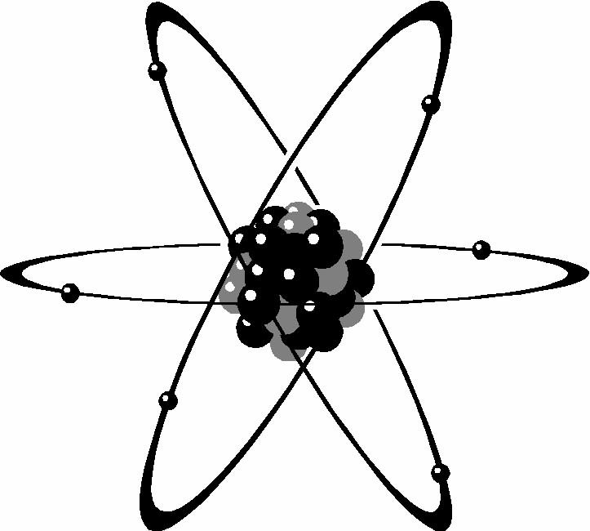
All matter is made up of extremely small particles called atoms.
Atoms are the building blocks of matter.
To give you some idea of the size of a single atom one million atoms of hydrogen would be less than the thickness of this page. 6,000,000,000,000,000,000 atoms of iron could fit across the head of a pin.
An oxygen atom weighs a tiny 0.000,000,000,000,000,000,000,026 g.
An element is a substance that is made of one kind of atom. Hydrogen, iron and oxygen are examples of elements. There are 92 elements found to occur naturally. Others have been made in nuclear reactors. Each element has its
own special type of atom.
AIM: To examine a range of elements.
MATERIALS:
- A variety of elements that can be safely handled.

PROCEDURE:
- Your teacher will provide you with some samples of elements.
- Take special note of any precautions given by your teacher.
- Make a simple table in which you can record the name of the element, its symbol, its colour and whether it is a solid, liquid or a gas at room temperature (i.e., its state).

QUESTIONS:
  - Use your textbook to find a definition for an ‘element’.

  - What is the name given to the tiny particles of an element?

  - In what state are most elements found?
  - List elements that occur naturally in their pure form. (i.e., in the ‘free
state’). You might have to use the library to answer this question.
  - How many different kinds of naturally occurring elements are there?
  - Chemists all over the world use the same set of symbols for the elements. How does this help them?
  - Some elements like lead (Pb) have a strange symbol. Why is this?

Activity 6: Symbols for the Elements
Chemists all over the world use the same set of symbols to represent the elements. Some symbols are made up of the first one or two letters of the name. Other elements have symbols that come from the Latin or Greek name for the element.
The symbols always have their first letter written in UPPER CASE. If more than one letter is used, the second letter is written in lower case.

- Copy and complete the table that follows by giving the symbols for the listed elements. Use your textbook to help you find the symbols.

A |  | B |  | C
Carbon |  | Aluminium |  | Copper
Hydrogen |  | Calcium |  | Gold
Iodine |  | Chlorine |  | Iron
Nitrogen |  | Magnesium |  | Lead
Sulfur |  | Helium |  | Mercury
Oxygen |  | Zinc |  | Potassium
Phosphorus |  | Bromine |  | Silver
Uranium |  | Nickel |  | Sodium

- You will notice that the elements have been listed in three columns, A, B and C. Why have they been grouped in this way?
Au !!!

Activity 6 (continued): Symbols for the Elements
Your teacher will give you a copy of the worksheet below. To help you learn the symbols for the common elements, fold back the right hand column. Fill in the column on the extreme right, check your answers, fold back that column and repeat the process. Do not stop practicing until you get them all correct, three times in a row.
Knowing these is most important to your success in Chemistry.

Element |  |  |  |  |  |  |  |  | Symbol
Carbon |  |  |  |  |  |  |  |  | C
Hydrogen |  |  |  |  |  |  |  |  | H
Iodine |  |  |  |  |  |  |  |  | I
Nitrogen |  |  |  |  |  |  |  |  | N
Oxygen |  |  |  |  |  |  |  |  | O
Phosphorus |  |  |  |  |  |  |  |  | P
Potassium |  |  |  |  |  |  |  |  | K
Sulfur |  |  |  |  |  |  |  |  | S
Uranium |  |  |  |  |  |  |  |  | U
Aluminium |  |  |  |  |  |  |  |  | Al
Bromine |  |  |  |  |  |  |  |  | Br
Calcium |  |  |  |  |  |  |  |  | Ca
Chlorine |  |  |  |  |  |  |  |  | Cl
Chromium |  |  |  |  |  |  |  |  | Cr
Helium |  |  |  |  |  |  |  |  | He
Copper |  |  |  |  |  |  |  |  | Cu
Magnesium |  |  |  |  |  |  |  |  | Mg
Nickel |  |  |  |  |  |  |  |  | Ni
Silicon |  |  |  |  |  |  |  |  | Si
Gold |  |  |  |  |  |  |  |  | Au
Iron |  |  |  |  |  |  |  |  | Fe
Lead |  |  |  |  |  |  |  |  | Pb
Mercury |  |  |  |  |  |  |  |  | Hg
Sodium |  |  |  |  |  |  |  |  | Na
Zinc |  |  |  |  |  |  |  |  | Zn

CHALLENGE
Check out this interactive website:
http://www.funbrain.com/periodic/

Use the resources of your school library to find out more about any one of the elements listed above.
- Describe how an atom of your chosen element made up. (A simple diagram which shows the parts of your atom would help)
- What are some of its properties?

Activity 7: The Periodic Table
As you study more chemistry you will become very familiar with the Periodic Table of Elements. This is a chart, which shows quite a lot of information about the elements and is very useful to the chemist.
Find one of these displayed in your laboratory.
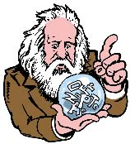

Did you know ………..

The famous Russian scientist Dmitri Mendeleev in 1869 began the periodic table we use today. It shows how the elements can be grouped. Elements that are close together in the table have similar properties. Newly discovered elements have been added to Mendeleev's original table of 63 elements. There are now over a hundred elements known, some of these have been formed in nuclear reactors and are not naturally found.

On the next page is a simplified Periodic Table. Collect from your teacher a copy of this table and stick it into your notebook. In later activities you will need to refer back to this chart.

- Examine a Periodic Table on display in your classroom and then, on your copy of the chart, colour the elements that are metals in red and the non- metals in blue. Which are the most common - metals or non-metals?

- Using three differently coloured borders, identify those elements that are solids, those that are liquids and those that are gases. Are elements mostly solids, liquids or gases? Are there any elements that are difficult to classify?

- Can you find an element that is named after:
- the inventor of the Periodic Table?
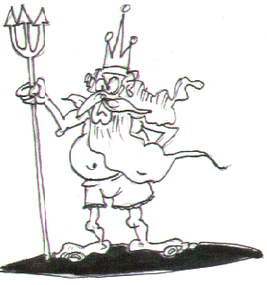
- an American state?
- the King of the Ocean?
- a Greek god?

- Can you find these?
- a metal used in caring for clothes.
- Albert’s element.
- a foolish trick.
- a tasty sandwich filler.

Activity 8: Molecules
If a lump of iron sulfide was cut into smaller and smaller pieces, eventually we would get to a tiny particle made of one atom of iron joined to one atom of sulfur. This tiny particle is called a molecule. A molecule consists of two or more atoms chemically joined together. It is the smallest part of a compound that keeps a set of chemical and physical properties. If the iron was separated from the sulfur the particle could no longer be called iron sulfide, nor would it have the properties of iron sulfide. Many gases exist as molecules.

A molecule consists of two or more atoms chemically joined together.

Examine each of the following diagrams. Identify which of these are atoms and which are molecules.

H

H
A hydrogen (H₂) gas particle.

Ne

O
A neon (Ne) gas particle.

N
A particle of nitric oxide

C

O

O

A carbon dioxide (CO₂) gas particle.

Activity 9: Mixtures & Compounds
In this activity your class will examine the properties of two elements, the metal iron and the non-metal sulfur. You will look at:

- How their properties are affected when they are mixed together.
- What happens to their properties when this mixture is heated.
AIM:
To study how the properties of iron and sulfur are affected by:
- mixing them together
- heating the mixture strongly.

MATERIALS:
For each group:
- sulfur powder | - 3 wire leads
- iron filings in a test tube | - hand lens
- filter paper | - dry cell (battery)
- magnet | - globe in a holder

For a demonstration:
- safety glasses | - matches
- test tube holder | - dilute hydrochloric acid (2M HCl)
- Bunsen burner | - steel wool & sulfur powder

PROCEDURE:
- Under the heading “Mixtures and Compounds” copy the aim into
your notebook.
- Draw a table in your notebook similar to the one given below. Keep
records of your observations in the appropriate columns in this table.

SUBSTANCE | APPEARANCE | ELECTRICAL CONDUCTIVITY | MAGNETISM | ACTION OF ACID
IRON
SULFUR
IRON & SULFUR MIXTURE
IRON & SULFUR AFTER HEATING
- Place a small amount of each element into separate, equally sized piles on a piece of filter paper. Use the hand lens to study each of the samples. Record your observations in the table you have prepared.

- Place the magnet carefully against the side of the test tube containing the iron filings. Also test the sulfur to see if it is magnetic. Record your
observations.
Do not place the magnet directly onto the iron filings!
- Connect one electrical lead to one side of the battery and then to one side of the globe holder. Join another lead to the other side of the globe holder. Connect a third lead to the other side of the battery as shown in the diagram. Test each of the elements for their electrical conductivity by placing the probes very close to one another on a sample of the test element.

DRY CELL

- Record your observations.

- Combine the equal sized piles of iron and sulfur, then mix them together thoroughly on the filter paper. Study the mixture with the hand lens once again. Can you identify individual particles of iron and sulfur?

- Suggest a method you could use to separate the two elements.

- Test your method.

- Are the properties of the mixture similar to the properties of the elements that make up the mixture?

Your teacher will do this part for you because the test tube will have to be broken to extract the substance that forms inside it. This stage can be dangerous.

Place a small quantity of sulfur in the bottom of a test tube and lightly pack some steel wool halfway into the test tube. Carefully heat the test tube over a
roaring Bunsen flame.
- Repeat all observations and tests on the substance in the test tube. Record your observations in the table.

QUESTIONS:
- What changes, if any, have occurred to the properties of the mixture
heated in the test tube?
- How easy would it be to separate the iron and sulfur again?
What has happened to make this task much harder?
- Write a word equation for the chemical reaction you observed. Your
teacher will show you how to use an arrow in the equation.
- Explain the difference between a mixture and a compound.
- Which of these diagrams represents a mixture and which represents a compound?

= iron atom

= sulfur atom

A B

- Notice from diagram B that each sulfur atom is joined to an iron atom. In a lump of iron sulfide there will be exactly the same number of sulfur atoms as iron atoms. The kind of structure shown in B is called a lattice. A lattice is a regular, three-dimensional arrangement of particles. A model of one is shown in the diagram on the left. Many compounds that are solids have a lattice structure. The structure of a crystal is due to its particles being packed into a lattice.
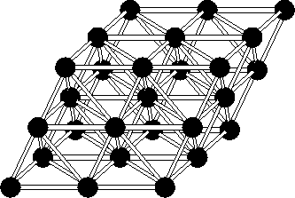
A model of a lattice
More compounds……………
Your teacher may show you what happens when
- magnesium ribbon is heated strongly.
- a mixture of equal parts of zinc powder and sulfur powder are heated on a heat proof mat using a lighted taper fixed onto a metre ruler. This must be done outside.
BE CAREFUL – STAND BACK!!!

Activity 10: Review of Elements, Mixtures & Compounds

How do we distinguish between mixtures and compounds???

- Work with the members of your group to define each of the terms, ‘mixture’ and ‘compound’.
Discuss your ideas with your teacher then record a definition for each in your notebook.

- Draw a table that you can use to classify these substances as being
‘elements’, ‘mixtures’ or ‘compounds’:

air, water, iron sulfide, zinc, milk, sulfur, carbon monoxide,
rust, sugar, cobalt, salt (sodium chloride), soil, pot-pourri,
cup of coffee, ink, nitrogen, chlorine.

- Scientists consider elements and compounds to be ‘pure substances’.
Examine the following diagram to see if you can work out why this should
be so. Check your ideas with your teacher.

Element Mixture Compound

- What name is used to describe the particles that make up
  - an element?
  - a compound?

Review: Elements. Mixtures and Compounds (continued)

- Match the following phrases with the terms on the right. Check your answers, then copy these statements into your notebooks as definitions to learn:

1. | Made of one kind of atom. | a. | molecules
2. | The smallest particles of an element. | b. | lattice
3. | Elements can be grouped as metals and.... | c. | atoms
4. | Two or more elements chemically combined. | d. | element
5. | Tiny particles that make up most gases. | e. | non-metals
6. | The particles of many solid compounds arrange to form a.... | f. | compound

- Which of the following diagrams represent:
• atoms?
a.
b.
c.
d.
e.
f.
g.
• elements?
• compounds?

Activity 11: Chemistry in Short

Writing out the names of chemical substances all the time would be a very long process. Some names like dimethylammonium methanoate are very long indeed. Instead, scientists use a shortcut for writing the names of
compounds - they write the chemical formula of the substance.
This shows
- the chemical symbols of the elements that make up the substance.
- the number of each type of atom present in a single molecule of the
compound.
Some of these formulae you know already. For example H₂O means water
and CO₂ means carbon dioxide.
The formulae of some common substances are shown in this table. Note how useful the formula is in showing the numbers of the various atoms that are
present. The ratio symbol ‘:’ is read as ‘for every’.

Substance | Formula | Ratio of atoms present
Water | H₂O | 2 atoms of hydrogen : 1 atom of oxygen
Salt | NaCl | 1 atom of sodium : 1 atom of chlorine
Sugar | C₁₂H₂₂O₁₁ | 12 atoms of carbon: 22 atoms of hydrogen : 11 atoms of oxygen
Sand | SiO₂ | 1 atom of silicon : 2 atoms of oxygen

Copy and complete the following table:
COMPOUND | NUMBER AND TYPE OF ATOMS  IN THE COMPOUND | FORMULA
Carbon dioxide | 1 carbon : 2 oxygen
Nitric acid | 1 hydrogen : 1 nitrogen : 3 oxygen
Potassium permanganate |  | KMnO₄
Potassium dichromate |  | K₂Cr₂O₇
Sulfuric acid | 2 hydrogen : 1 sulfur : 4 oxygen
Sodium hydrogen carbonate |  | NaHCO₃
Copper carbonate | 1 copper : 1 carbon : 3 oxygen
Acetic acid |  | CH₃COOH

Which of the compounds does this diagram represent?

Activity 12: Rules for Naming Ionic Compounds

An ionic compound is formed when a metal atom bonds with a non-metal atom. To be more accurate, the ionic compound is formed when a metal ion bonds with a non-metal ion. For now, you can just think of it as atoms joining together through chemical bonds.

Rules for naming ionic compounds:
- The atom that appears on the left hand side of the periodic table (the metal) is said first. Its name does not change at all.
- The atom that appears on the right hand side of the periodic table (the non-metal) is said second. Its name is changed to end with “ide”. Eg: Iodine becomes iodide

Name these ionic compounds from the names of the atoms:
Atoms in the ionic compound | Name of compound
Aluminium bonds with phosphorous
Nickel bonds with sulphur
Iodine bonds with iron
Oxygen bonds with mercury

Name these ionic compounds from their formula:
Formula | Name | Formula | Name
MgI₂ |  | Cr₂S₃
FeO |  | UO₂
Pb₃P₂ |  | CuCl₂
NiI₂ |  | Al₂O₃
K₂O |  | AuN₃

Activity 13: Formulae of Compounds

NOT A PART OF THE YEAR 8 CURRICULUM

Activity 14: Physical and Chemical Changes
The changes studied in chemistry can be classified as either:
- physical changes or
- chemical changes.

When an ice block melts, frozen water changes its state to form water in the liquid phase. No new chemical substance is formed. Freezing the water once more can easily reverse this change.

This kind of change is a physical change.
Sanding a piece of wood makes sawdust. Even though this is not easily reversed it is a physical change because no new chemical is formed.

When a sausage burns on a barbecue, a new chemical substance is formed that is black and apart from its shape, is unlike the sausage it started as - it has quite different chemical properties.

A chemical change is said to have occurred.
This change cannot be easily reversed.
- Record the differences between these terms in a two-column table
using the headings ‘Physical Changes’ and ‘Chemical Changes’.
- How would you know if a chemical change had occurred?
List the kinds of observations that would help decide that a chemical
change had taken place.
- Following are two lists of changes some of which have been incorrectly listed under the two headings. Rewrite the table so that the lists are
correct.

Physical changes | Chemical changes
- Bending wire | - Decomposing leaves
- Burning paper | - Respiration
- Iron rusting | - Breaking a plate
- Filtration | - Evaporating

- Read this paragraph and then in your notebooks list the information, which tells you that a chemical change was occurring.

“Sarah dropped a piece of copper into an unknown, colourless liquid in a test tube and was surprised to see the mixture change to a bright blue colour. Many tiny bubbles rose quickly to the surface and formed a cloud of brown gas that rose out of the test tube. Soon a horrible smell was detected that stung her nostrils and made her eyes water. The test tube itself became very hot in her hand”.

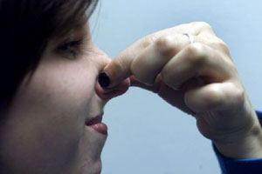

Activity 15: Observing Some Chemical Reactions

AIM:
To investigate some examples of chemical change.
MATERIALS:
- test tubes x 3 | - pop stick
- test tube rack | - health salts
- water in a dropper bottle | - marble chips (CaCO₃)
- zinc granules (Zn)  - labels | - hydrochloric acid (HCl) in a dropper bottle

PROCEDURE
A
Marble chips
+
Hydrochloric acid
B
Zinc
+
Hydrochloric acid
C
Health salts
+
Water

Follow these instructions:

- Label the test tubes A, B and C.
- Place about ten marble chips into test tube A.
- Place one or two zinc granules into test tube B.
- Place a small quantity of health salts in test tube C using the pop stick.
- Add a full dropper of hydrochloric acid to the marble chips in test tube A.
- Add a full dropper of hydrochloric acid to the zinc granules in test tube B.
- Add a full dropper of water to the health salts in test tube C.

OBSERVATIONS
Record your observations of any changes in a table like the one drawn below.

Test tube | Mixture | Observations
A | Acid + marble chips
B | Acid + zinc
C | Water + health salt

For each of the tests you completed:

- Did you see a change?
If you did, was it a physical or a chemical change?

- Let us see what happened in the first reaction by studying this word equation:

Hydrochloric + calcium calcium + carbon + water
acid carbonate chloride dioxide

A chemist would write this reaction as follows:

2HCl + CaCO₃ CaCl₂ + CO₂ + H₂O

Notice that in this chemical change the different chemicals have swapped partners to form new substances having new properties. The chloride left the hydrogen of the acid to join with the calcium of the marble chips, while the carbon dioxide came from the marble chips.

From the chemist’s equation:
- Can you work out where the water (H₂O) came from?
- Can you work out why the chemist needed 2 HCl molecules to write this equation correctly?

- In test tube B, zinc chloride (ZnCl₂) was formed, as well as a gas.
Can you work out what the gas must have been and then write a word
equation for the reaction. (You may need your teacher to help you).

Activity 16: Changing Partners!

When soluble substances are dissolved in water their particles seem to
disappear. What really has happened to them? In this activity you will investigate the behaviour of solutes particles when they dissolve in water.

AIM: In your notebook, write an aim for this activity.
MATERIALS:
- Dropper bottles containing
- sodium carbonate (Na₂CO₃)
- cobalt chloride (CoCl₂)
- copper sulfate (CuSO₄)
- barium chloride (BaCl₂)
- test tube rack
- test tubes (6)

PROCEDURE:
- How many combinations of these solutions can you form, if you mix them together two at a time?
- Draw up a table that can be used to show the result of each of these combinations. (Hint: show the solutions across the top of the table and the same solutions down the side)
- Investigate what happens when you add together in a test tube, 5 drops of paired solutions.

DISCUSSION:
- Were the changes you observed physical or chemical?
- Why do you think so?
- Chemical reactions can be shown by simple equations like this one:

REACTANTS PRODUCTS

Where:
........the reactants are the substances that have undergone a change.
........the products are the substances made by this change.
........the arrow means ‘results in’ or ‘forms’
QUESTIONS:
- What happened when the paired solutions were mixed together?
- Draw a simple diagram that could be used to model what has happened to the particles in one of these reactions.
- Write a word equation for each reaction. Your teacher will help you with this.
- Find out what is meant by the term ‘precipitate’ as it applies to chemistry.
- Identify the reactants and products in each of the following chemical equations (a table might be a useful way of presenting
your answer).

i. 2H₂ + O₂ 2H₂O

ii. Zn + H₂SO₄ ZnSO₄ + H₂

Activity 17: Preparation of Carbon Dioxide

AIM:
To prepare carbon dioxide gas and then examine some of its physical and chemical properties.

MATERIALS:
- conical flask, two holed stopper, thistle funnel and delivery tube
- gas jars with covers (2)
- limewater
- party candle in a 250 mL beaker
- plasticine
- pneumatic trough or icecream bucket
- 2M hydrochloric acid (HCl)
- marble chips (CaCO₃)
- wax taper

PROCEDURE
- One way to catch a gas released in a chemical reaction is by the ‘downward displacement of water’.

Thistle funnel
Conical flask
Marble chips
and HCl
Gas jar
Pneumatic trough

- Set up the apparatus as it is shown in the diagram. Completely fill a gas jar with water and then slide a gas jar lid on its top. When you are ready, turn the gas jar upside down into the trough and when its top is under the water, remove the lid.

- Carefully add enough of the acid through the thistle funnel so that the end of the thistle funnel in the flask is completely covered.
ACID
BE CAREFUL NOT TO SPILL THE ACID!!!
If you do then:
- Dilute the spill immediately using water.
- Advise your teacher.

- Allow the gas to form for a short time before collecting it in the
gas jar can you explain why you should do this?

- Collect two gas jars of carbon dioxide gas by the downward displacement of water from the gas jars.

OBSERVATIONS:
- Draw a simple 2-D diagram to show how this gas was collected.
Label your diagram fully.
- Under a heading ‘Properties of Carbon Dioxide’ record its colour and
smell.
- Stand the party candle in a piece of plasticine in the bottom of the 250 mL beaker. Light the candle using the wax taper then carefully pour the CO₂ gas into the beaker. Add your observations to those already made:

- Is CO₂ heavier or lighter than air?
- Does CO₂ burn?
- Will CO₂ allow burning to take place?

- Pour several centimetres of limewater into the second jar of gas.
Quickly replace the cover. While holding the cover, gently shake the gas jar. Alternatively, bubble some of the gas through some limewater.
Record your observations.

Investigation: Speedy CO₂!

We have found that carbon dioxide gas can be prepared in the laboratory by adding acid to marble chips.

What factors affect the rate at which this gas is made???

Your group’s task:
- design a way of finding an answer to this question.
- use these headings:

  - hypothesis: remember that an hypothesis is a testable statement.
  - method: make sure you describe
    - the experimental variable
    - dependent variable (how will you measure it?)
    - variables you will have to control
    - the control set up

- carry out the investigation and write a conclusion to your experiment.

Follow up activity:
Assess the written report of your neighbouring group.
Be tough but fair. Be prepared to report back to the class
on the strengths and weaknesses of their report.

Research………..

- Use your library resources to find out more about
carbon dioxide.
- How common is it in our atmosphere?
- Which planet has an atmosphere made almost entirely
of CO₂?
- Why is this gas important for plants?
- What is dry ice? At what temperature does it form?
- Why is this gas important to the makers of soft drinks and champagne?

Activity 18: Preparation of Oxygen Gas

Oxygen is one of the most common elements, making up nearly half the mass of all rocks, about 66% of the mass of your body and 90% of the mass of pure water. It can occur in its free state as oxygen gas (O₂) or ozone (O₃).
It is a very active gas chemically, joining readily with other elements to form oxides. It is a very important gas to living things because it is needed in the process of respiration.

In the laboratory, oxygen gas is collected in a similar way to carbon dioxide, i.e., by the downward displacement of water.
One way of making it is to use hydrogen peroxide (H₂O₂) and add to it another substance called manganese dioxide (MnO₂).

MnO₂
2H₂O₂ 2H₂O + O₂

You will notice, if you look carefully at this equation, that the manganese dioxide does not get used up in this reaction. It acts as a ‘reaction helper’ or catalyst. The same amount of MnO₂ could be used over and over.

1. Write a word equation for this reaction.
2. Explain what ‘catalyst’ means.

Molecules of oxygen (O₂);
a di-atomic gas

AIM:
To prepare oxygen and examine some of its physical and chemical properties.

MATERIALS:
- gas generating equipment from Activity 26 | - party candle standing in a  250 mL beaker.
- hydrogen peroxide (H₂O₂) | - wooden splints
- manganese dioxide (MnO₂) | - Bunsen burner & matches
- gas jar with lid | - limewater
- test tubes with stoppers (4) | - tongs & steel wool
WARNING:
MnO₂ is very dirty – do not spill!

METHOD:
- Set up the gas generating equipment as it is shown in the diagram below. Draw a simple line diagram in your notebooks.
- Use a spatula to add a small amount of MnO₂ to the flask.
- Place the stopper, thistle funnel and delivery tube in position in the
flask.
- Slowly add enough H₂O₂ to cover the lower end of the thistle funnel.
Allow the air from the flask to escape, then collect the oxygen gas in
the gas jar. Place the lid on the gas jar when it is full of oxygen.
- Fill each of the test tubes with the gas, sealing each with a rubber
stopper before removing them from the water.
Hydrogen peroxide
and manganese dioxide
Thistle funnel
Conical flask
Gas jar
Water
Delivery tube

Pneumatic trough

Under a heading ‘OBSERVATIONS’ record what you observe to happen in each of the following tests:

Test A: (Teacher demonstration only)
Using the tongs, hold a loose wad of steel wool in a Bunsen flame until it is red-hot. Plunge the hot wool into the gas jar of oxygen. What did you observe?

Test B:
Light one of the wooden splints, let it burn until it forms some glowing coals, then blow out the flame. Insert the glowing splint into one of the test tubes of oxygen gas. What happens?

Test C:
Pour the second test tube of oxygen into a beaker containing a lighted candle. What happened to the candle flame?

Test D:
Record the colour and smell of the gas sample in the third test tube. To smell the gas, hold the test tube about 10 cm away from your nose and gently waft the gas towards you with your hand. Describe the colour and smell of oxygen gas.

Test E:
Add about a centimetre depth of limewater to the last test tube of oxygen gas. Return the stopper to the tube then shake the test tube to mix the gas with the limewater. Was there a colour change?

QUESTIONS:
- Suggest a good way to decide if an unknown gas is oxygen.
- Why is oxygen so important to living things?
- Which group of living things make oxygen gas?
- The amount of oxygen gas in the air remains fairly stable. Explain why this is so.

Library Research:
- Find out the meaning of ‘combustion’. How are the processes of combustion and respiration similar?
- How is oxygen made in industry?
- Liquid oxygen has some interesting properties. Find out the
boiling point, freezing point and colour of this liquid.
Demonstration: Hot Foam!!!

This spectacular demonstration shows:
1. the formation of oxygen from H₂O₂
2. the action of catalysts
3. an exothermic reaction

Reaction:
2H₂O₂ 2H₂O + O₂

MATERIALS:
- 1 x 1 L glass measuring cylinder
- detergent (Morning Fresh - type)
- 50 mL of (at least) 100 volume hydrogen peroxide (H₂O₂)
- Jar of solid potassium dichromate (K₂Cr₂O₇) plus teaspoon
and/or
- Jar of solid potassium iodide (KI) plus teaspoon
- White tray

PROCEDURE:
- Place the measuring cylinder inside the white tray.
- To the measuring cylinder, add:
  - 15 mL of detergent
  - 50 mL of 100 vol H₂O₂ TAKE CARE! - corrosive

- Add 1/2 teaspoon of either K₂Cr₂O₇ or KI, and stand back!!!

Safety:
Use safety glasses and rubber gloves.

Activity 19: Preparation of Hydrogen Gas
1
A
Hydrogen gas is made in the laboratory by pouring an acid over a reactive metal like zinc.

AIM:
To prepare hydrogen gas and study its properties.

MATERIALS:
- gas generator: test tube, one hole rubber stopper and delivery tube
- zinc pieces (about 4)
THIS IS DANGEROUSLY STRONG
………DO NOT SPILL OR SPLASH
- 4M hydrochloric acid (HCl)
- icecream bucket half full of water
- test tubes and stoppers (3)
- matches and wax tapers
CAUTION - WEAR SAFETY GLASSES
METHOD:
- Set up the gas generating equipment.
- Place about 4 zinc pieces in the bottom of the test tube then pour in enough hydrochloric acid to cover the end of the zinc pieces.
- Collect three test tubes of hydrogen gas by the downward displacement of water. Seal each test tube with a stopper while they are still under water.
- Point the open end of one of the test tubes downwards and away
from any person. Remove the stopper. Count slowly to ten.
Get your partner to hold a lighted taper close to the open end.
- Carry out a similar test but this time hold the test tube so that the open
end faces upwards. Remove the stopper, count slowly to ten, and then try igniting the gas with the lighted taper.
You might need to try this again with the third test tube of gas.

QUESTIONS:
- Describe a good way to test for the presence of hydrogen gas.
What is the name given to this test?
- Is hydrogen gas lighter or heavier than air? How do you know?
- Record the colour and odour of hydrogen gas.

- A summary of the chemical reaction that took place to make the hydrogen gas is shown below. Rewrite this as a word equation.

Zn + 2HCl ZnCl₂ + H₂

- In this equation

a. Which substances were the reactants?
b. Which substances were the products?
c. Which substance was the source of the hydrogen?
- You may have heard of the hydrogen filled airships called zeppelins. These became unpopular. Why was this?
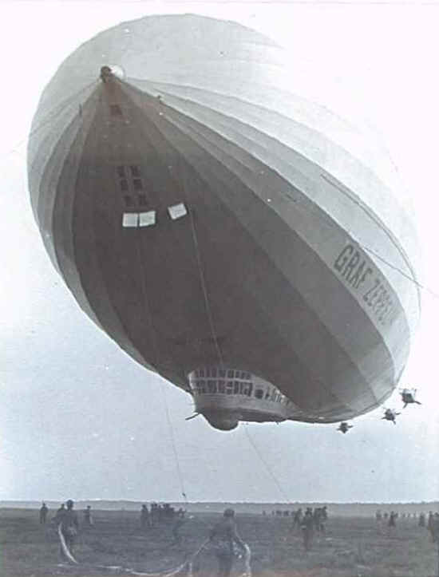

- Use the library or Internet to find video of the Hindenburg disaster.

Activity 20: Oxygen and Rust

The air around us is a mixture of gases. One of them is oxygen, vital for the survival of living things. We breathe in oxygen so that we can use it to break down food to release the energy it contains. This process is called respiration.
Rusting of steel takes place when the iron in the steel joins with oxygen from the air to form iron oxide.

- How much of the air around us is made of oxygen?
- How can we find out?

AIM:
To find out what percentage of the air is made up of oxygen.

MATERIALS:
Damp steel wool loosely packed into the end of the vial.

l
- large plastic vial
- steel wool
- 250 mL beaker
PROCEDURE:
Plastic vial stood upside down in a beaker of water
Set up the equipment as shown
in the diagram. On the side of the test
tube mark how far the water rises
inside the vial with a waterproof felt
pen. Leave the equipment set up in a
safe place for at least two days.

RESULTS: (after two days)
- Mark the new water level on the side of the vial.
- Measure the distance from the second mark to the top of the vial.
- Measure the distance from the first mark to the top of the vial.
- Subtract the first measurement from the second measurement.
- Divide your answer by the second measurement.
- Multiply by 100. This will give you the % of the air that was used up by the rusting iron.

CONCLUSION:
- What percentage of the air did the rusting iron use up?
- Use your textbook to find out the percentage of oxygen in the air.

Review: Chemical Sciences
Collect a copy of this worksheet from your teacher…
- Complete this table:
Compound | Elements  present | Number of atoms of each element | Name of compound
CaCO₃ |  | 1Ca: 1C: 3O | Calcium Carbonate
CH₃COOH |  |  | Acetic Acid
H₂SO₄ |  |  | Sulfuric Acid
C₆H₁₂O₆ |  |  | Glucose
Mg₃(PO₄)₂ |  |  | Magnesium Phosphate
Al₂O₃
SO₂ |  |  | Sulphur Dioxide
N₂O₄
FeSO₄ |  |  | Iron Sulfate
CO |  |  | Carbon Monoxide
AgNO₃ |  |  | Silver Nitrate
ZnCl₂
- Define the following:
  - ATOM =
  - ELEMENT =
  - COMPOUND =
  - PHYSICAL CHANGE =
  - CHEMICAL CHANGE =
  - MIXTURE =
  - SUBLIMATION =

- Which of the following are physical changes (underline them) and which
are chemical changes (circle them):
crushing ice, burning hydrogen, boiling water, rotting meat, melting butter, making CO₂, melting ice, dissolving salt in water, tearing paper, evaporating water, filtering a suspension.

- Complete these statements:
a. Limewater will go milky if gas is present.
b. gas will ignite a glowing splinter of wood.
c. The test is used to show that a gas is hydrogen.

