Elements and Compounds

- Elements are found in the Periodic Table. All elements can be shown as a symbol. Complete the following table.
Name of Element | Symbol
Hydrogen
Sodium
 | Ca
 | S
 | He
Iron
Chlorine
 | Mg
Zinc
 | Au
Potassium

- Colour in or highlight the elements that are metals in the table above.
- Describe what a compound is.

- Fill in the missing details in the table below.

Name of Compound | Formula | What atoms are found in the compound?
Zinc oxide | ZnO | 1 zinc, 1 oxygen
Magnesium oxide |  | 1 magnesium, 1 oxygen
Sodium chloride | NaCl
 | CO₂ | 1 carbon, 2 oxygens
 |  | 2 Aluminium, 3 sulfurs
Potassium nitrate |  | 1 potassium, 1 nitrogen, 3 oxygens
Copper sulphate | CuSO₄
 | PbO

- What elements would you react together to make the compound iron oxide? ..................................... and …………………………………..

- Identify the following substances as either a mixture or a compound.

  - Carbon dioxide
  - Air
  - Water
  - Salty water
  - Soil
  - Bronze
  - Copper oxide
  - Table salt

- Groups and Periods of the Periodic Table

Elements are arranged in rows and columns in the periodic table in order of increasing atomic mass. The vertical columns are called __________ and the horizontal rows are called ___________. Li, ____ and K are in the same group while N, ____ , F are in the same period.
Elements in the same groups have similar ___________ and physical properties

- Elements in Group 17 (halogens)

Write down the names or symbols of the first 5 elements in Group 17

  - ____________________
  - ____________________
  - ____________________
  - ____________________
  - ____________________

- Trends in Group 17 – The Halogens

Look at the table below:
halogen | Order down group 17 | boiling point (°C)
fluorine | 1 | –188
chlorine | 2 | –34
bromine | 3 | 58
iodine | 4 | 184

Plot this information as a bar graph below:
boiling point (°C)
200

150

100

50

0

–50

–100

–150

–200
1
Order down group
2
3
4
5

Questions
- What is the pattern of the boiling point going down Group 17?

- Which halogens are gases at room temperature (25 °C)?

- Astatine is below iodine in Group 17. Predict the boiling point of astatine using your graph as a guide. Now research what the actual boiling point of astatine is. How close was your prediction?

- Elements in Group 18 (noble gases)

- Another name for noble gases is inert gases. What does inert mean and why are group 18 elements given this name?

________________________________________________

- Write down the names or symbols of the first 5 elements in group 18.

  - ____________________
- ____________________
- ____________________
- ____________________
- ____________________

- Solid, Liquid, Gas Comprehension

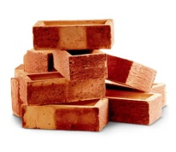
Solids stay in one place. They do not _________. Solids are often __________. The ____________ of an object is the amount of space it takes up. Solids cannot be ____________ – their volume can’t be ______________.
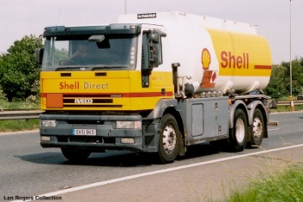
Liquids cannot be moved in a truck like solids can because they flow. Liquids are carried in ___________ and can be pumped. The _____________ of a liquid cannot be changed – liquids can’t be squashed.

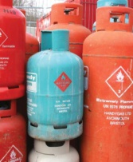
Gases are normally transported in cylinders. Gases flow very _____________ and ____________ out to ________ the container they are in. Gases __________ have a fixed volume. A gas can be squashed to fit in a smaller container. Gases are less dense than ___________ and ____________.

Word to use: changed dense don’t easily fill flow liquids solids spread squashed tankers volume

- Fill in the missing words in the definitions below.

Missing words: elements, different, one, joined, atom, type, two

- An element consists of ______ ______ of _______.

- A compound contains _____ or more __________ ______ joined together.

- A mixture contains two or more _________, but they are not chemically ________.

- Using the definitions, decide whether the following diagrams represent an element, a compound, or a mixture. Explain your choice.

a) This diagram shows an
C
H
H
H
H
C
H
H
H
H
C
H
H
H
H

_______________________.

I think this because:

_________________________

_________________________

_________________________

b) This diagram shows an
Ne
Kr
Kr
Kr
Kr
Kr
Ne
Ne
Ne
Ne
Ne
Ne
Ne
Ne
Ne
Ne

_______________________.

I think this because:

_________________________

_________________________

_________________________
c) This diagram shows an
Xe
Xe
Xe
Xe
Xe
Xe
Xe
Xe
Xe
Xe
Xe
Xe

_______________________.

I think this because:

_________________________

_________________________

_________________________

S
S
S
S
S
S
S
S
S
S
S
S
S
S
S
S
S
S
S
S
S
S
S
S
S
d) This diagram shows an

_______________________.

I think this because:

_________________________

_________________________

_________________________

- According to our definition above, H₂O (water) is a compound. However, it is sometimes called a molecule. O₂ (oxygen gas) is also a molecule. Can you think of a way to define a molecule?

A __________ consists of _____ or more _______ chemically

________ together. These _____ can be of the same _________ or

different elements.
- Tick the box if the stated property applies to a solid, liquid and/or gas

Property | Solid | Liquid | Gas
It will mould its shape to its container
It will spread out on a surface
It will hold its shape unless broken
It does not flow
It can be compressed
Its particles are free to move past each other
There is lots of space between each particle
Its particles are in contact with one another
It can flow
Its particles are not in contact with one another
Its particles cannot move past each other
There is little space in-between each particle

- In diagram 1 box, draw how the particles appear in a solid. In the Explanation box, describe how the particles are behaving. Repeat this for a liquid in diagram 2 and a gas in diagram 3.

Explanation...
................................................................................................................................................................................................................................................................................................

Diagram 1

Diagram 2
Diagram 3
Explanation...
................................................................................................................................................................................................................................................................................................

Explanation...
................................................................................................................................................................................................................................................................................................

- The melting point is the temperature at which a substance changes from a ________ to a ________
- The boiling point is the temperature at which a substance changes from a ________ to

a _________
- Water melts at _______°C and boils at __________°C

- What is the physical state of water at these temperatures?
45 °C = ____________________
125 °C = ____________________
-24 °C = ____________________
75 °C = ____________________

- Label each of the 3 pictures with the correct state of matter
Label each of the arrows with the name of the change in state
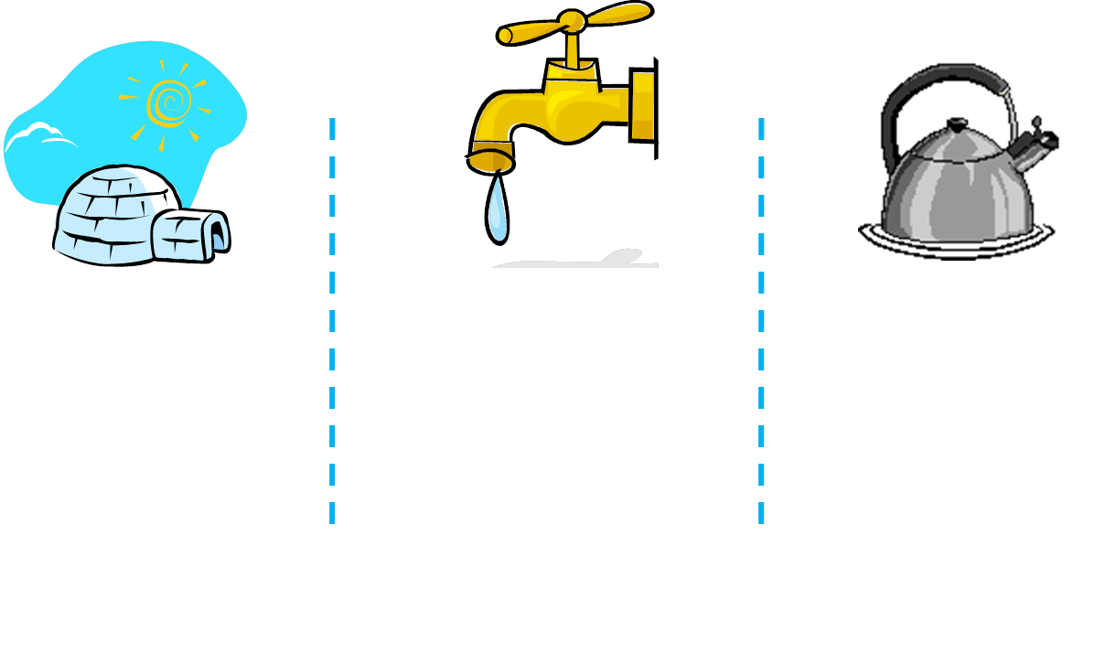
Temperature at which the change of state occurs ______°C
Temperature at which the change of state occurs ______°C
Increase in temperature

Element | Melting point (°C) | Boiling Point (°C) | State at room temperature (25°C) ?
Chlorine | -101 | -34
Iodine | 114 | 184
Fluorine | -220 | -188
Bromine | -7 | 59
- Using the information provided in the table, fill in the final column.

- Describe what happens to the kinetic and potential energy of the particles in a block of ice as it melts.

- Describe what happens to the kinetic and potential energy of cold water particles as the water warms up.

