Yr 9 Science – Mid-Term revision

- Differentiate between hormonal and nervous regulation based on:

Type of message

Mode of transport
Answers in a table in my PowerPoint in Moodle.

Duration of reaction

Speed of reaction

Example for each type.

- Write the word equation for photosynthesis.
Enzymes

ANSWER BEHIND THIS PANEL.
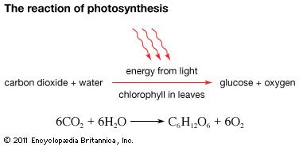

- Write the word equation for cellular respiration.
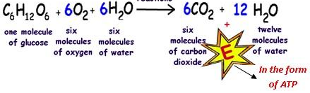

ANSWER BEHIND THIS PANEL.

- Indicate which of the following equations is an example of an anabolic reaction and which is catabolic reaction. Explain your answer.
a)

This reaction is an example of an anabolic reaction because it is converting smaller compounds into larger ones. Carbon dioxide and water are chemically bonded together to produce a larger molecule of glucose.

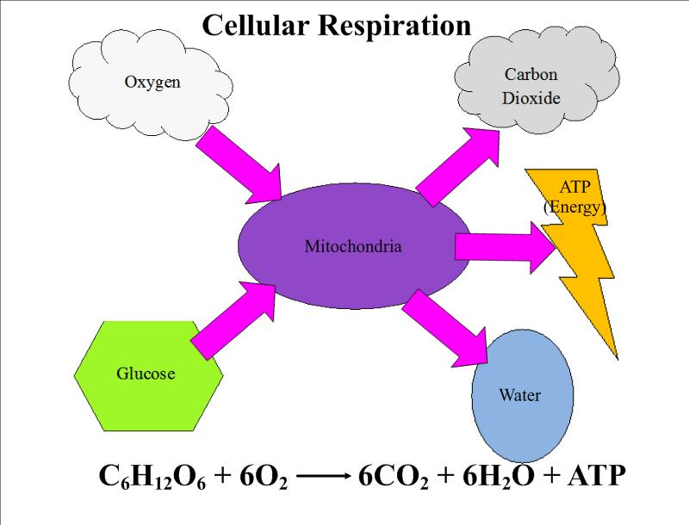
b)

This reaction is an example of an catabolic reaction because it is converting a larger compound into smaller compounds. Glucose is broken down into carbon dioxide and water molecules which are smaller.

- Explain what this graph is showing.

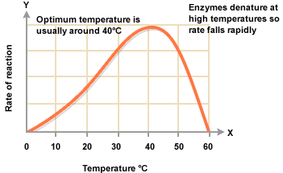

This graph shows how the reaction rate of an enzyme speeds up as temperature increases. But, when it rises past its optimum temperature, the enzyme is denatured and is no longer capable of carrying out its function and the rate of reaction falls.

- Identify the two gases involved in cellular respiration.

Oxygen gas and carbon dioxide.

- Identify the body systems involved in cellular respiration and describe how nutrients reach body cells and waste products are removed from body cells. Use a diagram to assist in your explanation.

Oxygen gas is inhaled into the lungs using the respiratory system. Oxygen diffuses through the wall of the alveolus and into the blood vessel, from high to low concentration area. The blood carries oxygen using the circulatory system to the cell, where it diffuses into the cell. Carbon dioxide produced by the reaction also diffuses from the cell into the blood vessel, where it is carried by the circulatory system to the lungs where it diffuses from the blood into the alveoli; an area of high concentration(blood) to an area of low concentration(alveolus).
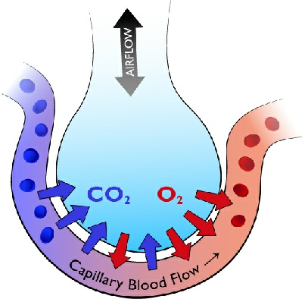
High O₂ concentration
Low O₂ concentration
Low CO₂ concentration
High CO₂ concentration

Remove this panel to reveal the answer.

- Describe the features of an alveolus that allow oxygen and carbon dioxide to diffuse easily.

a) A very thin wall of the alveolus – this allows gas to diffuse easily across it.

b) Blood vessel is very close to the alveolus – this allows easy transit from blood to alveolus.

c) Moisture within the alveolus – the wetter the surface the easily the gases are dissolved, therefore more gas is diffused across.

d) number of alveoli – the larger number of alveoli the greater the surface area for gas to diffuse across.

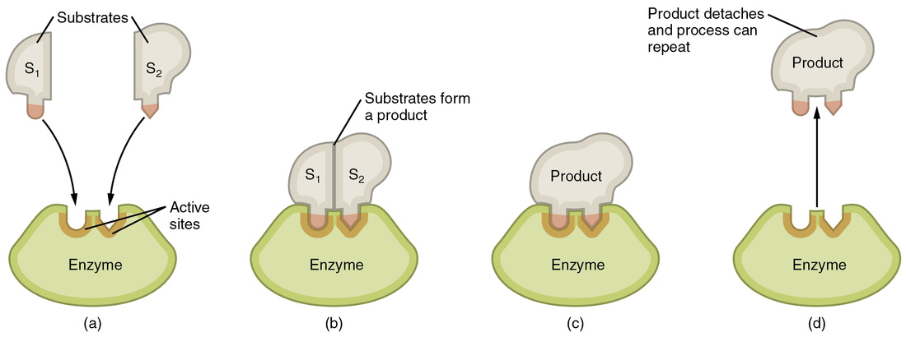
- Draw a labelled diagram of an enzymatic reaction for anabolism.
Enzyme- substrate complex
Enzyme is free to be reused.

ANSWER IS BEHIND THIS PANEL

- Draw a labelled diagram of an enzymatic reaction for catabolism

substrate
Active sites
Enzyme- substrate complex
Products
P₁
P₂
P₁
P₂
Products form

ANSWER IS BEHIND THIS PANEL

- Identify some features of enzymes.

  - They operate at an optimum temperature;
  - They operate at an optimum pH;
  - They can be reused once they catalyse a reaction.
  - They speed up the rate of chemical reactions.
  - At high temperatures they are denatured.

- List the factors that affect the reaction rate of enzymes.

- Temperature;
- pH(acidity level);
- concentration of enzyme;
- concentration of substrate.

- How is osmosis different from diffusion?

Osmosis requires water to move across a semi-permeable membrane from an area of high concentration to an area of low concentration. (Hi-Low).

- Complete the following sentences.
A sensory neuron carries messages from receptor to central nervous system.
A relay neuron carries messages from sensory neuron to motor neuron.
A motor neuron carries messages from central nervous system to effector.

- Jackie steps on a nail and lifts her foot immediately.

a) What type of response is this? Spinal reflex

b) What is the stimulus? nail piercing the foot

c) What is the receptor? pain receptor in skin

- What carries the impulse from receptor to the CNS? Sensory neuron

- What carries the message from CNS to effector? Motor neuron

- What is the effector in this case? Thigh muscle

- What is the response? Lifting of the foot

- Why does this type of response bypass the brain? To be rapid and reduce extent of injury.

- State any two examples of a reflex that occur in the body. eye blinking and sneezing/coughing.

- What is an acquired reflex? Give an example.

It is a reflex that is learnt by constant repetition; eg. Riding a bike; placing
a foot on the brake in case of emergency.

- What do you call a gland that secretes its contents straight into blood vessels instead of ducts?

Endocrine gland

- What is the name of the chemical that is secreted by these glands?

Hormone

END

