Non-specific Immunity

Diseases and Pathogens

1. What are Communicable diseases?

2. Define Pathogen and list 4 main types of pathogens

3. What does contagious mean?

4. What is a vector?

5. Describe the structure of bacteria and viruses (diagrams are also useful)

Bacteria | Viruses

6. List the main differences between Bacteria and Viruses

Body Defences

7. What is the difference between Non-specific and specific defences?

8. On the diagram below label the different external defences and how it protects.

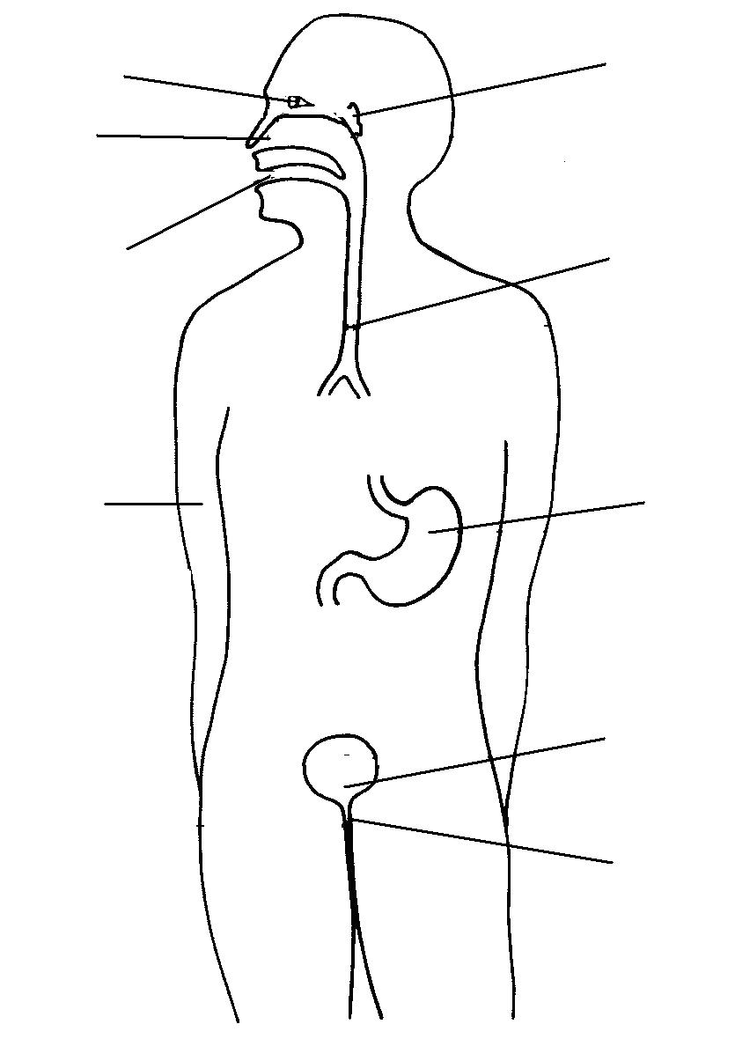

9. List the 4 Protective Reflexes that occur in our body and briefly explain how it protects.

