CELL MEDIATED IMMUNITY

- specific process
- involves T-lymphocytes (T-cells)
• formed in the bone marrow
• mature in the thymus where they learn to recognise antigens only if in combination with `self-antigens'
• live in the lymphoid tissues

- T-cells are activated by antigen presented by macrophages
- clone to form a large number of activated T-cells differentiate into subpopulations

1. Helper T-cells:

- 60-80% of T-cells
secrete chemical messengers called lymphokines to:
• stimulate plasma cells to form antibody
• stimulate growth of all T-cells (interleukin)
• entice more macrophages & neutrophils to the invaded area. Macrophages are made angry!..

- Without Helper T cells there is no immune response

AIDS:
Invades the Helper T-cells destroying the cells that `turn on' the immune system.
Also invades & destroys macrophages.
Sometimes brain cells .... dementia of AIDS

HB12 1.5 Cell mediated response notes ex Sherwood 14 June 2001

2. Killer T-cells destroy cells infected with virus
(except nerve cells)
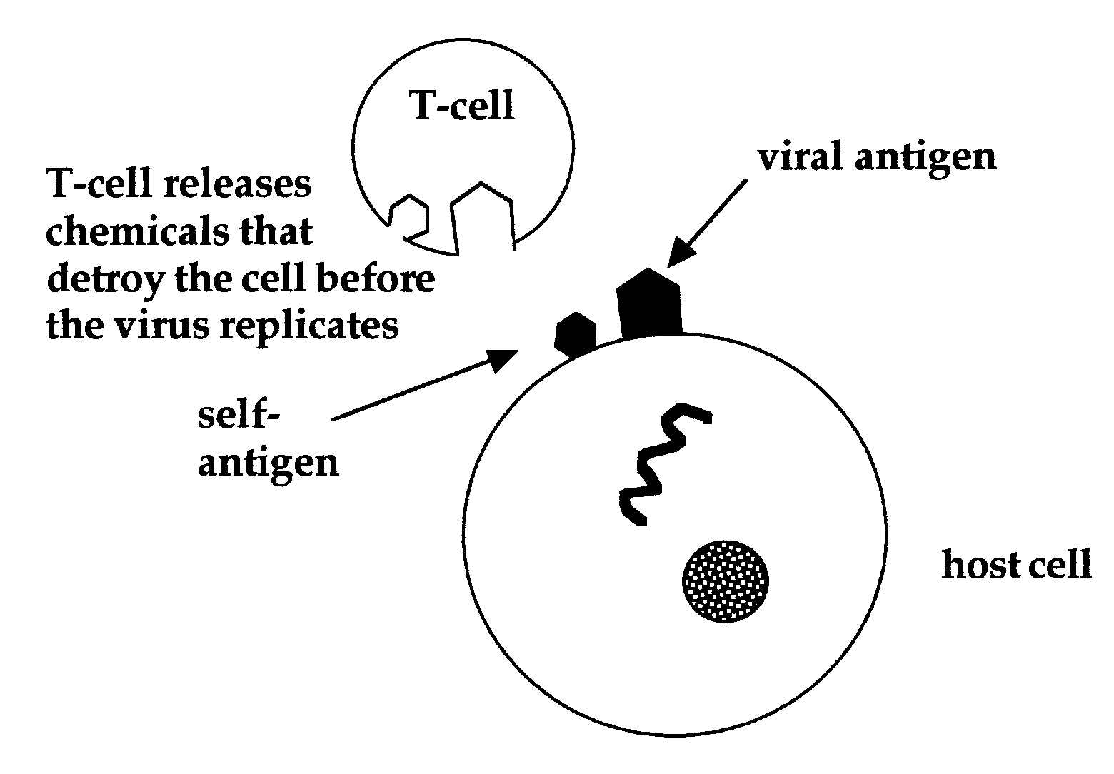

Killer T-cells destroy
- cells infected with viruses
- cancer cells
- transplanted cells-graft rejection

- Suppressor T-cells increase slowly after infection.
Limit the immune reaction by inhibiting Helper cells.

4. Long lived memory cells are left in the blood & lymphatic system

HB12 1.5 Cell mediated response notes ex Sherwood 14 June 2001

