IMMUNITY
ACQUIRED IMMUNITY
PASSIVE
ACTIVE
Antibodies passed through the placenta
(Natural)
Injection with serum containing antibodies
Reaction to infection
Immunisation with a vaccine
Antibody level
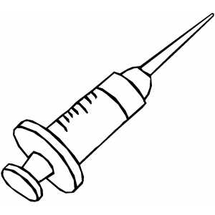
0 1 3 4 5 6 7 8 9 10 11 12 13 14
Immune
Non-immune
Secondary response
Weeks
Why this delay in forming antibodies?
Antibody level
0 1 3 4 5 6 7 8 9 10 11 12 13 14
Immune
Non-immune
Weeks
- What is the main difference between passive and active immunity?

- Why has the antibody level increased after the second injection?

- What might be the injection consist of?

- Could this person have developed these antibody levels without being sick?

- Why is the antibody falling?

- Explain why this person is no longer immune after week 6.

- What kind of substance was injected in this case?

- Why do you think so?

