Human Biology 12
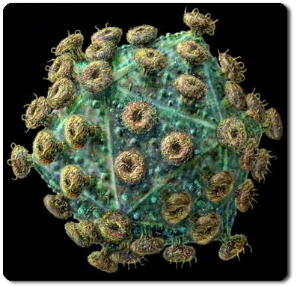
Module 1.5 Review

- Why are diseases caused by bacteria usually easier to diagnose and treat than those caused by viruses?

- What are some of the diseases caused by:
- Bacteria

- Viruses

- Other pathogens?

- What is meant by the terms:
- Pathogen

- Contagious

- Vector

- Epidemic

- Endemic

- Pandemic?

- How are pathogens prevented from entering the body through:
- the skin

- the digestive tract

- the respiratory tract

- the urinogenital tract?

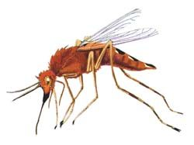
- How do T-lymphocytes differ from B-lymphocytes?
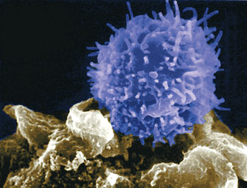

- What is meant by an
- an antigen

b) an antibody

- How would the body protect itself from an acute bacterial infection?

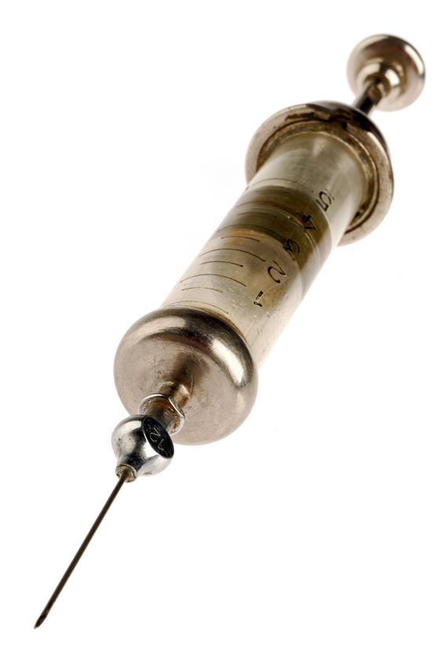

- How do
- vaccines

- sera work?

- What causes AIDS and how is it transmitted?

- How can the spread of AIDS be prevented?

